**Palynologists and**

**Plant Micropalaeontologists of Belgium (PPMB)**

**Miscellanea palaeontologica 2017**

**Program and abstracts**

Edited by Philippe STEEMANS & Philippe GERRIENNE

## A meeting of the NFSR Working Group: “Micropaléontologie végétale et Palynologie (MVP)”

Palaeobiogeology, Palaeobotany, Palaeopalynology

University of Liège December, 2017

 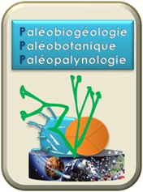

**Program**

09h30-10h00 - Welcome coffee

10h00-10h20 – Catherine Demoulin& Valentin Fischer.Feeding and ecological diversity of Tournaisian holocephalans: approach through the study of dental microwear

10h20-10h40 – **Camille François, Blaise Kabamba Baludikay, Daniel Baudet, Jean-Louis Paquette, Michel Fialin, Jean-Louis Birck, Delphine Limmois, Vinciane Debaille, Fred Jourdan, Jean-Yves Storme& Emmanuelle Javaux.** Geochronological contributions on the diagenesis and sediment sources of the Mbuji-Mayi Supergroup, (Proterozoic, DRCongo)

10h40-11h00 - **Thomas Servais & Borja Cascales-Miñana**. Acritarchs, cryptospores, and why almost all palaeontology text-books got it wrong

11h00-11h20 – **Corentin Loron, Galen Halverson, Rob Rainbird, Tom Skulski, Elizabeth Turner & Emmanuelle Javaux**. A sampling season in Arctic Canada: the Dismal Lakes Group

11h20-11h40 - **Yohan Cornet, JérémieBeghin, Blaise K. Baludikay, Camille François, Philippe Compère2, Emmanuelle J. Javaux.** Early eukaryotes: insights from microanalyses of proterozoic microfossils

12h00-14h00 – Lunch (Sandwiches)

14h00-14h20 – **David M. Kroeck, Mathilde Blanchon, Claude Monnet & Thomas Servais.** Revision of the early Palaeozoic acritarch genus *Vulcanisphaera* – Indications for ecophenotypism?

14h20-14h40 – **Taniel Danelian.** Biodiversity dynamics of Late Cambrian to Silurian radiolarians

14h40-15h00 – **Shucan Zheng, Thomas Servais, Qinglai Feng.** Lower Cambrian Organic-walled microfossils from the Middle and Upper Yangtze region, South China

15h00-15h20 – **Philippe Steemans, Victoria J. Garcia Muro, Philippe Gerrienne and Claudia V. Rubinstein.**South American miospore evolution, from their first appearance up to the Early Devonian.

15h20 – 15h40 – Coffee break.

15h40 – 16h00 **- Borja Cascales-Minana, Philippe Steemans, Gonzalo Rial, Philippe Gerrienne, Rodolfo Gozalo, José B. Diez, José I. Valenzuela-Rios & Maurice Streel.** First spore data of the Upper Devonian Bolloncillos Formation (NE Iberian Peninsula)

16h00-16h20 **– Sergey M Snigirevsky, Brigitte Meyer-Berthaud, Philippe Steemans, Maria V Bobyleva,Milana A Pavlova, Anna P Sivkova & Philippe Gerrienne.** A new look at some Late Devonian floras from Easter Europe.

16h20-16h40 – **Cyrille Prestianni & Anne-Laure Decombeix.** Bipolar or not that’s the question: earliest spermatophyte growth habit into question.

16h40-17h00 – Farewell Coffee

Abstracts without oral presentation –

**Marc Paillet, Jérémie Beghin, Thomas Leclef, Mariusz Lamentowicz, Kamyar Karan, Mona Court-Picon, Mohammed Allan, Nathalie Fagel, Maurice Streel& Philippe Gerrienne.** Reconstitution des conditions de formation de la tourbe des périodes Atlantique ancien à Subatlantique ancien dans la tourbière ombrotrophe du Misten (Est de la Belgique) sur la base d’analyses à haute résolution des pollens, des thécamoebiens et de la géochimie.

**Maurice Streel,FernandDavid, Emile Roche, Etienne Juvigne, Jan de Coninck, Caroline de Meyer & Philippe Gerrienne.** Tourbières d’altitude en Haute Savoie

**Feeding and ecological diversity of Tournaisian holocephalans: insights from dental microwear**

# Catherine Demoulin1,*,□, Claire Derycke2, Christian Michel3, Valentin Fischer1

1 University of Liège, Department of Geology, Evolution & Diversity Dynamics Lab, 14, allée du 6 Août B18, quartier AGORA, 4000 Liège, (Sart-Tilman), Belgium. V.Fischer@uliege.be

□ Now at University of Liège, Department of Geology, Palaeobiogeology-Palaeobotany- Palaeopalynology Lab, 14, allée du 6 Août B18, quartier AGORA, 4000 Liège, (Sart-Tilman), Belgium. [cdemoulin@uliege.be](mailto:cdemoulin@uliege.be)

2 University of Lille – Sciences et Technologies, Department Earth Sciences, Evo-Eco-Paleo UMR 8198, 59655 Villeneuve d'Ascq Cedex, France. claire.derycke@univ-lille1.fr

3 University of Liège, Department of Biology, Ecology and Evolution, Freshwater and Oceanic science Lab, 4000 Liège, Belgium. Christian.Michel@uliege.be

* Corresponding author

At the end of the Devonian, several profound extinctions affected a large number of marine groups. However, some of them, such as holocephalan chondrichtyans, showed a great diversification during the recovery of the ecosystems, during the Tournaisian. Despite the fact that a large taxic diversity has been documented for these holocephalans; their ecological diversity is however poorly known, because the shape of isolated teeth can be a poor predictor of the ecology of these animals. Microwear analysis has the potential to reveal distinct diets and actual use of teeth in these extinct animals during the Tournaisian. We analysed the microwear of Tournaisian holocephalans from the Tournai and Ourthe formations of Belgium. Dental microwears were observed qualitatively on 20 teeth with a scanning electron microscope and mapped and analysed in detail for 7 of them with ArcMap software. While pits are almost totally absent in our sample, our microwear dataset revealed two populations of scratches with distinct length distributions. We suggest that these populations were produced by two different mechanisms. The first population contains mainly long scratches (>0.2 mm, up to 2.0 mm) that are often oriented 40° to 70° compared to the anteroposterior axis of the tooth. We propose that these scratches would have been produced by trituration. The second population comprises almost exclusively of short scratches (<0.2 mm) especially abundant on the mesial face of the teeth and preferentially oriented subparallel to the anteroposterior axis. They would have been produced when the holocephalans dug into sea bottom sediments while searching for food. To identify materials that might have caused the observed microwear, we compared the hardness of the holocephalan orthodentine, making the bulk of the crown of holocephalan teeth, and materials present in their environment. The skeleton of a wide series of marine organisms (crinoids, brachiopods, molluscs) is composed of calcite or aragonite, which appears to be slightly harder than holocephalan orthodentine. These materials may thus scratch holocephalan teeth but are hardly able to produce pits because of the small difference in hardness. Tournaisian holocephalans were thus probably feeding on benthic faunae and they likely dug in the sediment at the search of food. If correct, this might rule out prey items located clearly above the sea floor, such as ammonioids or high-stalked crinoids. However, most of our specimens showed similar microwear features, which prevents us to highlight ecological differences between the taxa we sampled.

**Geochronological contributions on the diagenesis and sediment sources of the Mbuji-Mayi Supergroup, (Proterozoic, DRCongo)**

**Camille François1, Blaise Kabamba Baludikay1, Daniel Baudet2, Jean-Louis Paquette3, Michel Fialin4, Jean-Louis Birck5, Delphine Limmois5, Vinciane Debaille6, Fred Jourdan7, Jean-Yves Storme1 & Emmanuelle Javaux1**

1 Palaeobiogeology-Palaeobotany-Palaeopalynology, UR Geology, University of Liège, Quartier Agora, Allée du 6 Août, 14, Bât. B18. B-4000 Liège 1, Belgium. [C.Francois@uliege.be](mailto:C.Francois@uliege.be)

2 Earth Sciences Department, Royal Museum for Central Africa, Tervuren, Belgium. [daniel.baudet@africamuseum.be](mailto:daniel.baudet@africamuseum.be)

3 Laboratoire ‘‘Magmas et Volcan’’ (CNRS UMR 6524), Université B. Pascal, Clermont-Ferrand Cedex, France. [J.L.paquette@opgc.univ-bpclermont.fr](mailto:J.L.paquette@opgc.univ-bpclermont.fr)

4 Camparis, Université Paris 6, France. michel.fialin@upmc.fr

5 Laboratoire G2E, IPG-Paris, France. [birck@ipgp.fr](mailto:birck@ipgp.fr); [limmois@ipgp.fr](mailto:limmois@ipgp.fr)

6 Laboratoire G-Time, Université Libre de Bruxelles, Belgium. [vdebaill@ulb.ac.be](mailto:vdebaill@ulb.ac.be)

7[Western Australian Argon Isotope Facility](http://sites.google.com/site/fredjourdancv/the-40ar-39ar-laboratory), Curtin University, Perth, Australia. [F.Jourdan@exchange.curtin.edu.au](mailto:F.Jourdan@exchange.curtin.edu.au)

The Mbuji-Mayi Supergroup, DRC, is located between the Archean-Paleoproterozoic Kasai Craton and the Mesoproterozoic Kibaran Belt. This sedimentary sequence is unaffected by regional metamorphism and comprises a large diversity of well-preserved microfossils, evidencing the evolution of complex life (early eukaryotes) for the first time in Meso-Neoproterozoic record of Central Africa (Baludikay et al., 2016). The lithostratigraphy consists of two distinct successions (i) BII Group: a badly constrained upper carbonate sequence intercalated with some shale levels. Basaltic lavas topping the Mbuji-Mayi Supergroup were dated around 950 Ma (e.g. Cahen et al., 1984) and (ii) BI Group: a lower siliciclastic sequence (ca. 1174 Ma to ca. 1055 Ma (e.g. Cahen, 1974; Delpomdor et al., 2013).

The diagenesis of BI Group was dated by U-Th-Pb dating with LA-ICP-MS and Electron MicroProbe (on xenotime, monazite and zircon) between 1030 and 1065 Ma (François et al., 2017). Different sources of sediments were observed in the basin and through time. We performed Re-Os dating on fossiliferous shales to better constrain the age of this BII Group and the age of microfossils in the Meso-Neoproterozoic interval. We also re-evaluated the age of basaltic lavas topping the Supergroup with Ar-Ar technique to constrain the end of diagenesis.

Baludikay, B.K., Storme J-Y., François C., Baudet D. and Javaux E.J. (2016). A diverse and exquisitely preserved organic-walled microfossil assemblage from the Meso–Neoproterozoic Mbuji-Mayi Supergroup (Democratic Republic of Congo) and implications for Proterozoic biostratigraphy. *Precambrian Research 281*, 166-184.

Cahen, L., Snelling, N. J., Delhal, J., Vail, J. R., Bonhomme, M. and Ledent, D. (1984). The geochronology and evolution of Africa. Clarendon.

Cahen, L., Ledent, D. and Snelling, N. J. (1974). Données géochronologiques dans le Katangien inférieur du Kasai oriental et du Shaba nord-oriental (République du Zaïre). *Mus. Roy. Afr. Centr.-Tervuren (Belg.) Dépt. Geol. Min. Rapport annuel*, *1974*, 51-70.

Delpomdor, F., Linnemann, U., Boven, A., Gärtner, A., Travin, A., Blanpied, C., and Preat, A. (2013). Depositional age, provenance, and tectonic and paleoclimatic settings of the late Mesoproterozoic–middle Neoproterozoic Mbuji-Mayi Supergroup, Democratic Republic of Congo. *Palaeogeography, palaeoclimatology, palaeoecology*, 389, 4-34.

François, C., Baludikay, B. K., Storme, J. Y., Baudet, D., Paquette, J. L., Fialin, M. and Javaux, E. J. (2017). Contributions of U-Th-Pb dating on the diagenesis and sediment sources of the Lower Group (BI) of the Mbuji-Mayi Supergroup (Democratic Republic of Congo). *Precambrian Research,* 298*,* 202-219.

**Acritarchs, cryptospores, and why almost all palaeontology text-books got it wrong**

**Thomas Servais & Borja Cascales-Miñana**

UMR 8198 Evo-Eco-Paléo, CNRS-Université Lille 1, Cité Scientifique, 59655 Villeneuve d’Ascq, France. [Thomas.Servais@univ-lille1.fr](mailto:Thomas.Servais@univ-lille1.fr); [borja.cascales-minana@univ-lille1.fr](mailto:borja.cascales-minana@univ-lille1.fr)

Evitt (1963, PNAS 49 : 298–302) defined the acritarchs as an informal group of organic-walled microfossils with unknown biological affinities (that could not be attributed a known group of phytoplankton, such as the dinoflagellates). Richardson et al. (1984, J. Micropal. 3:109-124) proposed the diagnosis of another informal grouping, the ‘anteturma Cryptosporites’ in order to classify primitive spore-like palynomorphs (that could not be attributed with certainty to the spores of land-plants). Since the description of the terms "acritarchs" and "cryptospores", many other definitions have been proposed confronting the morphology and its biological interpretation. Consequently, almost no palaeontological text-book or website cites correctly the original definition of the ‘acritarchs’ and the ‘cryptospores.’ Instead, many ambiguous interpretations of the terms circulate in literature, leading to great confusion. We advocate that, as long as the exact biological affinity of most of the individual morphotypes remains unknown, the informal groupings of the acritarchs and the cryptospores are still valuable and should be used in palaeontology text-books.

**A sampling season in Arctic Canada: the Dismal Lakes Group.**

**Corentin Loron1*, Galen Halverson2, Rob Rainbird3, Tom Skulski3, Elizabeth Turner4 & Emmanuelle Javaux1**

1 Palaeobiogeology-Palaeobotany-Palaeopalynology, UR Geology, University of Liège, Quartier Agora, Allée du 6 Août, 14, Bât. B18. B-4000 Liège 1, Belgium. [c.loron@uliege.be](mailto:c.loron@uliege.be); [ej.javaux@uliege.be](mailto:ej.javaux@uliege.be)

2 Department of Earth and Planetary Sciences, McGill University, Montreal, QC, Canada. galen.halverson@mcgill.ca

3Geological Survey of Canada Ottawa, ON, Canada. [rob.rainbird@canada.ca](mailto:rob.rainbird@canada.ca); tom.skulski@canada.ca

4Harquail School of Earth Sciences Laurentian University Sudbury, ON, Canada. eturner@laurentian.ca

*CORRESPONDING AUTHOR

The Mesoproterozoic Dismal Lakes Group outcrops in the Northwestern Territories and Nunavut in Canada. This is a relatively well constrained succession, overlying the 1590+-3 Ma Hornby Bay Group and below the 1267+-2 Ma Coppermine River Group. The shallow marine succession is an alternation of organic-rich shale and stromatolitic dolostone with subordinate cherty units and nodules. Micropaleontological studies were directed in the eighties by Bob Horodyski and colleagues in chert and shale material, leading to a first characterization of the Dismal Lakes Group biota. Only prokaryotic microfossils were reported. A field expedition, supported by the Agouron Institute and co-organized by the Geological Survey of Canada (Ottawa, ON) and the university of McGill (Montreal, QC), was conducted this summer in the Artic Canada in order to sample more material for microfossil investigations, along with new sedimentological, paleoredox and geochronological studies. This research is part of a PhD thesis supported by the FNRS and ERC STg ELITE.

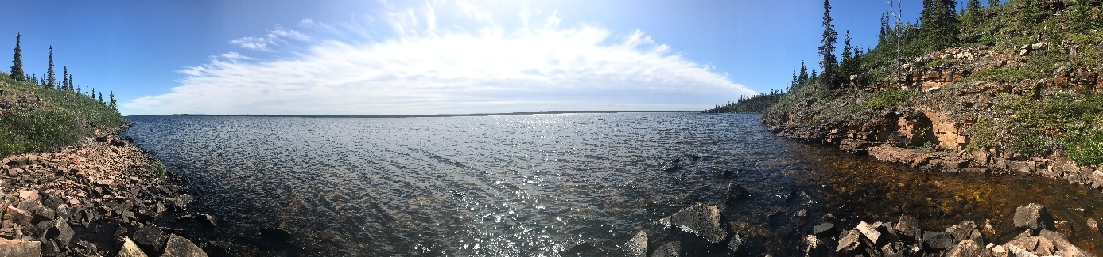

**Early eukaryotes: insights from microanalyses of Proterozoic microfossils**

**Yohan Cornet1, JérémieBeghin1, Blaise K. Baludikay1, Camille François1, Philippe Compère2 & Emmanuelle J. Javaux1**

1 Palaeobiogeology-Palaeobotany-Palaeopalynology, UR Geology, University of Liège, Quartier Agora, Allée du 6 Août, 14, Bât. B18. B-4000 Liège 1, Belgium. [y.cornet@uliege.be](mailto:y.cornet@uliege.be); [jbeghin@uliege.be](mailto:jbeghin@uliege.be); [bkbaludikay@uliege.be](mailto:bkbaludikay@uliege.be); [C.Francois@uliege.be](mailto:C.Francois@uliege.be); [ej.javaux@uliege.be](mailto:ej.javaux@uliege.be)

2 UR FOCUS, University of Liege, Liege, Belgium. [pcompere@uliege.be](mailto:pcompere@uliege.be)

The late Mesoproterozoic–early Neoproterozoic is an important period to investigate the diversification of early eukaryotes through changing global conditions. Although proterozoic fossils related to crown group eukaryotes are known, most microfossils of unambiguous eukaryotes remain unassigned to a particular clade. Among these, organic-walled microfossils include distinct forms such as ~820-720 Ma-old *Cerebrosphaera globosa,* 1100-720 Ma-old *Trachyhystrichosphaera* *aimika, T*. *botula*, and the multicellular 1100-720 Ma-old *Jacutianema solubila*. To characterise the taxonomy, the paleobiology and possible relationships to crown groups, we combine analyses of their morphology, wall ultrastructure and microchemistry, using optical and electron (SEM and TEM) microscopy and Raman and FTIR microspectroscopy.

*Cerebrosphaera* specimens from the Svanbergfjellet Fm (Spitsbergen) and the Kanpa Fm (Officer Basin, Australia) include vesicles with dark robust walls ornamented by cerebroid folds. Our study shows the occurrence of complex tri or bi-layered wall ultrastructures, confirming the eukaryotic nature of these large ornamented microfossils, and a highly aromatic and recalcitrant biopolymer composition.

The genus *Trachyhystrichosphaera* is characterised by the presence of a variable number of hollow heteromorphic processes. FTIR microspectroscopy performed on specimensfrom the Taoudeni Basin (Mauritania), and the Mbuji-Mayi Supergroup (RDC) indicates a strong aliphatic and carbonyl composition of the wall biopolymer. Morphometric analyses realised on 360 specimens of Mauritania allowed us to constrain the diversity and morphological plasticity of the genus. TEM permits to characterise the ultrastructure of the genus.

Various morphotypes of the species *Jacutianema solubila* from the Svanbergfjellet Fm (Spitsbergen) were observed by TEM. They show a complex wall ultrastructure comprising oblique sub-units, and a variable wall thickness. FTIR analyses show complex spectra dominated by aliphatic functional groups. These data will allow us to test previous hypotheses about its taxonomy.

Knoll, A.H. (2014). Cold Spring Harb Perspect Biol;Butterfield, N.J. (2015) *Current* *Biology* 25, 845–875; Butterfield *et al* (1994) *Fossil and Strata* 34, 82p; Butterfield, N.J. (2005) *Lethaia* 38 (2), 155-169.

**Revision of the early Palaeozoic acritarch genus *Vulcanisphaera* – Indications for ecophenotypism?**

**David M. Kroeck1,2,*, Mathilde Blanchon1, Claude Monnet1,3, & Thomas Servais1,4**

1 Evo-Eco-Paléo, UMR 8198 CNRS, Université de Lille, Avenue Paul Langevin, Bâtiment SN5, Cité Scientifique, 59655 Villeneuve-d'Ascq, France.

2 [davidmarius.kroeck@ed.univ-lille1.fr](mailto:davidmarius.kroeck@ed.univ-lille1.fr)

3 [claude.monnet@univ-lille1.fr](mailto:claude.monnet@univ-lille1.fr)

4 [thomas.servais@univ-lille1.fr](mailto:thomas.servais@univ-lille1.fr)

* Corresponding author

The classification of acritarchs represents a major problem concerning the study of this group. Due to the often purely descriptive approach of many earlier studies, which in many instances were focused on biostratigraphic utility, it can be assumed that a large part of the described taxa are not real biological entities but rather represent different (eco-) phenotypes. Morphological changes had been interpreted mostly as a result of chronological evolution, whereas in many cases it can be certainly assumed that they reflect changing environmental conditions. Therefore, critical taxonomic revisions of selected taxa, that take into account palaeobiological and palaeoecological factors, are required, and essential to identify morphological trends of certain forms in response to those factors.

Earlier investigations (e. g. Stricanne & Servais 2002; Servais et al., 2004) show that a large intraspecific morphological variation can indeed be observed within certain acritarch taxa. Many of the described taxa represent only morphotypes in a wider, continuous range of morphologies within individual taxa, and therefore cannot persist as distinct species, or even genera. Following these works, this new study focuses on the Cambro-Ordovician genus *Vulcanisphaera* Deunff, 1961, which was first described with its type species *V*. *africana* from Cambro-Ordovician sequences of the Algerian Sahara. A first detailed revision of this genus, including the description of four new species, was provided by Rasul (1976), investigating populations in material from the Tremadocian Shineton Shales in the Wrekin District of Shropshire, England. Additional species were subsequently described from different other areas, including Spain, France, Poland, and Canada. The comprehensive examination of the literature reveals that in total 33 species have been attributed to the genus.

The new revision, that is presented here, includes an extensive review of the literature, as well as reinvestigations of large populations in material from upper Cambrian/Tremadocian successions of the type localities in Algeria and England. In order to revise the classification of the genus biometric measurements of morphological characteristics, such as vesicle diameter, process length, shape, and presence/absence of polygonal fields, were carried out, and used as a base for statistical analyses. The results of these investigations show clearly that only three species can be maintained: *Vulcanisphaera* *africana*, *V*. *capillata*, *V*. *simplex*. These species have a large morphological variability, which is probably dependent on environmental influences.

Rasul, S.M. (1981). New species of the genus Vulcanisphaera (Acritarcha) from the Tremadocian of England. *Micropalaeontology*, 22 (4), 479-484.

Servais, T., Stricanne, L., Montenari, M. and Pross, J. (2004). Population dynamics of galeate acritarchs at the Cambrian-Ordovician transition in the Algerian Sahara. *Palaeontology*, 47 (2), 395-414.

Stricanne, L. & Servais, T. (2002). A statistical approach to classification of the Cambro-Ordovician galeate acritarch plexus. *Review of Palaeobotany and Palynology*, 118, 239-259.

**Biodiversity dynamics of Late Cambrian to Silurian radiolarians**

**Taniel Danelian**

Univ. Lille, CNRS, UMR 8198 – Evo-Eco-Paleo, F-59000 Lille, France. [taniel.danelian@univ-lille1.fr](mailto:taniel.danelian@univ-lille1.fr)

Based on a comprehensive database of Late Cambrian to Silurian radiolarian occurrences, radiolarian biodiversity is explored using various quantitative methods to identify trends in taxonomic richness and composition, and to test these patterns for biases.

The dataset compiles data available in the literature, by selecting only publications with enough independent chronostratigraphic information (commonly graptolite control or absolute dating) to calibrate radiolarian species occurrences at the stage level; it is composed of incidence data (i.e. presence/absence), and species described under open nomenclature (e.g. “sp. A”) or with uncertain attribution (e.g. “cf.”) are included. The age of some samples has been revised or clarified from the original works when subsequent dating has become available.

The analysed database thus contains 168 species found in 23 assemblages covering the Late Cambrian – Ordovician interval and 161 Silurian species found in 33 assemblages.

Taxonomic assignments of species were reviewed in the original publications and species names were harmonized to remove nomenclatural artifacts. Biodiversity dynamics through time were estimated by multiple approaches, including taxonomic richness indices, changes in richness (origination, extinction), poly-cohort analysis, taxonomic distinctness, and similarity analysis.

Data analysis of the compiled dataset reveals some interesting trends for the Silurian radiolarian record, with the early Silurian appearing to be an interval of faunal recovery from the end-Ordovician mass extinction event. Indeed, following the Hirnantian (end-Ordovician) mass extinction, the Rhuddanian stage records very low levels of diversity, which then increase gradually throughout the Llandovery series and reach a maximum by the Sheinwoodian stage, before decreasing during the Homerian, and finally rebounding during the Gorstian stage. Thus the early Silurian (Llandovery) appears to be an interval during which few species went extinct, although the number of last occurrences increases progressively to reach a peak in the Ludfordian. At the same time first occurrences progressively decrease and are relatively low during the Silurian. Only the Gorstian is marked by a sudden increase in origination and appears to correspond to an interval of recovery following the Homerian low in radiolarian diversity.

**Lower Cambrian organic-walled microfossils from the Middle and Upper Yangtze region, South China**

**Shucan Zheng1,2, Thomas Servais3, Qinglai Feng1,2**

1 State Key Laboratory of Geological Processes and Mineral Resources, Faculty of Earth Sciences, China University of Geosciences, Wuhan 430074, China, [zhengshucan@126.com](mailto:zhengshucan@126.com)

2 School of Earth Science, China University of Geoscience, Wuhan 430074, China, [zhengshucan@cug.edu.cn](mailto:zhengshucan@cug.edu.cn)

3 UMR 8198 du CNRS: Evo-Eco-Paleo, Université de Lille, Avenue Paul Langevin, SN5, 59655 Villeneuve d’Ascq, France. [Thomas.Servais@univ-lille1.fr](mailto:Thomas.Servais@univ-lille1.fr)

The ‘Cambrian Explosion’ was a global process of multi-stage evolution of the marine biota. However, the different biological aspects of the appearance of animal phyla and various biomineralization processes raise the question of the source or trigger mechanism of the ‘Cambrian Explosion.’ Based on this consideration, a palynological analysis has been conducted on the basal lower Cambrian sequences from South China.

Organic-walled fossils of various biological affinities have been recovered from the silty argillaceous rocks deposited in the shallow shelf facies and local sag basin facies in the Sichuan Basin (South China) providing us a deeper insight into the Cambrian radiation. The microfossils can be classified among the acritarchs and Small Carbonaceous Fossils (SCFs). The SCFs include filamentous and multicellular microorganisms, organic sheaths of spongy spicules and small shelly fossils, and zooclasts suspected of the arthropod crown group.

The fossils in the interval ranging from the Fortunian to stage 3 built a direct link between the abrupt appearance of major bilaterian clades and the diverse organisms in the Ediacaran. Besides, these organic-walled fossils extend the SCFs fossil record back to the basal Cambrian negative carbon isotope excursion (BACE) with diverse life forms which may provide the key to the deep roots of the Cambrian explosion of metazoans.

**South American miospore evolution,**

**from their first appearance up to the Early Devonian**

**Philippe Steemans1, Victoria J. Garcia Muro2, Philippe Gerrienne1, and Claudia V. Rubinstein2**

1 Palaeobiogeology-Palaeobotany-Palaeopalynology, UR Geology, University of Liège, Quartier Agora, Allée du 6 Août, 14, Bât. B18. B-4000 Liège 1, Belgium. [p.gerrienne@uliege.be](mailto:p.gerrienne@uliege.be), [p.steemans@uliege.be](mailto:p.steemans@uliege.be)

2 IANIGLA, CCT CONICET Mendoza. Av. Ruiz Leal s/n, Parque General San Martín, Mendoza, Argentina. CC: M5502IRA. Phone: +54 261 524 4217, [crubinstein@mendoza-conicet.gov.ar](mailto:crubinstein@mendoza-conicet.gov.ar); [vgarcia@mendoza-conicet.gov.ar](mailto:vgarcia@mendoza-conicet.gov.ar)

For a long time, the miospore palynology of pre-Middle Devonian beds from South America has been little studied. Besides inaccessible private data belonging to petroleum societies and others, many papers on that matter have however recently been published, mostly on Brazilian and Argentinian localities. In this contribution, we critically review the current evidence.

The oldest cryptospores have been found in a Dapingian locality from Argentina. The material is poor and badly preserved. Those cryptospores have been interpreted as the earliest evidence for embryophytes (land plants). Despite of the presence of a tetrahedral tetrad, generally accepted as being exclusively linked to land plants, some authors questioned the embryophyte affinities of the Dapingian Argentinian cryptospore assemblage.

Late Ordovician cryptospore occurrences are infrequent in South America. In the Salar del Rincón Formation (Puna,northwesternArgentina), an assemblage of cryptospores has been isolated. The age of the Salar del Rincón Formation has been widely discussed. On the basis of various fossil evidences, the section crosses the Ordovician/Silurian boundary, ranging from the Hirnantian up to the Rhuddanian. Cryptospores are rare but diversified in the latest Ordovician part of the section. A typical assemblage has been collected from the Hirnantian beds, including among others *Pseudodyadospora petasus*, *Rimosotetras problematica*, *Segestrespora laevigata*, *S.membranifera*, ?*S. rugosa*, *Sphaerasaccus glabellus*.

The Hirnantian Caspalá Formation (Cordillera Oriental, northwestern Argentina) contains a rich assemblage of cryptospores, similar to the previous Ordovician one. The earliest trilete spores from the whole American continent are observed in the Caspalá Formation. They are: *Ambitisporites avitus*, *Leiotriletes* spp*.*, *Aneurospora*? sp*.* and *Chelinospora* cf*. prisca*.

The early Silurian is represented by the lower part of the post-glacial Lipeón Formation, in Cordillera Oriental and Sierras Subandinas, which yields less diverse cryptospore assemblages and only a few trilete spores (i.e. *Ambitisporites avitus*, *Leiotriletes* spp.) exclusively in the Caspalá section (Cordillera Oriental).

Three wells have penetrated Silurian beds from east Paraguay. Samples have been taken from the Itacurubi Group of the ParanaBasin. A biozonation has tentatively been established for the miospores observed in the Llandovery. However, recent observations in South America and other countries have demonstrated that the criteria used for this biozonation are no more relevant, except the first incoming of *Archaeozonotriles chulus*, close to the Aeronian/Telychian boundary.

Two other wells have been drilled through the upper part of the Eusebio Ayala, the Vargas Peña and the Cariyformations from east Paraguay and have been studied for miospores and chitinozoans. The *Archaeozonotriletes chulus/nanus* Morphon biozone characterizes the middle and upper Vargas Peña Formation and the lower Cariy Formation. The base of the *A. chulus/nanus* biozone of miospores corresponds approximately to the base of the chitinozoan *Conochitina proboscifera* biozone, *Desmochitina* cf. *densa* sub-biozone, and is probably close to the Aeronian/Telychian boundary.

Acritarchs and spores of the Tucunuco Group have been inventoried in different localities where the La Chilca and Los Espejos formations are outcropping, in the Central Precordillera of San Juan. No trilete spores were recorded in the Llandovery-Wenlock La Chilca Formation. In general, the abundance of trilete spores increases towards the upper levels of the Los Espejos Formation. Of special palaeogeographical and biostratigraphic interest is the presence of a possible, badly preserved ?*Streelispora newportensis* in the northern locality of Río Jáchal*.* Because of its importance a new sampling is necessary to confirm its presence. Moreover, *Chelinospora* cf*.cantabrica* is present in the lowest studied level of the same section, which appear in the *reticulata-sanpetrensis* (RS) biozone, suggesting a Ludlow–Early Pridoli? age. *Chelinospora retorrida*, *Cymbosporites paulus*? in Wellman 1993 and *Dictyotriletes* cf. *emsiensis*Morphon allow recognizing the Lochkovian *micrornatus-newportensis* (MN) biozone in the uppermost beds of the Los Espejos Formation. Thus, the Silurian/Devonian boundary was identified in that locality. Acritarchs and brachiopods support this age attribution.

Eighteen samples have been studied from Petrobras well 1-JD-1-AM in the Jandiatuba area, Solimoes Basin, northern Brazil. Fifty-three species were identified and it was possible to correlate the assemblage with the biostratigraphical scale of the Lower Devonian established in Europe. Authors have considered the samples as belonging to the biozone Z of the Oppel zone BZ. Numerous *Dictyotriletes* were recorded. Those ones that showed a morphological evolution from specimens similar to *Dictyotriletes granulatus* up to *D. emsienis* and *D.* cf. *subgranifer* were incorporated into the newly created morphon, *Dictyotriletes emsiensis*.

Hereby, we compare the successions of the main miospore events in South America with those from other palaeoplates. We also discuss the relationships between miospore and early land plant assemblages. The palaeogeographic implications of all those observations are herein evaluated.

**First spore data of the Upper Devonian Bolloncillos Formation (NE Iberian Peninsula)**

**Borja Cascales-Minana1*, Philippe Steemans2, Gonzalo Rial2, Philippe Gerrienne2, Rodolfo Gozalo3, José B. Diez4, José I. Valenzuela-Rios3 & Maurice Streel2**

1 Evo-Eco-Paleo, UMR 8198-CNRS, University of Lille, F-59655 Villeneuve d'Ascq, France. [borja.cascales-minana@univ-lille1.fr](mailto:borja.cascales-minana@univ-lille1.fr)

2 Palaeobiogeology-Palaeobotany-Palaeopalynology, UR Geology, University of Liège, Quartier Agora, Allée du 6 Août, 14, Bât. B18. B-4000 Liège 1, Belgium. [P.steemans@uliege.be](mailto:P.steemans@uliege.be); [gontnq@gmail.com](mailto:gontnq@gmail.com); [p.gerrienne@uliege.be](mailto:p.gerrienne@uliege.be); [Maurice.streel@uliege.be](mailto:Maurice.streel@uliege.be)

3 Departament of Geology, Universiy of Valencia, c/ Dr. Moliner 50, E-46100 Burjassot, Spain. [rodolfo.gozalo@uv.es](mailto:rodolfo.gozalo@uv.es); [jose.i.valenzuela@uv.es](mailto:jose.i.valenzuela@uv.es)

4 Departamento de Xeociencias Mariñas e Ordenación do Territorio, Universidade de Vigo. 36200, Vigo, Spain. [jbdiez@uvigo.es](mailto:jbdiez@uvigo.es)

*Corresponding author

The Upper Devonian Bolloncillos Formation consists of a series of detritic rocks with alternance of shales and sandstones. Previous works have documented a great diversity of ostracods, tentaculites and conodonts from which key biozone correlations of marine environments have been done.In this communication, we present the first dispersed spore data of this formation. The isolated spore assemblage is formed by 26 spore taxa, belonging to 20 genera, including *Acinosporites* [sp.,](http://www.amjbot.org/content/96/10/1849.full#ref-50) *Ambitisporites avitus-dilutus*, *Aneurospora greggsii*, *Aneurospora* sp., *Convolutispora* sp*.*, *Emphanisporites mcgregorii*, *Emphanisporites rotates*, *Geminospora punctata*, *Geminospora lemurata, Retusotriletes rotundus*, *Retusotriletes rugulatus,* *Rugospora* cf. *spinosa, Rugospora* cf. *minuta*, *Samarisporites triangulatus, Verrucosisporites bulliferus* and *Zonotriletes brevivelatus* (among others). Spore evidence (*Retusotriletes rugulatus* and *Verrucosisporites bulliferus*) suggests that the time interval covered by the palynoflora would correspond to the *ovalis-bulliferous* Assemblage Zone of the Old Red Sandstone Palaeocontinent. This zone, equivalent to several key spore zonations of western Europe, such as the BJ (*bulliferus-jekhowskyi*), BM (*bulliferus-media*) zones, as well as the BA (*bricei-acanthaceus*) spore zone (lower part), advocates for a mid- to late Frasnian age for the outcrop.Results also indicate that *Zonotriletes brevivelatus*, a taxon previously only documented from the Lower Devonian of North Africa, would extend its distribution through Devonian. The new data presented here allow improved comparisons between marine biostratigraphy and Devonian terrestrial facies zonations. Implications of the temporal-spatial distribution of spore taxa are discussed.

**Acknowledgements.** BCM thanks the support provided by the *Région Hauts-de-France*, and the *Ministère de**l’Enseignement Supérieur et de la Recherche* (CPER Climibio), and the European Fund for Regional Economic Development.

**A new look at some Late Devonian floras from Eastern Europe**

**Sergey M. Snigirevsky1, Brigitte Meyer-Berthaud2, Philippe Steemans3,Maria V. Bobyleva1,Milana A. Pavlova1, Anna P. Sivkova1 & Philippe Gerrienne3,\***

1 Deparment of Sedimentary Geology, St. Petersbourg State University, Universitetskaya nab. 7-9-11, St. Petersbourg 199178, Russia. [s.snigirevsky@spbu.ru](mailto:s.snigirevsky@spbu.ru); [Mariia.Bobyleva1997@yandex.ru](mailto:Mariia.Bobyleva1997@yandex.ru); [milana.a.pavlova@yandex.ru](mailto:milana.a.pavlova@yandex.ru); [annie.sivkova@gmail.com](mailto:annie.sivkova@gmail.com)

2 Amap - BotAnique et Modélisation de l’Architecture des Plantes et des végétations, CNRS, CIRAD, INRA, IRD, Université de Montpellier, Montpellier, France. [meyerberthaud@cirad.fr](mailto:meyerberthaud@cirad.fr)

3 Palaeobiogeology-Palaeobotany-Palaeopalynology, UR Geology, University of Liège, Quartier Agora, Allée du 6 Août, 14, Bât. B18. B-4000 Liège 1, Belgium. [P.Steemans@uliege.be](mailto:P.Steemans@uliege.be); [P.Gerrienne@uliege.be](mailto:P.Gerrienne@uliege.be)

* Corresponding author

The Late Devonian (Frasnian: 383-372 Ma; Famennian: 372-359 Ma) is one of the most crucial period of time for the evolution of land biotas; for example, all plant lineages, angiosperms excepted, were already present at the end of Famennian times. Late Devonian floras of Eastern Europe have already been extensively studied since the end of 19th century, but (i) a number of published specimens are in need of taxonomic reassessment, and (ii) many others have not been published or published in Russian/Ukrainian/Estonian etc. (languages of the Former Soviet Union), without diagnoses in Latin/English/German, etc.

The present collaborative work aims at re-studying the Late Devonian palaeobotanical collections of M. D. Zalessky and of Natalia S. Snigirevskaya, housed in the Komarov Botanical Institute of the Russian Academy of Sciences, in the Central scientific research geological survey museum named after Academician F.N. Chernyshev (TSNIGR Museum) and in the Department of Sedimentary Geology of St. Petersbourg State University. Those collections are already well known because they include important specimens of *Archaeopteris* Stur, the earliest modern tree, and of anatomically preserved stems, branches and roots of archaeopteridalean affinities assigned to the genus *Callixylon* Zalessky from the type locality.

The Late Devonian floras that will be revised during the project come from various localities of Eastern Europe, including among others the Donetz Basin (Ukraine and Russia), north-western part of the Russian Platform and Northern Timan (Russia). From a palaeogeographical viewpoint, all these localities are located on the Baltica palaeoplate that was roughly in an equatorial position during the second half of the Devonian Period. It is of great importance, because most other Late Devonian plant localities were located outside the equatorial belt. Moreover, Baltica was in an intermediate position between Laurentia and Siberia or Kazakhstan, where abundant Late Devonian floras have been collected. Comparisons of all those floras will allow improved knowledge of their evolution and migration.

**Bipolar or not that’s the question: earliest spermatophyte growth habit into question.**

**Cyrille Prestianni1 & Anne-Laure Decombeix2**

1 OD Earth and Life, Royal Belgian Institute of Natural Sciences, Rue Vautier 29, 1000 Brussels. [Cyrille.prestianni@naturalsciences.be](mailto:Cyrille.prestianni@naturalsciences.be)

2 UMR AMAP, TA A51/PS2,Bd de la Lironde, 34398 Montpellier cedex 5, France. [anne-laure.decombeix@cirad.fr](mailto:anne-laure.decombeix@cirad.fr)

The earliest true spermatophytes are found in the Upper Devonian where up to 20 species have been described. They show a wide morpho-anatomical disparity of their reproductive structures. By contrast, the vegetative systems of almost all of them are characterized by a very narrow diversity. In all documented cases, it consists of a zigzag-shaped pseudomonopodial main axis bearing helically arranged dichotomous branching systems. This general organisation appeared early in the lignophyte phylogenetical tree. The earliest diverging trimerophytes include several well described fossil genera such as Psilophyton and Pertica that are similarly characterized by a pseudomonopodial stem and helically arranged dichotomous branching systems. This bauplan, though experiencing considerable variations, was as well conserved within Middle Devonian lignophytes such as the aneurophytales and stenokoleales. By contrast, the data available for the Lower Carboniferous spermatophytes indicate that though the morpho-anatomical disparity of ovules was comparable to that of the Devonian, a much higher disparity is observed for the vegetative parts, with the apparition of various growth habits and new characters of the primary and secondary vascular system. Exogenous ecological reasons are most often advocated to explain this major change as the disappearance of Archaeopteris and new climatic conditions allowed the exploration and occupation of new niches. We however suspect a major breakthrough to have occurred among spermatophyte growth habit with the apparition of bipolar growth around the Devonian/Carboniferous boundary. We will here discuss this hypothesis based on new available developmental evidences.

**Reconstitution des conditions de formation de la tourbe des périodes Atlantique ancien à Subatlantique ancien dans la tourbière ombrotrophe du Misten (Est de la Belgique) sur la base d’analyses à haute résolution des pollens, des thécamoebiens et de la géochimie.**

**Marc Paillet1, Jérémie Beghin1, Thomas Leclef1, Mariusz Lamentowicz2, Kamyar Karan1, Mona Court-Picon3, Mohammed Allan4, Nathalie Fagel4, Maurice Streel1,* & Philippe Gerrienne1**

1 Palaeobiogeology-Palaeobotany-Palaeopalynology, UR Geology, University of Liège, Quartier Agora, Allée du 6 Août, 14, Bât. B18. B-4000 Liège 1, Belgium. [marc.paillet@gmail.com](mailto:marc.paillet@gmail.com); [jeremie.beghin@uliege.be](mailto:jeremie.beghin@uliege.be); [Maurice.Streel@uliege.be](mailto:Maurice.Streel@uliege.be); [P.Gerrienne@uliege.be](mailto:P.Gerrienne@uliege.be)

2 Department of Biogeography and Palaeoecology, Adam Mickiewicz University (Faculty of Geographical and Geological Science), Dzięgielowa 27, 61-680 Poznań, Poland. [mariuszl@amu.edu.pl](mailto:mariuszl@amu.edu.pl)

3 Earth and Life History Division, Archaeosciences Unit, Royal Belgian Institute of Natural Sciences, Rue Vautier 29, B1000-Bruxelles, Belgium. [mona.courtpicon@ymail.com](mailto:mona.courtpicon@ymail.com)

4 AGEs, Département de Géologie, Université de Liège, Allée du 6 Août, B18 Sart Tilman B4000-Liège, Belgium. [Mohammed.Allan@uliege.be](mailto:Mohammed.Allan@uliege.be); [nathalie.fagel@uliege.be](mailto:nathalie.fagel@uliege.be)

* Corresponding author

La tourbière du Misten (Hautes-Fagnes, Belgique), épaisse de 7 mètres, a été étudiée avec pour objectifs la reconstitution de l’évolution de la tourbière et des conditions de la formation de la tourbe, à partir de l’analyse des grains de pollen et spores, des thécamoebiens, ainsi que de la géochimie. En complément d’un travail récent (Streel et al. 2014) qui s’intéressait seulement à la partie supérieur du sondage, la partie étudiée ici représente une grande partie de la période Atlantique, l’entièreté de la période Subboréal et le début de la période Subatlantique, soit environ l’intervalle de temps compris entre 7300 BP et 2000 BP. La reconnaissance d’assemblages polliniques repères définis par un travail plus ancien (Persch 1950), réalisé dans la périphérie de la même tourbière, permet de corréler étroitement entre eux les deux sites étudiés, 460 cm d’épaisseur dans la partie centrale de la tourbière correspondent à 230 cm d’épaisseur dans la périphérie. La datation précise des repères polliniques dans la séquence qui fait l’objet de ce travail permet une meilleure datation du travail de 1950. La comparaison des données polliniques indique que, comme attendu, proportionnellement, la pluie pollinique de *Corylus* est plus importante et celle du *Quercetum mixtum* moins importante dans la partie centrale de la tourbière qu’à la périphérie de celle-ci. L’analyse des thécamoebiens dans la partie centrale de la tourbière constitue l’apport majeur du présent travail. Cinq biozones ont été identifiées par une analyse contrainte stratigraphiquement. Trois fonctions de transfert ont été appliquées et comparées. Couplée à la mesure du taux d’humification des niveaux concernés, elles permettent une analyse détaillée du taux d’humidité de la tourbe, et donc des conditions climatiques locales au moment de la formation de cette dernière. L’intégration des résultats polliniques dans la zonation basée sur les thécamoebiens permet de définir, de dater et d’interpréter 18 intervalles de temps relativement courts, de l’ordre de 200 à 300 ans chacun. Nos résultats valident et complètent une première interprétation climatique (Allan et al. 2013) combinant analyse géochimique et données préliminaires acquises sur les thécamoebiens.

Allan, M., Le Roux, G., Piotrowska, N., Beghin, J., Javaux, E., Court-Picon, M., Mattielli, N., Verheyden, S. and Fagel, N. (2013). Mid- and late Holocene dust deposition in Western Europe: the Misten peat bog (Hautes Fagnes – Belgium). *Climate of the Past*, 9, 2285–2298.

Claussen, M., Kubatzki, C., Brovkin, V., Ganopolski, A., Hoelzmann, P. and Pachur, H.J. (1999). Simulation of an abrupt change in Saharan vegetation in the mid-Holocene. *Geophysical Research Letters*, 26, 2037–2040.

Persch, F. (1950). Zur postglazialen Wald-und Moorentwicklung im Hohen Venn. *Decheniana*, 104, 81–93.

Streel, M., Beghin, J., Gerrienne, P., Hindrickx, M.-N., Luthers, C., Court-Picon, M., Frankard, P., Allan, M. and Fagel, N. (2014). Late Subatlantic history of the ombrotrophic Misten Bog (Eastern Belgium) based on high resolution pollen, testate amoebae and macrofossil analysis. *Geologica Belgica*, 17/2, 148–160.

Wanner, H., Solomina, O., Grosjean, M., Ritz, S.P. and Jetel, M. (2011). Structure and origin of Holocene cold events. *Quaternary Science Reviews*, 30, 3109–3123.

Figure 1 (page suivante) : Comparaison des données polliniques entre Hattlich (Persch 1950) et le sondage Misten MIS-08-01b (ce travail).

Toutes les données AP sont calculées sans tenir compte de *Corylus.* La position des 9 points de repère reconnus dans les deux diagrammes est indiquée en rouge. Les âges cal BP sont donnés avec 94,5 % de probabilité. La limite Atlantique/Subboréal est suggérée au point de repère 5. Le diagramme Misten n’atteint pas la limite Boréal/Atlantique observée dans le diagramme Hattlich.

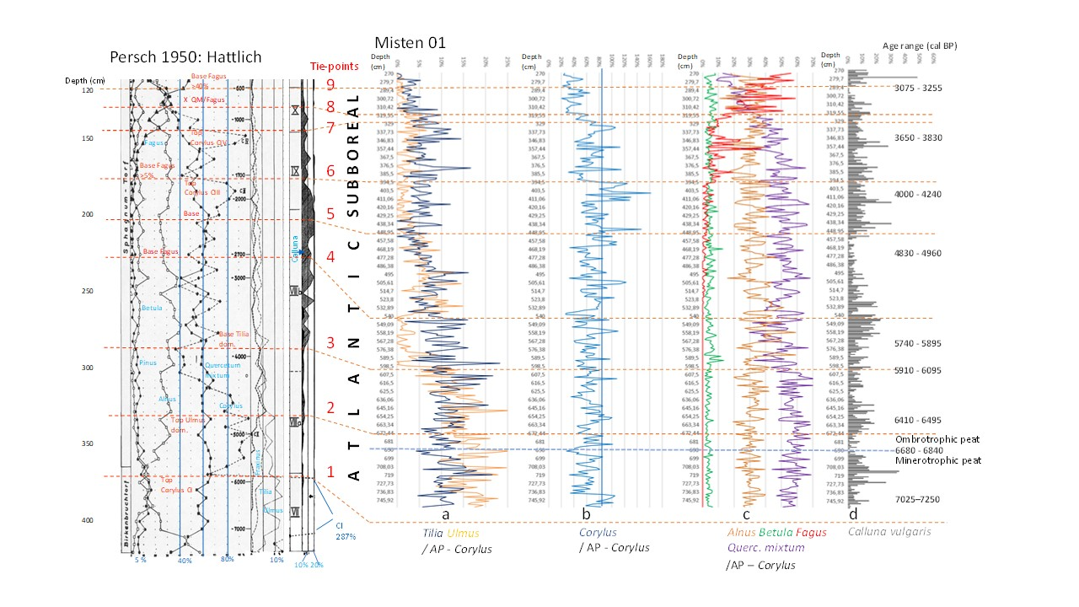

Figure 1. Comparaison des données polliniques entre Hattlich (Persch 1950) et le sondage Misten MIS-08-01b (ce travail).

Figure 2 (page suivante) : Comparaison des ‘proxies’ observés sur la tourbière du Misten (pollen, flux de poussières, εNd, humification et thécamoebiens).

Caractéristiques polliniques d’après la fig. 1. Deux thécamoebiens principaux pour les périodes Atlantique-Subboréal en Hautes-Fagnes sont représentés. Les intervalles de temps représentés par des chiffres noirs de 3 à 18 résultent de la confrontation des données polliniques et des données sur les thécamoebiens. Flux de poussières, εNd, humification sont repris de Allan et al. (2013). Les thécamoebiens sont classés en fonction de leur affinité avec les conditions d’humidité contemporaines. Les trois barres bleues foncées soulignent les évènements froids d’après Wanner et al. (2011) et les barres bleues claires indiquent la période d’incertitude dans la durée de ces évènements. Le modèle de désertification du Sahara est repris de Claussen et al (1999).



Figure 2. Comparaison des ‘proxies’ observés sur la tourbière du Misten (pollen, flux de poussières, εNd, humification et thécamoebiens)

**Tourbières d’altitude en Haute Savoie**

**Maurice Streel1,* FernandDavid2, Emile Roche1, Etienne Juvigne3, Jan de Coninck4, Caroline de Meyer4 & Philippe Gerrienne1**

1 Palaeobiogeology-Palaeobotany-Palaeopalynology, Quartier Agora, Allée du 6 Août, 14, Bât. B18. B-4000 Liège 1, Belgium. [M.Streel@uliege.be](mailto:M.Streel@uliege.be); [rocheemile@yahoo.fr](mailto:rocheemile@yahoo.fr); [P.Gerrienne@uliege.be](mailto:P.Gerrienne@uliege.be)

2 Institut Méditerranéen d’Écologie et de Paléoécologie, Faculté des Sciences de Saint-Jérôme, Case 451, 13397, Marseille cedex 20, France. [david@cerege.fr](mailto:david@cerege.fr)

3 Geography Department, University of Liège, Quartier Village 4, clos Mercator 3, Bât. B11, B-4000 Liège 1, Belgium. [ejuvigne@uliege.be](mailto:ejuvigne@uliege.be)

4 Universiteit Gent, Research Unit Palaeontology - WE13, Krijgslaan 281/S8, B-9000 Gent, Belgium. Contact Stephen Louwye [stephen.louwye@ugent.be](mailto:stephen.louwye@ugent.be)

* Corresponding author

Un sondage réalisé au centre d’une tourbière à 1200 m d’altitude près du lieu-dit « Bouttecul », commune d’Onnion, Haute Savoie (France), a démontré la présence d’une dizaine de mètres de tourbe reposant sur 4m 50 d’argile litée, à caractère varvaire, celle-ci superposée à 1m 50 d’argile compacte. Cette argile compacte contient non seulement des pollens d’âge quaternaire, mais aussi des pollens et des microorganismes d’origine marine, remaniés à partir de roches beaucoup plus anciennes. Une étude détaillée des pollens dans l’argile litée (David et al. 2006) et une étude préliminaire dans l’argile compacte montre que la sédimentation est ralentie par rapport au dépôt tourbeux, avec très peu de sédiments pendant le Tardiglaciaire et le début du Pléniglaciaire. L’argile compacte, non litée, a été déposée par le glacier pendant le Pléniglaciaire, c'est-à-dire pendant la glaciation wurmienne, il y a environ 20.000 ans. La surface du glacier wurmien a donc bien du atteindre l’altitude de 1200m au moins pour déposer au site de Bouttecul l’argile compacte (Till) contenant aussi des microfossiles remaniés (Fig. 1).

56 espèces de dinocystes d’âges Jurassique et Crétacé ont été identifiées dans l’argile compacte de la base du sondage. Les plus récents appartiennent au Crétacé le plus jeune, d’âge maastrichtien, et datés d’environ 70 millions d’années. Il est peu probable que le glacier wurmien soit venu du nord-ouest, c'est-à-dire de la vallée du Rhône où il a pris naissance, par l’intermédiaire de la vallée de la Ménoge (La « vallée verte ») car dans cette direction n’affleurent pas de roches d’âge maastrichtien qui auraient pu être érodées et transportées dans les moraines du glacier. En revanche, de telles roches existent dans la vallée du Risse au sud-est du site. C’est sans doute un glacier venant du sud-est, résultant vraisemblablement de la confluence des glaciers de l’Arve, du Giffre et du Risse, qui a déposé l’argile compacte et les microfossiles remaniés maastrichtiens. Une confirmation de l’existence d’un tel glacier au-delà de 1200m d’altitude est venue d’une collecte d’échantillons argileux dans la grotte de la « Grande Barme » à 1210m, près du sommet du « Rocher Blanc ». Ces échantillons contiennent des spores, des pollens et des dinocystes du Crétacé supérieur qui ne peuvent provenir du remaniement des parois de la grotte puisque celles-ci sont constituées de roches d’âge jurassique. Ces microfossiles ont donc été introduits dans la grotte par de l’eau ruisselant à la surface d’un glacier ayant atteint cette altitude. Les seules roches d’altitude, d’âge maastrichtien, dont l’érosion aurait pu fournir les microfossiles remaniés trouvés à Bouttecul et dans la grotte de la Grande Barme, pourraient être cherchées sur les flancs du « massif des Jottys » qui culmine à plus de 1265m à l’est du village de Mégevette. Ceci est confirmé par le mémoire de Caroline de Meyer (2005) qui a étudié les dinocystes dans ce massif, conjointement avec une analyse très détaillée de la géologie du site.

Une autre tourbière d’altitude est connue à 8km au sud-est de Bouttecul, à 1515m d’altitude au lieu-dit « Sommand », commune de Mieussy. Cette tourbière a été étudiée par Becker (1952) parmi 127 sondages répartis essentiellement dans les Alpes du Nord. Le sondage analysé recoupe 6m 50 de tourbe (Fig. 1) mais peut-être subdivisé en deux parties distinctes entre lesquelles l’auteur invoque une interruption de sédimentation dans un ancien lac « peut-être par suite d’une couverture durable de neige ou de glace morte ». Entre 0 et 425cm, on a une succession pollinique correspondant à l’histoire postglaciaire connue tandis que, de 450cm à 650cm, l’auteur s’interroge sur « la présence éventuelle d’une formation interglaciaire ou interstadiaire ». Un nouveau sondage, profond de 11 m, réalisé dans la même tourbière en 1992, est en cours d’étude. Il montre à partir de 3 m une sédimentation tourbeuse riche en argile et une argile plus compacte à partir de 5 m. Le travail de Becker ne fait pas allusion à la présence éventuelle de microfossiles anciens redistribués. S’ils étaient reconnus dans le nouveau sondage, peut-être pourrait-on envisager soit l’hypothèse de l’intervention d’un glacier résultant de la glaciation rissienne (125.000 ans) connue pour avoir atteint des altitudes plus élevées que la glaciation wurmienne (Fig. 2), soit infirmer l’hypothèse d’une lacune sédimentaire à la base de l’Holocène.

van den Bogaard, P. (1995). 40Ar/39Ar ages of sanidine phenocrysts from Laacher See Tephra (12,900 yr BP): Chronostratigraphic and petrological significance. *Earth and Planetary Science Letters*, 133(1-2), 163-174.

David, F., Damblon, F., Farjanel, G., Juvigné, E., Streel, M., Berthier, F. (2006). Variabilité des enregistrements polliniques en montagne et reconstitutions paléoécologiques. *Belgeo*, 2003/3, 265-278.

Becker, J. (1952). Etude palynologique des tourbes flandriennes des Alpes françaises. *Mémoires du Service de la carte géologique d’Alsace et de Lorraine, Université de Strasbourg*, 61 pp.

de Meyer, C. (2005). Biostratigrafie met dinoflagellaten en geologische detailkartering van de Couches rouges te Mégevette (Préalpes médianes, Chablais). *Manuscrit présenté pour l’obtention du diplôme de Licenciée en Géologie (Universiteit Gent)*, 125 p. + annexes et planches.

Figure 1 (page suivante). Comparaison entre les sondages de Sommand (Becker 1952) et Bouttecul (David et al. 2006).

Le maximum de Corylus (Période Boréale) permet de corréler les deux sondages. La partie inférieure du sondage de Sommand n’a pas d’équivalent dans le sondage de Bouttecul.

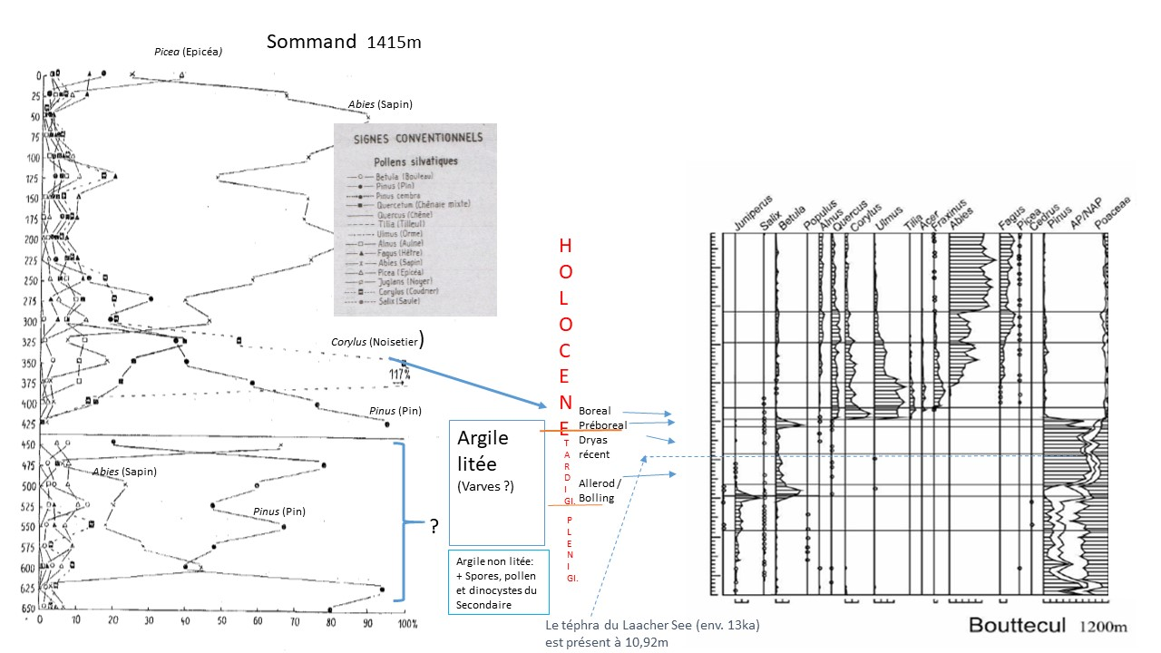

Figure 1. Comparaison entre les sondages de Sommand (Becker 1952) et Bouttecul (David et al. 2006).

Figure 2 (page suivante). Comparaison entre l’étendue des calottes glaciaires pendant la Glaciation Wurm et pendant la Glaciation Riss.

Le point rouge indique l’emplacement du sondage de Bouttecul ; le point bleu l’emplacement du sondage de Sommand.

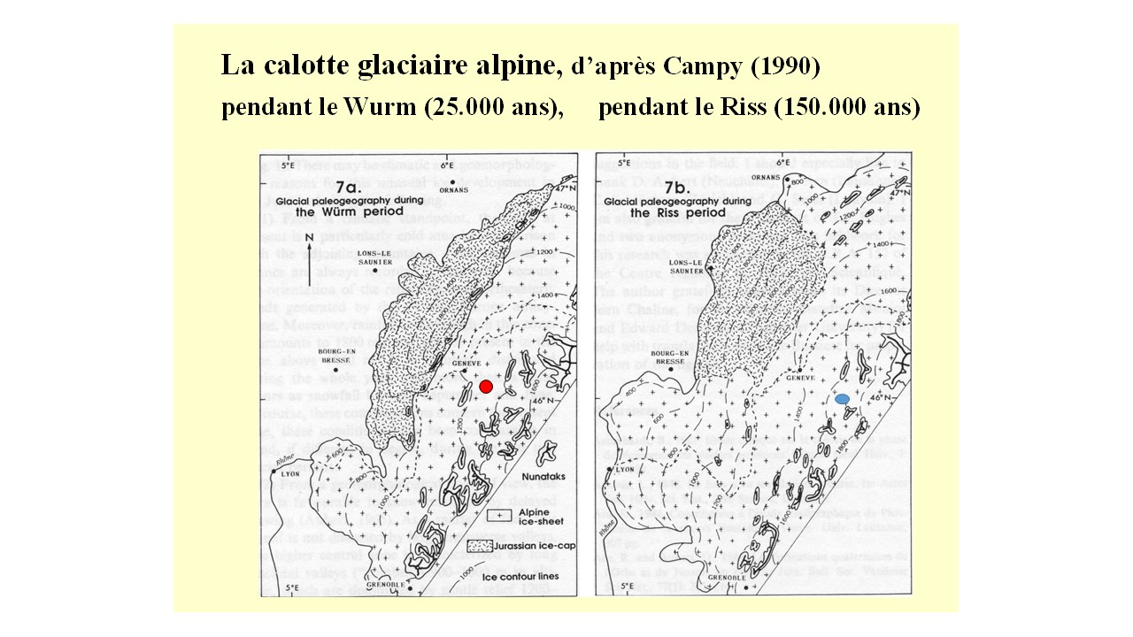

Figure 2. Comparaison entre l’étendue des calottes glaciaires pendant la Glaciation Wurm et pendant la Glaciation Riss.