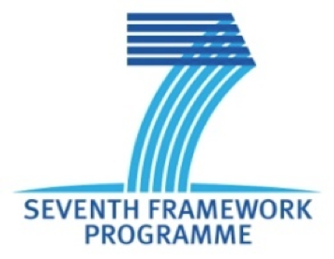
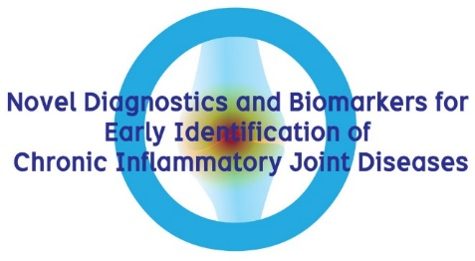
WP1: A Summary

Christelle Sanchez, PhD
DBOARD meeting 20th September 2017

Presentation of the main results obtained in WP1 – Proteomic of D-BOARD project.
- Introduction and main objectives
- Ali Mobasheri : Proteomic study of cartilage explants secretome to discover new OA biomarkers
- Christelle Sanchez : Proteomic study of OA subchondral osteoblasts secretome to discover new OA biomarkers
- Christelle Sanchez : STUDY OF SYNDECAN-4 EXPRESSION IN VITRO BY OA OSTEOBLASTS, SYNOVIOCYTES AND CHONDROCYTES, AND IHC ON OA KNEE AND HIP
- Thomas Pap : STUDY OF SYNDECAN-4 AS OA BIOMARKER IN SYNOVIAL FLUID AND SERUM
- Mona Dvir-Ginzberg : SIRT-1 data
- Publications related to WP1

