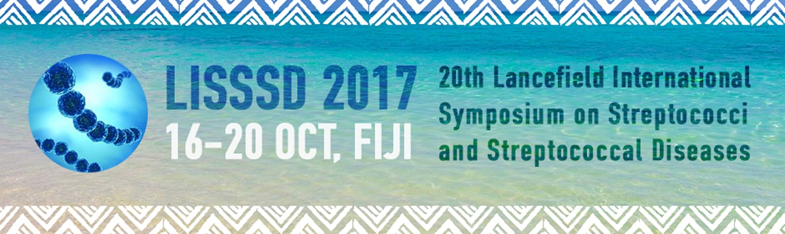

Prevalence and capsular-polysaccharide type distribution of colonizing group B streptococci (GBS) isolated from recto-vaginal samples in pregnant women in Hanoï, Vietnam
Cecile Meex 1 , Anais Devey 1 , Nhung Pham Hong 2 , Melanie Van Geet 1 , Rajae Darfouf 1 , Rosalie Sacheli 1 , Pierrette Melin 1
1. National Reference Centre for Streptococcus agalactiae University Hospital, CIRM, LIEGE, Belgium
2. Microbiology Bach Mai Hospital, Hanoi Medical University, HANOI, Vietnam
Background: The study was organized by the Belgian National Reference Center (NRC) for Streptococcus agalactiae or GBS, and carried out in Vietnam. The aim of the study was to determine the prevalence of GBS colonization among pregnant women in Hanoï and to characterize the capsular-polysaccharide (CPS) type of the isolated strains.
Methods: For a 2-months period in 2015, 888 recto-vaginal swabs were collected in Bach-Mai-Hospital from pregnant women at 35-37 weeks’ gestation and were cultured for detection of GBS. Strains were stored and transferred to the Belgian NRC for further characterization. CPS-typing was performed by both latex agglutination and PCR (Poyart, 2007; Kong, 2008).
Results: Among the 888 swabs, 111 were positive for GBS, that is a prevalence of colonization of 12.5%. A total of 90 strains were available for typing: 91,11% could be serotyped by latex agglutination and all the strains, including the 8 phenotypically non-typable strains, were successfully genotyped. CPS type V was the most prevalent (36.7%) followed by CPS types Ib (25.6%), III (21.1%), VI and VII (8.9% and 4.4%). CPS type II was found twice and serotype Ia was found once. CPS types IV, VIII and IX weren’t present in this population.
Conclusion: With predominance of types V, Ib and III, this distribution of CPS-types of GBS colonizing pregnant women in Hanoï, Vietnam, differs from distributions described in Europe and in o Asian countries. This study provides useful information for the development of a universal vaccine that could contribute to improve the prevention of neonatal GBS infections.

