Invest smarter…
All my Tweets on The Art & Science of
Internet-Based Investing

Jean-Marie Choffray, PhD MIT-77
Professor Emeritus, ULiège
March 13, 2021

“Invest smarter…” I started this project five years ago. After hundreds of hours of reading, thinking and writing, here they are: “All my Tweets on The Art & Science of Internet-Based Investing”, as most of them appear in my Twitter archive. My initial goal was to share my observations, analyses, and conclusions as to the evolution of the world and the behavior of the markets over a period of several years – which happened to correspond with the Presidency of Donald J. Trump. Also, I wanted to organize and illustrate the key heuristics that I learned, often painfully, as a modest investor. Needless to say that I never expected to experience a full-scale pandemic, and its accompanying episode of mass hysteria. A very real, and global, Black Swan!

My main conclusion today is that our world hasn’t changed that much over time. It’s almost like it was stuck in a “steady state”, or some kind of “eternal present”. Human beings continue to “lie, cheat and steal”… (US Secretary of State Mike Pompeo). De La Bruyère (1645-1696) was perfectly right in his “Characters”, and the observations of Erasmus (1467-1536) in “Praise of Folly” are more relevant than ever: “Let us not speak of the evil which man does to man: he ruins him, imprisons him, dishonors him, tortures him, sets traps for him, betrays him; to enumerate everything, with outrages, lawsuits, swindles, would be to count the grains of sand.”

So, I think that any investor could still succeed and prosper in today’s digital markets while following the advice of Henry Clews (1836-1923) in “Fifty Years in Wall Street”. As to me…, without a doubt, I am no Warren Buffett :-)! Feel free to disagree with what you will read in the following pages, and don’t hesitate to develop your own theory of investing as you allocate capital and observe results – a painful and solitary exercise. Success is at that price! Fortunately, based on what I achieved during these hectic years, it shouldn’t be hard for you to do better...

“Bon vent”… in the fog of the markets!

* * *

Jean-Marie Choffray @JMChoffray 23 févr. 2021 Pinned Tweet
Daily Treasury Yield Curve Rates... https://treasury.gov/resource-center/data-chart-center/interest-rates/Pages/TextView.aspx?data=yield

Jean-Marie Choffray @JMChoffray 13 mars 2021
All my tweets to date can be downloaded freely from ORBi. https://orbi.uliege.be/handle/2268/191851

Jean-Marie Choffray @JMChoffray 13 mars 2021
Still as true as ever...
ROI = (E/P) + G, or
ROI = (1/PER) + G,
with
• ROI : Return On Investment,
• E : EPS, or Fully Diluted Earnings Per Share,
• P : Price Per Share, Stock Price,
• G : EPS Growth (Trailing Twelve Months),
• PER : Price Earnings Ratio = P/E.

Jean-Marie Choffray @JMChoffray 13 mars 2021
(1/2) For a rational investor, the ROI of any investment should cover his opportunity cost, i.e. his Cost of Capital. So, any increase in the reference Interest Rate (e.g. 10-yr Treasury), and/or in his Risk Premium, will translate into added pressure in terms of ROI.

Jean-Marie Choffray @JMChoffray 13 mars 2021
(2/2) For listed companies, assuming they cannot accelerate earnings growth, this new requirement will lead to a drop in their P/E ratio, and in their market capitalization.

Jean-Marie Choffray @JMChoffray 13 mars 2021
Some of my old classmates are still as wrong as they were fifty years ago, no pun intended.

Jean-Marie Choffray @JMChoffray 13 mars 2021
10-Year Treasury Yield Growth > 10% in ten days!

Jean-Marie Choffray @JMChoffray 13 mars 2021
MACD [ WEEKLY (QQQ) ] >> Smells fishy...!

Jean-Marie Choffray @JMChoffray 13 mars 2021
Nothing better than a useless drug to cure a non-existent disease!

Jean-Marie Choffray @JMChoffray 13 mars 2021
In simple terms, "Singularity" refers to a system that is capable of human-level thinking. But..., will such a system ever be able to recognize that it was created by a human mind?

Jean-Marie Choffray @JMChoffray 13 mars 2021
Science: We have a problem :-)! Complex simulation of Chance (random mutations) and Necessity (ordinal selection) processes consistently lead to Nothingness (Unintelligible Irrationality)....

Jean-Marie Choffray @JMChoffray 13 mars 2021
Fifty years ago, when I was working at night at the MIT Computer Center, we used to say of any computer program: "Garbage in, garbage out." Still true today!

Jean-Marie Choffray @JMChoffray 13 mars 2021
Testing the "Chance" hypothesis... I challenge any curious mind to write a computer program that, from a series of independent triplets of random numbers drawn from a continuous uniform distribution (x-axis, y-axis, color), would draw on a screen a sparrow on a tree branch...

Jean-Marie Choffray @JMChoffray 13 mars 2021
Testing the "Evolution" hypothesis... I challenge any curious mind to write a program that, from a series of random numbers drawn from a uniform distribution (x-axis, y-axis, color), and a color utility (substitution) function, would draw on a screen a squirrel on a branch...

Jean-Marie Choffray @JMChoffray 12 mars 2021
If history is any guide, current "extreme" Valuation Ratios (Price/Earnings, Price/Sales, Price/Assets) have rarely been observed... So, either the Theory is wrong, or the Market is wrong! We should soon know :-)!

Jean-Marie Choffray @JMChoffray 12 mars 2021
MACD [ WEEKLY (SPY) ] >> Bearish Cross in Uptrend?
Is it going to be confirmed?

Jean-Marie Choffray @JMChoffray 12 mars 2021
The next three months could be interesting... Fasten your seatbelt and keep your pinky finger on the RETURN key!

Jean-Marie Choffray @JMChoffray 12 mars 2021
In 2008 (Credit/Subprime Bubble), Springtime was also memorable...

Jean-Marie Choffray @JMChoffray 12 mars 2021
To be kept in mind? In 2000 (Dotcom Bubble), the market started to collapse in early April...

Jean-Marie Choffray @JMChoffray 12 mars 2021
Always let the market do its job: destroy illusions & reveal opportunities (Top Gainers/Top Losers). Hence, bad news... is good news!

Jean-Marie Choffray @JMChoffray 12 mars 2021
To live or not to live? That is the question!

Jean-Marie Choffray @JMChoffray 12 mars 2021
Don't worry! The world is not going to collapse, nor disappear... What we are observing today is normal turbulance and human folly. History teaches that the best investment opportunities for the next ten years will necessarily follow...

Jean-Marie Choffray @JMChoffray 12 mars 2021
I am afraid that we all learn it the hard way: "Never try to teach a pig to sing; it wastes your time, and it annoys the pig!"

Jean-Marie Choffray @JMChoffray 12 mars 2021
Any decision problem can be broken down into a series of binary choices. Solving the simplest then leads to solving the most complex. René Descartes (1596-1650) was right :-)!

Jean-Marie Choffray @JMChoffray 12 mars 2021
Covid or not Covid? It's probably the right time to accept, and to learn, to live in an uncertain world...

Jean-Marie Choffray @JMChoffray 12 mars 2021
In the markets, better to earn a little money regularly than to lose everything instantly...

Jean-Marie Choffray @JMChoffray 12 mars 2021
Probably the most important principle that I learned fifty years ago at MIT: "Better be approximately right, than precisely wrong!"

Jean-Marie Choffray @JMChoffray 12 mars 2021
A careful study of philosophy offers the choice between nothingness and God... Based on more than seventy years of observations, nothingness doesn't seem to me to make much sense!

Jean-Marie Choffray @JMChoffray 12 mars 2021
"Either human intelligence ultimately owes its origin to mindless matter, or there is a Creator. It is strange that some people claim that it is their intelligence that leads them to prefer the first to the second." (John Lennox)

Jean-Marie Choffray @JMChoffray 12 mars 2021
"If religion is a fairy tale of those afraid of the dark, then atheism is a fairy tale of those afraid of the light." (John Lennox)

Jean-Marie Choffray @JMChoffray 11 mars 2021
President signs $1.9 trillion stimulus bill into law on U.S. lockdown anniversary. The package provides $400 billion for $1,400 direct payments to most Americans, $350 billion in aid to state and local governments,... Biden: All U.S. adults to be eligible for vaccines by May, some normalcy coming by summer | Reuters

Jean-Marie Choffray @JMChoffray 11 mars 2021
Based on a joint assessment of financing conditions and the inflation outlook, the Governing Council expects purchases under the PEPP over the next quarter to be conducted at a significantly higher pace than during the first months of this year. Monetary policy decisions (europa.eu)

Jean-Marie Choffray @JMChoffray 11 mars 2021
St. Louis Fed @stlouisfed
Staff Pick: Trade deficits for the U.S. are nothing new. From 1800 to 1870, the U.S. ran a trade deficit for all but three years http://ow.ly/EoJg50DTCcY

Jean-Marie Choffray @JMChoffray 11 mars 2021
NY Fed Research @NYFedResearch
Also in the February Survey: The year-ahead inflation expectation edged up to 3.1 percent, its highest level since July 2014. https://nyfed.org/2JG7hCo

Jean-Marie Choffray @JMChoffray 11 mars 2021
RBLX IPO Probably worth keeping an eye on... https://sec.gov/Archives/edgar/data/0001315098/000119312521075435/d87104d424b4.htm

Jean-Marie Choffray @JMChoffray 9 mars 2021
Ray Dalio @RayDalio
Everyone makes mistakes. The main difference is that successful people learn from them and unsuccessful people don’t. By creating an environment in which it's okay to safely make mistakes so people can learn from them, you’ll see rapid progress and fewer significant mistakes.

Jean-Marie Choffray @JMChoffray 9 mars 2021
Amena Bakr @Amena__Bakr
Once again the attacks on Aramco this week, highlight the vulnerability of Saudi and other regional oil infrastructure to new forms of warfare, as drone and missile technology becomes more sophisticated and more widely available. https://energyintel.com/pages/eig_article.aspx?DocID=1099848&utm_campaign=top-story&utm_medium=site&utm_source=2&utm_content=Analysis%3a+Attacks+Highlight+Dangers+of+Yemen+War-1099848&ts=1… #OOTT #SaudiArabia

Jean-Marie Choffray @JMChoffray 9 mars 2021
Don't take it personal, it's just shorting... $ACAD, $ATNX, $GRAY

Jean-Marie Choffray @JMChoffray 9 mars 2021
Interest rates are a reflection of the value of time... When they are nil, they virtually abolish the dimension of life (space-time) that allows projection into the future!

Jean-Marie Choffray @JMChoffray 9 mars 2021
Historically, civilizations have always been destroyed by freeing sexuality, rejecting religions, and debasing money...

Jean-Marie Choffray @JMChoffray 9 mars 2021
Laura Ingraham @IngrahamAngle
Reject their irrational controls and nonsensical edicts.

Jean-Marie Choffray @JMChoffray 8 mars 2021
Must read... https://world-exchanges.org/storage/app/media/FH.FY%202020%20Market%20Highlights%20v8.pdf

Jean-Marie Choffray @JMChoffray 8 mars 2021
Enough is never enough... $1.9 trillion package will provide enough resources to fuel a “very strong” U.S. economic recovery, but will not address longstanding inequality problems. Yellen says Biden COVID bill to fuel 'very strong' U.S. recovery | Reuters

Jean-Marie Choffray @JMChoffray 8 mars 2021
Natural selection and Free will are everlasting enemies. When one wins, the other loses...

Jean-Marie Choffray @JMChoffray 8 mars 2021
History is inflationary... As this cycle matures, expect substantially more stimulus and monetization... The art of politics has always been to make the inevitable palatable, and, even better, desirable!

Jean-Marie Choffray @JMChoffray 8 mars 2021
Meaninglessness is meaningless :-)!

Jean-Marie Choffray @JMChoffray 8 mars 2021
Pandemics disappear when people accept to lose their illusions and their fears... It's usually a long and painful process!

Jean-Marie Choffray @JMChoffray 8 mars 2021
To state that human thought is the result of chance (randomness) and/or necessity (evolution), is a denial of its very existence.

Jean-Marie Choffray @JMChoffray 8 mars 2021
An interesting paradox: "Life has no meaning..." has necessarily no meaning!

Jean-Marie Choffray @JMChoffray 8 mars 2021
Whether people like it or not, wish it or not, without an original cause, life's rational intelligibility does not stand.

Jean-Marie Choffray @JMChoffray 8 mars 2021
To cooperate or to compete, that is the question!

Jean-Marie Choffray @JMChoffray 8 mars 2021
Life is a projection of the mind in space-time.

Jean-Marie Choffray @JMChoffray 8 mars 2021
Identifying and losing your illusions as to the rationality of market behavior (herd behavior is mostly irrational!) is a necessary condition to start being productive as an investor.

Jean-Marie Choffray @JMChoffray 8 mars 2021
The art of decision-making... Choosing the best option always requires losing some deep-rooted illusions. This is why people always choose it as a last resort, after having tried all the others!

Jean-Marie Choffray @JMChoffray 7 mars 2021
Let's be honest! In the markets, not every business that is financed counts, and not every business that counts is financed...

Jean-Marie Choffray @JMChoffray 7 mars 2021
Vatican News @VaticanNews
As Iraq declares 6 March a "National Day of Tolerance and Coexistence", Cardinal Miguel Ayuso praises #PopeFrancis' meeting with Grand Ayatollah Ali Al-Sistani. #PopeInIraq

Jean-Marie Choffray @JMChoffray 7 mars 2021
A "natural" limit to mathematical models? "Not everything that counts can be counted, and not everything that can be counted counts”. (Attributed to Albert Einstein).

Jean-Marie Choffray @JMChoffray 6 mars 2021
(1/2) " Furthermore, those who, to be liberated from political or sexual restraint, accept the doctrine of absolute meaninglessness tend in a short time to become so much dissatisfied with their philosophy"

Jean-Marie Choffray @JMChoffray 6 mars 2021
(2/2) "... (in spite of the services it renders) that they will exchange it for any dogma, however manifestly nonsensical, which restores meaning if only to a part of the universe." A. Huxley, Ends and Means, 1937.

Jean-Marie Choffray @JMChoffray 6 mars 2021
"We thought of ourselves as [...] existing within a meaningless universe. And because [... of that], rearmament is in full swing, economic nationalism becomes ever more intense, the battle of rival propagandas grows ever fiercer, and general war becomes increasingly probable."

Jean-Marie Choffray @JMChoffray 6 mars 2021
"All that we are (and consequently all that we do) is the result of what we have thought." A. Huxley, Ends and Means, 1937.

Jean-Marie Choffray @JMChoffray 6 mars 2021
"Most ignorance is vincible ignorance. We don't know
because we don't want to know." A. Huxley, Ends and Means, 1937.

Jean-Marie Choffray @JMChoffray 6 mars 2021
(1/2) "Our conviction that the world is meaningless is due in part to the fact that the philosophy of meaninglessness lends itself very effectively to furthering the ends of erotic or political passion;"

Jean-Marie Choffray @JMChoffray 6 mars 2021
(2/2) "... in part to a genuine intellectual error, the error of identifying the world of science, a world from which all meaning and value has been deliberately excluded, with ultimate reality." A. Huxley, Ends and Means, 1937.

Jean-Marie Choffray @JMChoffray 6 mars 2021
"[...] many scientists and philosophers came to imagine that this useful abstraction [... mathematical model] from reality was reality itself." A. Huxley, Ends and Means, 1937.

Jean-Marie Choffray @JMChoffray 6 mars 2021
Talking about "intra-specific" competition (specialization), Huxley notes: "we are wantonly and deliberately pursuing a policy which we need not pursue and which we have the best scientific reasons for supposing to be disastrous to the species as a whole." Ends and Means, 1937.

Jean-Marie Choffray @JMChoffray 5 mars 2021
Yan Qin @YanQinyq
China released key goals in 14th Five-Year Plan: 2021-2025
>6% GDP growth in 2021
-13.5% in Energy consumption per unit of GDP by 2025
-18% in Carbon emissions per unit of GDP by 2025
Thread on Climate and Energy targets in the new FYP

Jean-Marie Choffray @JMChoffray 5 mars 2021
Andy Critchlow @baldersdale
With Brent crude pushing for $70/b on #OPEC rollover possibility a reminder of this #Infographic from @SPGlobalPlatts documenting Trump's twitter diplomacy the last time oil was at these levels. #OOTT https://spglobal.com/platts/plattscontent/_assets/_images/latest-news/022619-Trump-HR.jpg

Jean-Marie Choffray @JMChoffray 5 mars 2021
Amena Bakr @Amena__Bakr
Spring is in the air, demand is recovering, oil prices are buoyant and inventories are shrinking, but Opec Plus decided not to eat their cake yet, by agreeing to rollover. https://energyintel.com/pages/eig_article.aspx?DocID=1099555&utm_campaign=top-story&utm_medium=site&utm_source=1&utm_content=Opec-Plus+to+Keep+Supply+Mostly+Steady-1099555&ts=1… #OOTT #opec

Jean-Marie Choffray @JMChoffray 5 mars 2021
MACD(SPY)<=0.0 + MACD(VIX)>0.0 = Probably the right time to sit down, shut up and watch...

Jean-Marie Choffray @JMChoffray 3 mars 2021
World's first bitcoin ETF soars past $500 million in assets under management https://finance.yahoo.com/news/worlds-first-bitcoin-etf-soars-past-500-million-in-assets-under-management-213407975.html?soc_src=social-sh&soc_trk=tw&tsrc=twtr…

Jean-Marie Choffray @JMChoffray 3 mars 2021
"COVID still exists in Texas, the United States and across the globe, but it is clear from the recoveries, the vaccinations, from the reduced hospitalizations and from the safe practices Texans are using that state mandates are no longer needed." Greg Abbott.

Jean-Marie Choffray @JMChoffray 3 mars 2021
Now that the wall of madness is collapsing, we'll see who runs the fastest.

Jean-Marie Choffray @JMChoffray 3 mars 2021
When you want to know the truth, you just have to find out who benefits from the crime (Hercule Poirot).

Jean-Marie Choffray @JMChoffray 3 mars 2021
As all investors find out sooner or later, the key to success is to work hard to never lose.

Jean-Marie Choffray @JMChoffray 3 mars 2021
The fact that evil is rampant all over the world does not prevent you from doing good.

Jean-Marie Choffray @JMChoffray 3 mars 2021
As a rule, if you accept to pay someone to do nothing, you will be amazed at how well he/she does it.

Jean-Marie Choffray @JMChoffray 3 mars 2021
Most people are such liars that they don't trust anyone who is telling the truth.

Jean-Marie Choffray @JMChoffray 3 mars 2021
Algos play fast, but flesh & blood investors have a better understanding of the rules of the game...

Jean-Marie Choffray @JMChoffray 2 mars 2021
Greg Abbott @GregAbbott_TX
I just announced Texas is OPEN 100%.
EVERYTHING.
I also ended the statewide mask mandate.

Jean-Marie Choffray @JMChoffray 27 févr. 2021
$NLS There is nothing more practical than a good theory. IFF the following ESTIMATES are VALID, the next few weeks should be interesting... FWD PER = 8.9; ROE = 49.6; PEG = 0.7; P/EBITDA = 5.2.

Jean-Marie Choffray @JMChoffray 27 févr. 2021
As we say in French: "Con, et fier de l'être" :-)!

Jean-Marie Choffray @JMChoffray 27 févr. 2021
We’re deleting this tweet. Lockdowns aren’t “quietly improving cities” around the world. But they are an important part of the public health response to COVID-19. World Economic Forum sur Twitter : "We’re deleting this tweet. Lockdowns aren’t “quietly improving cities” around the world. But they are an important part of the public health response to COVID-19. https://t.co/D2Pyb9x4yy" / Twitter

Jean-Marie Choffray @JMChoffray 27 févr. 2021
"Eventually, of course, the party ends... Financial history is replete with the names of famous conglomerateurs who were initially lionized as business geniuses by journalists, analysts and investment bankers, but whose creations ended up as business junkyards." W. Buffett.

Jean-Marie Choffray @JMChoffray 26 févr. 2021
Debt-to-GDP ratio: How much debt is too much for a country? It partly depends on three factors: economic growth rates, the strength of a country’s institutions and the level of interest rates on the debt http://ow.ly/BJFo50DKfeA

Jean-Marie Choffray @JMChoffray 26 févr. 2021
When fully staffed, the FOMC is composed of 12 voting members—the seven members of the Board of Governors, the president of the @NewYorkFed and presidents of four other Federal Reserve banks. Learn more about the FOMC in our blog http://ow.ly/7Nmb50DJ9ua

Jean-Marie Choffray @JMChoffray 26 févr. 2021
Oil prices increased over the past week owing to increased demand and decreased supply. Read more from the latest U.S. oil report: New York Fed sur Twitter : "Oil prices increased over the past week owing to increased demand and decreased supply. Read more from the latest U.S. oil report: https://t.co/DRXHLoKF9Z https://t.co/YT1nHslXgy" / Twitter

Jean-Marie Choffray @JMChoffray 26 févr. 2021
Sen. @RandPaul's on a roll. Breitbart News sur Twitter : "Sen. @RandPaul's on a roll. https://t.co/LhdVHHQP0a" / Twitter

Jean-Marie Choffray @JMChoffray 26 févr. 2021
$SWN If I am not mistaken, shorts (>40M shares) will have about one hour (CC at 9:30 a.m. CT) to decide on their fate. It should be an interesting hour :-)!

Jean-Marie Choffray @JMChoffray 26 févr. 2021
"Since a politician never believes what he says, he is amazed when people take his word for it."
Charles de Gaulle (1890-1970)

Jean-Marie Choffray @JMChoffray 26 févr. 2021
Is President Donald Trump going to be right? "You will get a depression the likes of which you have never seen." October 20, 2020.

Jean-Marie Choffray @JMChoffray 26 févr. 2021
“What were you doing during the warm season ?
She asked this borrower.
— Night and day, to anyone
I sang, please you if it may.
— You sang ? I’m delighted :
Well, dance now.”
Jean de la Fontaine (1621-1695)

Jean-Marie Choffray @JMChoffray 26 févr. 2021
"Posse quod velit, velle quod opportet"
[Pouvoir ce qu’on veut, vouloir ce qu’il faut]
Augustine (354-430)

Jean-Marie Choffray @JMChoffray 25 févr. 2021
10-year Treasury yield jumps to a one-year high of 1.6%, a rapid move unnerving investors U.S. bonds: Treasury yields rise to highest level in more than a year (cnbc.com)

Jean-Marie Choffray @JMChoffray 25 févr. 2021
In less than a month Tesla's market cap lost ~$200B...

Jean-Marie Choffray @JMChoffray 25 févr. 2021
Welcome to the desert of the markets... Over the last 48hr, the US market capitalization approximately lost the equivalent of the future coronavirus relief plan ($1,9T)!

Jean-Marie Choffray @JMChoffray 25 févr. 2021
$NLS There is nothing more practical than a good theory. IFF the following ESTIMATES are VALID, the next few weeks should be interesting... FWD PER = 8.9; ROE = 49.6; PEG = 0.7; P/EBITDA = 5.2.

Jean-Marie Choffray @JMChoffray 25 févr. 2021
To the best of my knowledge, there are only four competing “theories” of life: Nothingness (preposterous…), Randomness (unlikely…), Violence (despicable…), and Love (achievable…). To live is to choose, but to choose well :-)!

Jean-Marie Choffray @JMChoffray 24 févr. 2021
$NLS, $EBIX, $RIOT, $MARA, $WKHS, $CCIV... Definitely not for the faint of heart!

Jean-Marie Choffray @JMChoffray 24 févr. 2021
To date, investors/speculators appear to prefer a Porsche Cayman to a Bitcoin... It does not surprise me :-)!

Jean-Marie Choffray @JMChoffray 24 févr. 2021
Some experts announced yesterday that life expectancy had just fallen from 78.7 years to 77.8 years... Assuming these estimates are reliable and valid (a major assumption...) the only question is: "What does that change to my life?"

Jean-Marie Choffray @JMChoffray 24 févr. 2021
Jean d´Ormesson (1925-2017) wrote: “The only question is God, whether he exists or whether he does not exist." Today, we tend to be less ambitious: "The only question is the Covid, whether it exists or whether it does not."

Jean-Marie Choffray @JMChoffray 23 févr. 2021
Fun to watch the ripple effect of cascading dominos...

Jean-Marie Choffray @JMChoffray 23 févr. 2021
Thomas Massie @RepThomasMassie
« Once you realize the personal ethical standards of policy makers like Dr Fauci and many of those at the CDC lead them to comfortably misrepresent scientific data in order to achieve public policy goals, it is not just your prerogative to question their “science,” it is your duty.”

Jean-Marie Choffray @JMChoffray 23 févr. 2021
"Be the change you want to see..." Justice C. Thomas' dissent in Pennsylvania election decision... https://supremecourt.gov/opinions/20pdf/20-542_2c83.pdf

Jean-Marie Choffray @JMChoffray 22 févr. 2021
MAX... 10-2 Year Treasury Constant Maturity. Is a recession brewing? 10-Year Treasury Constant Maturity Minus 2-Year Treasury Constant Maturity (T10Y2Y) | FRED | St. Louis Fed

Jean-Marie Choffray @JMChoffray 22 févr. 2021
In case you had a doubt, stocks are in an extreme bubble... ▷ S&P500 PE Ratio - Shiller PE Ratio - 150 Year Chart | Longtermtrends

Jean-Marie Choffray @JMChoffray 22 févr. 2021
Delusions tend to die off naturally when people start to believe that they won't lose anything by letting them die.

Jean-Marie Choffray @JMChoffray 22 févr. 2021
#gold, #bitcoin, $GLD, $NEM, $GOLD, $RIOT, $MARA
Would you trade today a Kg of gold for a bitcoin?
YES 51,1 %
NO 48,9 %
45 votes

Jean-Marie Choffray @JMChoffray 22 févr. 2021
The likelihood of a financial crisis increases with the number of people who believe that such a crisis is no longer impossible.

Jean-Marie Choffray @JMChoffray 20 févr. 2021
Covid Cases, like Political Careers, are Dropping Like Rocks Covid Cases, like Political Careers, are Dropping Like Rocks – AIER

Jean-Marie Choffray @JMChoffray 20 févr. 2021
As long as people choose “to lie, to cheat and to steal” (Cfr. Mike Pompeo), they will need financial markets to settle peacefully (lawfully?) their conflicts of interest. So, investors’ future looks bright…

Jean-Marie Choffray @JMChoffray 20 févr. 2021
We have a problem :-)! “The model is wrong; let’s change the model!” (S. Alexander, MIT, Oct. 1973). Under a reasonable set of assumptions (Generalized Logistic Model, fair estimates of contagiousness & mortality) a significant fraction of the population should have died by now…

Jean-Marie Choffray @JMChoffray 20 févr. 2021
My conclusion: Markets do really exist; Their behavior is intelligible; We are free to invest :-)!

Jean-Marie Choffray @JMChoffray 20 févr. 2021
Third Impossibility Axiom: Necessity can generate Reality (Self-Awareness) only if Reality is Imposed; which is absurd!

Jean-Marie Choffray @JMChoffray 20 févr. 2021
Second Impossibility Axiom: Randomness can generate Reality (Rational Intelligibility) only if Reality is Random; which is absurd!

Jean-Marie Choffray @JMChoffray 20 févr. 2021
First Impossibility Axiom: Nothingness can generate Reality (Space-Time) only if Reality is Nothingness; which is absurd!

Jean-Marie Choffray @JMChoffray 20 févr. 2021
"Once you eliminate the impossible, whatever remains, no matter how improbable, must be the truth." Arthur Conan Doyle (1859-1930)

Jean-Marie Choffray @JMChoffray 18 févr. 2021
$PLUG, $FCEL, $BE... Is the Green-Tech Bubble imploding?
$RIOT, $MARA, $GBTC... And, is the Bitcoin-Tech Bubble next?

Jean-Marie Choffray @JMChoffray 18 févr. 2021
What I got when merging Victor Hugo (1802-1885), La Conscience, with William Hughes Mearns (1875–1965), Antigonish…
“Last night I saw up in the air,
Almighty God who wasn’t there!
He wasn’t there again today,
Oh, how I wish He’d go away!"

Jean-Marie Choffray @JMChoffray 16 févr. 2021
1636, all over again...? MicroStrategy to borrow $600 million to buy more bitcoin (yahoo.com)

Jean-Marie Choffray @JMChoffray 16 févr. 2021
If Science held the truth, it wouldn't have to be...

Jean-Marie Choffray @JMChoffray 16 févr. 2021
"Making money becomes a matter of calculation, depending on the number of squalls that may occur during any particular year." (H. Clews, 1836-1923)

Jean-Marie Choffray @JMChoffray 16 févr. 2021
Life is a terminal illness... Isn't it time to start thinking again, living again, working again, and loving again :-)?

Jean-Marie Choffray @JMChoffray 15 févr. 2021
Trump defense attorney Michael van der Veen speaks with @LanaZak after the Senate's acquittal vote: "What happened at the Capitol on January 6 is absolutely horrific. But what happened at the Capitol during this trial was not too far away from that."
Watch the full interview: https://twitter.com/i/status/1360716676778622978

Jean-Marie Choffray @JMChoffray 15 févr. 2021
Reuters: Real-time prices on the power grid operated by the Electric Reliability Council of Texas (ERCOT) have climbed as high as $11,000 per megawatt. A typical price on the grid, which supplies most of the electricity for Texas, is less than $100 per megawatt. (Tim McLaughlin)

Jean-Marie Choffray @JMChoffray 9 févr. 2021 Pinned Tweet
When human madness reaches such heights (Covid, MMT, Bitcoin, TSLA, PLUG, etc.), one can only admire its effects, fear its consequences, remain cautious, and shut up... One last piece of advice: study carefully Erasmus of Rotterdam: In Praise of Folly, 1514.

Jean-Marie Choffray @JMChoffray 11 févr. 2021
Over the last twelve months, Science has definitely proven that it can't explain/solve everything... Life remains a test (cf. R. Girard), a lesson of humility, of humanity :-)!

Jean-Marie Choffray @JMChoffray 11 févr. 2021
A rational decision-maker cannot at the same time believe in chance (random mutations) and necessity (natural selection), and justify/impose the current lockdown... Hence, current policymakers are irrational :-)!

Jean-Marie Choffray @JMChoffray 11 févr. 2021
All theories are born, grow and die, usually in pain. "A Throw Of The Dice Will Never Abolish Chance” (Stéphane Mallarmé)

Jean-Marie Choffray @JMChoffray 9 févr. 2021
When human madness reaches such heights (Covid, MMT, Bitcoin, TSLA, PLUG, etc.), one can only admire its effects, fear its consequences, remain cautious, and shut up... One last piece of advice: study carefully Erasmus of Rotterdam: In Praise of Folly, 1514.

Jean-Marie Choffray @JMChoffray 8 févr. 2021
"What is essential to survive a bubble is first to recognize you are in one." L. Roberts

Jean-Marie Choffray @JMChoffray 8 févr. 2021
"The Central Bank has bastardized the most important price in the world which is the cost of money. We have crony capitalism as you know." Stanley Druckenmiller

Jean-Marie Choffray @JMChoffray 8 févr. 2021
"In 3 months in 2020 we increased the deficit more than the past 5 recessions combined (1973, 75, 82, early 90s', dot com bust and the GFC). The Fed in 6 weeks bought more treasuries than in 10yrs under Bernanke/Yellen." Stanley Druckenmiller

Jean-Marie Choffray @JMChoffray 8 févr. 2021
There are only three ways out of a debt crisis: war, default and inflation (slow-motion default). Today, history suggests that inflation is most likely...

Jean-Marie Choffray @JMChoffray 6 févr. 2021
$GME "has taught hedge funds the risk of running against groups of individual investors who leverage social media to go after them. Still, 5-10 years ago, they did not run this risk, and therefore, shorting stocks is now riskier than ever." (Jussi Askola)

Jean-Marie Choffray @JMChoffray 2 févr. 2021
"[Le Prince] ignore les lois, est assez hostile au bien en général, car il n'envisage que le sien; il s'adonne aux plaisirs, hait le savoir, l'indépendance et la vérité, se moque du salut public, et n'a d'autres règles que ses convoitises et son égoïsme" (E. de Rotterdam, 1514)

Jean-Marie Choffray @JMChoffray 2 févr. 2021
"L'esprit de l'homme est ainsi fait qu'on le prend beaucoup mieux par le mensonge que par la vérité." (Erasme de Rotterdam, L'éloge de la folie, 1514)

Jean-Marie Choffray @JMChoffray 2 févr. 2021
"... c'est toujours ce qu'il y a de plus inepte qui rencontre le plus d'admirateurs. Le pire plaît nécessairement au plus grand nombre, la majorité des hommes étant asservie à la Folie." (Erasme de Rotterdam, L'éloge de la folie, 1514)

Jean-Marie Choffray @JMChoffray 2 févr. 2021
"Deux obstacles principaux empêchent de réussir aux affaires: l'hésitation, qui trouble la clarté de l'esprit, et la crainte, qui montre le péril et détourne d'agir." (Erasme de Rotterdam, L'éloge de la folie, 1514)

Jean-Marie Choffray @JMChoffray 1 févr. 2021
No buyers in the market... Expect the law of gravity to release its force... https://t.co/YopwHE9UZz

Jean-Marie Choffray @JMChoffray 1 févr. 2021
A l'inverse de la fameuse maxime de Platon, "si vous consultez l'Histoire, vous verrez que le pire gouvernement fut toujours celui d'un homme frotté de philosophie ou de littérature." (Érasme de Rotterdam, 1469-1536)

Jean-Marie Choffray @JMChoffray 1 févr. 2021
Over the past twelve months, science has definitely proven that... science can't explain everything :-)!

Jean-Marie Choffray @JMChoffray 1 févr. 2021
“What concerns me more is the general anger - and almost hate - and the view of bringing people down that now is pervasive in almost all aspects of the country,” Ray Dalio

Jean-Marie Choffray @JMChoffray 1 févr. 2021
"Aujourd’hui, conscient des limites de l’expression directe et de la perversion médiatique qu’elle provoque, j’ai décidé de quitter les réseaux sociaux... J’ai goûté à cette violence et j’ai détesté." (Nicolas Bedos)

Jean-Marie Choffray @JMChoffray 21 janv. 2021
“But as with frogs in water that is slowly being heated to a boil, investors are being conditioned not to recognise the danger.” (Seth Klarman)

Jean-Marie Choffray @JMChoffray 17 janv. 2021
As an investor, always keep in mind that history teaches that people usually get the opposite of what they voted for…

Jean-Marie Choffray @JMChoffray 17 janv. 2021
I am always amazed and amused when some self-proclaimed intellectuals try to convince others that "free will" does not exist... :-)!

Jean-Marie Choffray @JMChoffray 17 janv. 2021
The so-called "developed world" will soon have to make a crucial choice: to print or to work?

Jean-Marie Choffray @JMChoffray 17 janv. 2021
If life is the sole result of chance (random mutations) and necessity (natural selection), the current confinement policy is absurd.

Jean-Marie Choffray @JMChoffray 15 janv. 2021
"It is always more central bank regardless of the song: Inflation? More central bank; Inequality? More central bank; Climate change? More central bank. The more they fail, the more they are then needed." (Michael Every, Rabobank)

Jean-Marie Choffray @JMChoffray 15 janv. 2021
https://t.co/1ECBno7DBd

Jean-Marie Choffray @JMChoffray 15 janv. 2021
Four Rules That Should Guide Bidenomics https://t.co/v2pxxUBe5K

Jean-Marie Choffray @JMChoffray 14 janv. 2021
"Like the ancient phoenix, democracy may burn itself on the altar; but as long as its spirit lives, it, like the sacred bird, will rise from its ashes... Democracy is in its essence a movement rather than an accomplished fact" F. G. Henke.

Jean-Marie Choffray @JMChoffray 14 janv. 2021
Better keep in mind... https://t.co/cw15gWDaDg
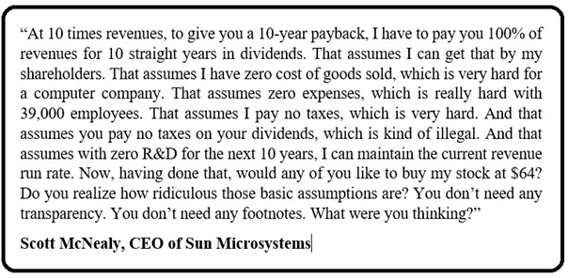

Jean-Marie Choffray @JMChoffray 14 janv. 2021
NASA finds there are fewer galaxies than first thought, leaving the possibility we're alone in the universe https://t.co/H6g6n4wl2q #FoxNews

Jean-Marie Choffray @JMChoffray 23 déc. 2020
UN COUP DE DES JAMAIS N'ABOLIRA LE HASARD (A throw of the dice will never abolish singular uncertainty). Stéphane Mallarmé - 1842-1898. https://t.co/liFiL1wyI6

Jean-Marie Choffray @JMChoffray 26 août 2020
"A voir ce que l'on fut sur terre et ce qu'on laisse, Seul le silence est grand; tout le reste est faiblesse." Alfred de Vigny (1797-1863)

Jean-Marie Choffray @JMChoffray 3 juil. 2020
Now that the "Great Panic of 2020" is brain dead, and that Jerome Powell has "stepped up to the plate," we have entered into a new era. The right time to "sit down, shut up, think hard and... act responsibly"?

Jean-Marie Choffray @JMChoffray 1 juil. 2020
S&P 500 ends best quarter since 1998 on a high note https://t.co/8eSMhD5HZ1

Jean-Marie Choffray @JMChoffray 30 juin 2020
Shell to write down up to $22 billion after coronavirus hit https://t.co/p3vC6yMFiV via @YahooFinanceCA
Jean-Marie Choffray @JMChoffray 29 juin 2020
Impossible Foods CEO says the meat industry will be obsolete in 15 years — ‘That’s our mission’ https://t.co/cx9LVGvHl7

Jean-Marie Choffray @JMChoffray 29 juin 2020
Fed adds bonds of major firms to portfolio https://t.co/DxHAduFHGo

Jean-Marie Choffray @JMChoffray 27 juin 2020
Coca-Cola Pausing All Social Media Advertising https://t.co/Bs5Rt9CUyI

Jean-Marie Choffray @JMChoffray 25 juin 2020
"Over the long haul, stocks have returned 10% and bonds produced 5% a year. Let’s say that’s the right risk premium. That will mean that if interest rates are zero, stock returns will be 5%. Future returns are going to be much lower." (B. Malkiel)

Jean-Marie Choffray @JMChoffray 25 juin 2020
Market entering (?) stage 4... Better watch out! https://t.co/1TxsDfGXDo

Jean-Marie Choffray @JMChoffray 23 juin 2020
Investing legend Burton Malkiel on day-trading millennials, the end of the 60/40 portfolio and more https://t.co/okteopSuet

Jean-Marie Choffray @JMChoffray 20 juin 2020
What is quadruple witching? https://t.co/iuHpdbHCt8 #FoxBusiness

Jean-Marie Choffray @JMChoffray 20 juin 2020
The rise and fall of a star... https://t.co/d4in79ojYR

Jean-Marie Choffray @JMChoffray 20 juin 2020
"Braun’s response to the latest crisis followed a similar pattern: downplay or dismiss the allegations, paint the company as a victim and attempt to switch over to business as usual." https://t.co/AdpADGxgrg via @YahooFinance

Jean-Marie Choffray @JMChoffray 19 juin 2020
As a rule, when you give people power, they basically start acting like fools... https://t.co/CSNdrdtjlq

Jean-Marie Choffray @JMChoffray 19 juin 2020
"Wirecard admitted that auditors at EY couldn’t find 1.9 billion euros ($2.1 billion) of cash on its balance sheet." !!! https://t.co/hwaIf16dQ6

Jean-Marie Choffray @JMChoffray 18 juin 2020
Same story all over again... https://t.co/B1nniKlzuC

Jean-Marie Choffray @JMChoffray 17 juin 2020
Is The ‘Second Wave’ Another Coronavirus Hoax? https://t.co/y2FclzZOyN

Jean-Marie Choffray @JMChoffray 16 juin 2020
Market reaction: VIX down... https://t.co/UH4nFPibO4

Jean-Marie Choffray @JMChoffray 9 juin 2020
"Studying popular stories that affect individual and collective behavior (Narrative Economics) has the potential to improve our ability to predict, prepare for, and lessen the damage of financial crises and other major economic events." (R. J. Shiller) https://t.co/9WadAE4mcD

Jean-Marie Choffray @JMChoffray 9 juin 2020
"History teaches us that Fascism always wins when the conditions for a Marxist revolution are perfect." https://t.co/w0rt8JdZtI

Jean-Marie Choffray @JMChoffray 9 juin 2020
Always stay rational when markets are irrational! https://t.co/LeA1usYPDL

Jean-Marie Choffray @JMChoffray 9 juin 2020
"What is going on is one of the greatest wealth transfers in history.” (CNBC's Jim Cramer)

Jean-Marie Choffray @JMChoffray 7 juin 2020
Most interesting... Phase II: The Next Chapter | KKR https://t.co/qE9w5XVj3V

Jean-Marie Choffray @JMChoffray 5 juin 2020
Lamborghini sales stay hot with stock market soaring again: CEO https://t.co/SY4TTo2MVD via @YahooFinance

Jean-Marie Choffray @JMChoffray 5 juin 2020
Nasdaq 100 reclaims its all-time high... https://t.co/qh3U2vA1sO

Jean-Marie Choffray @JMChoffray 5 juin 2020
"Total nonfarm payroll employment rose by 2.5 million in May, and the unemployment rate declined to 13.3 percent." https://t.co/QD1y10u9HK

Jean-Marie Choffray @JMChoffray 5 juin 2020
Consolidated Statement of Condition of All Federal Reserve Banks. Total assets: 3.3T (June 2019) -> 7.2T (June 2020). https://t.co/mkAv53b64v

Jean-Marie Choffray @JMChoffray 5 juin 2020
"All science is based upon an act of faith." (A. Huxley, Ends and means, 1937) https://t.co/AezSCfwqDI

Jean-Marie Choffray @JMChoffray 5 juin 2020
CBOE Volatility Index: VIX < 25. https://t.co/39n3JHAlrA

Jean-Marie Choffray @JMChoffray 4 juin 2020
"The envelope for the pandemic emergency purchase programme (PEPP) will be increased by €600 billion to a total of €1,350 billion." https://t.co/qAwYc4pvbR

Jean-Marie Choffray @JMChoffray 20 mai 2020
Science doesn’t explain everything (cf. J. Lennox). Similarly, financials will never explain valuations such as (P/E > 50), (P/S > 10), or (P/A > 5)!

Jean-Marie Choffray @JMChoffray 15 mai 2020
"Some people get rich studying artificial intelligence. Me, I make money studying natural stupidity." (Carl Icahn)

Jean-Marie Choffray @JMChoffray 15 mai 2020
"Total industrial production fell 11.2 percent in April for its largest monthly drop in the 101-year history of the index, as the COVID-19 (coronavirus disease 2019) pandemic led many factories to slow or suspend operations throughout the month." https://t.co/kLJtK2OftH

Jean-Marie Choffray @JMChoffray 14 mai 2020
"The scope and speed of this downturn are without modern precedent, significantly worse than any recession since World War II." https://t.co/IvVTtzulRx

Jean-Marie Choffray @JMChoffray 14 mai 2020
"The recovery may take some time to gather momentum, and the passage of time can turn liquidity problems into solvency problems." J. Powell.

Jean-Marie Choffray @JMChoffray 13 mai 2020
The Crisis of a Lifetime @ProSyn https://t.co/gW7NapEDEl

Jean-Marie Choffray @JMChoffray 11 mai 2020
An excellent example of a mathematical model that explains nothing, lacks robustness, and cannot be calibrated empirically :-)! https://t.co/8jm0McpShS

Jean-Marie Choffray @JMChoffray 11 mai 2020
As a modest investor, I tend to buy sheep (irrational fear) and sell deer (rational exuberance)...

Jean-Marie Choffray @JMChoffray 11 mai 2020
1/2 "If your goal is liberty and democracy, then you must teach people the arts of being free and of governing themselves."

Jean-Marie Choffray @JMChoffray 11 mai 2020
2/2 "If you teach them instead the arts of bullying and passive obedience, then you will not achieve the liberty and democracy at which you are aiming. Good ends cannot be achieved by inappropriate means. (A. Huxley, 1894-1963)

Jean-Marie Choffray @JMChoffray 11 mai 2020
How long can the printing last? As long as people are happy to exchange real goods for empty IOUs!

Jean-Marie Choffray @JMChoffray 11 mai 2020
When all is said and done... to PRINT or to WORK? That is the question!

Jean-Marie Choffray @JMChoffray 11 mai 2020
"Identifying the gap between the expected averages and the deaths actually recorded will help reveal a truer death toll. But reaching these figures will take time and further analysis." https://t.co/H5BhLQAZiD

Jean-Marie Choffray @JMChoffray 11 mai 2020
Did they open Pandora's box :-)?

Jean-Marie Choffray @JMChoffray 10 mai 2020
White House considers more coronavirus aid as jobs picture worsens https://t.co/9T7bE1Y5Jx

Jean-Marie Choffray @JMChoffray 10 mai 2020
"It's always the most inane who meets the most admirers... What's the point of concentrating on real knowledge, painful to acquire, which makes you boring and shy and which is appreciated, in short, by so few people?" (Erasmus, 1466-1536)

Jean-Marie Choffray @JMChoffray 10 mai 2020
1/2 “The great virtue of a free market system is that it does not care what color people are; it does not care what their religion is; it only cares whether they can produce something you want to buy."

Jean-Marie Choffray @JMChoffray 10 mai 2020
2/2 "It is the most effective system we have discovered to enable people who hate one another to deal with one another and help one another.” (Milton Friedman, 1912-2006)

Jean-Marie Choffray @JMChoffray 10 mai 2020
“Let us not speak of the evil which man does to man: he ruins him, imprisons him, dishonors him, tortures him, sets traps for him, betrays him; to enumerate everything, with outrages, lawsuits, swindles, would be to count the grains of sand.” (Erasmus, 1466-1536)

Jean-Marie Choffray @JMChoffray 10 mai 2020
“Few people understand the immense advantage of never hesitating and daring to do anything.” (Erasmus, 1466-1536)

Jean-Marie Choffray @JMChoffray 10 mai 2020
Is this game over ??? https://t.co/gQLLkhX5My
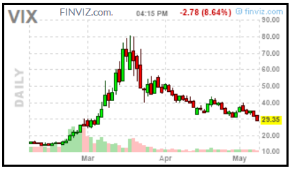

Jean-Marie Choffray @JMChoffray 10 mai 2020
“They know absolutely nothing and pretend to know everything... It is the glorification of the fool by the fool, of the ignorant by the ignorant.” (Erasmus, 1466-1536)

Jean-Marie Choffray @JMChoffray 8 mai 2020
"It is through these stupidities [... these fabulous fictions] that one leads this enormous and powerful beast that is the people." (Erasmus, 1466-1536)

Jean-Marie Choffray @JMChoffray 7 mai 2020
Rand Paul: ‘Reopen The Economy, No More Imaginary Money’ - https://t.co/wkBeC59Ezd

Jean-Marie Choffray @JMChoffray 7 mai 2020
Luxury department store chain Neiman Marcus files for bankruptcy https://t.co/gPhsrPcz5h

Jean-Marie Choffray @JMChoffray 7 mai 2020
The Nasdaq just wiped out all of its losses for 2020--a stunning feat in the aftermath of the coronvirus crisis https://t.co/33cx3cflbe

Jean-Marie Choffray @JMChoffray 7 mai 2020
"He may look like an idiot and talk like an idiot but don’t let that fool you. He really is an idiot." (Groucho Marx).

Jean-Marie Choffray @JMChoffray 7 mai 2020
Exclusive: U.S. drafts rule to allow Huawei and U.S. firms to work together on 5G standards - sources https://t.co/l3i3izsYOG

Jean-Marie Choffray @JMChoffray 6 mai 2020
"US private payrolls drop by 20.2 million in April, the worst job loss in the history of ADP report" https://t.co/hvDDCuYghv

Jean-Marie Choffray @JMChoffray 6 mai 2020
BMW: "The economic shifts caused by the pandemic make it difficult to provide a reliable forecast... To reflect this uncertainty, the company has widened the range for the EBIT margin for the Automotive segment and now expects a range between 0% and 3%." https://t.co/Qptho6bU1P

Jean-Marie Choffray @JMChoffray 6 mai 2020
BBC News - Coronavirus: Scotland's chief medical officer resigns over lockdown trips https://t.co/skIpmrZPtU

Jean-Marie Choffray @JMChoffray 6 mai 2020
Exclusive: Government scientist Neil Ferguson resigns after breaking lockdown rules to meet his married lover https://t.co/yNxf2hffZr

Jean-Marie Choffray @JMChoffray 6 mai 2020
"Wharton’s Jeremy Siegel declares end to the 40-year bull market in bonds" https://t.co/SZHUfiSnv5

Jean-Marie Choffray @JMChoffray 4 mai 2020
"La sagesse des marchés" (Markets wisdom)... https://t.co/iRkN2bDtEZ

Jean-Marie Choffray @JMChoffray 4 mai 2020
How driverless cars are being used to help in the COVID-19 crisis. https://t.co/BLQoqm3GRo via @wef

Jean-Marie Choffray @JMChoffray 4 mai 2020
By nature (i.e. trial-error process), markets are necessarily always wrong... But, they don't lie. Never! It's investors' collective responsibility to correct their mistakes, and to set the tone as to the future that they want to build.

Jean-Marie Choffray @JMChoffray 3 mai 2020
My conclusion today. Complete (non-parametric) uncertainty until November 4. Why not sell in May and go away? In all likelihood, a long and painful summer. Watch carefully key interest and exchange rates!

Jean-Marie Choffray @JMChoffray 3 mai 2020
American shale explorers are rapidly crimping production in the country’s most prolific oil fields as the worst price crash in history threatens the industry’s survival https://t.co/W9a5iUinLo via @markets

Jean-Marie Choffray @JMChoffray 3 mai 2020
"Buffett - whose entire fortune is the result of enjoying sequential bailouts from either governments or central banks time and again - appears to be becoming a measured Fed skeptic." https://t.co/X47ROt4I5E

Jean-Marie Choffray @JMChoffray 2 mai 2020
Trump Declares National Emergency As Foreign Hackers Threaten U.S. Power Grid via @forbes https://t.co/XyQbKGZVPQ

Jean-Marie Choffray @JMChoffray 23 avr. 2020
Tucker Carlson Slams Lockdowns As "Largest And Most Expensive Experiment In Human History" | Zero Hedge https://t.co/JFuJkmDah2

Jean-Marie Choffray @JMChoffray 23 avr. 2020
Record U.S. jobless claims wipe out post-Great Recession employment gains https://t.co/0X5fv5dG9g

Jean-Marie Choffray @JMChoffray 23 avr. 2020
$DO Balance sheet and debt maturity schedule don't lie😉! https://t.co/MMl0SLnP3b
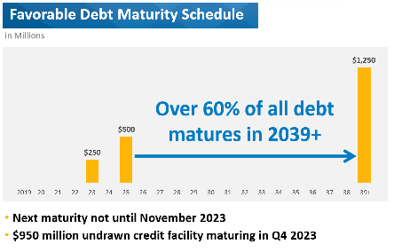

Jean-Marie Choffray @JMChoffray 23 avr. 2020
"Hundreds of members of the U.S. House of Representatives will gather in Washington on Thursday to pass a $484 billion coronavirus relief bill, bringing the unprecedented total of funds approved for the crisis to nearly $3 trillion." WASHINGTON (Reuters)

Jean-Marie Choffray @JMChoffray 23 avr. 2020
Daimler's earnings plunge as coronavirus hammers sales https://t.co/V5iUZlIz7x

Jean-Marie Choffray @JMChoffray 23 avr. 2020
"The impact of the Covid-19 pandemic on our business has been unprecedented, and I have never seen anything like it in my over seventy years in business." Sheldon G. Adelson

Jean-Marie Choffray @JMChoffray 22 avr. 2020
To PRINT or to WORK? Our answer today: to PRINT...

Jean-Marie Choffray @JMChoffray 21 avr. 2020
Barclays Bank announced today that it will exercise its issuer call option and redeem in full its iPath® Series B S&P GSCI® Crude Oil Total Return Index ETNs on April 30, 2020 (the "Redemption Date"). The ETNs trade on the NYSE Arca exchange under the ticker symbol "OIL".

Jean-Marie Choffray @JMChoffray 21 avr. 2020
"To pass for an idiot in the eyes of a fool is a gourmet delight." (G. Courteline, 1858-1929)

Jean-Marie Choffray @JMChoffray 21 avr. 2020
“I buy sheep and sell dear.” (M. A. Rothschild, 1744-1812). "Making money depends on the number of squalls that may occur during any year." (H. Clews, 1836-1923)

Jean-Marie Choffray @JMChoffray 21 avr. 2020
"Oil traders have never seen ‘insane’ market like this before, fear more declines to negative prices" https://t.co/83jtzCHvIH

Jean-Marie Choffray @JMChoffray 21 avr. 2020
"Auto supplier Robert Bosch earlier this year announced plans to start mass production of fuel cells starting in 2022." Daimler teams up with Volvo Trucks in fuel cell venture https://t.co/hHlydQPf4Z

Jean-Marie Choffray @JMChoffray 18 avr. 2020
“The phone is not ringing off the hook... Everyone is just frozen in the position they’re in.” (C. Munger) https://t.co/RzMZTrJPjq

Jean-Marie Choffray @JMChoffray 18 avr. 2020
“Be the change that you wish to see in the world.” Attributed to Mahatma Gandhi.

Jean-Marie Choffray @JMChoffray 18 avr. 2020
Ford issues $8 billion debt securities after virus causes $2 billion loss https://t.co/JUDiy0BC6F

Jean-Marie Choffray @JMChoffray 18 avr. 2020
"I’ll never tire of repeating: we need to demilitarize world affairs, international politics and political thinking." https://t.co/AwEZxUBbIM

Jean-Marie Choffray @JMChoffray 17 avr. 2020
DO: "We have done a good job taking care of our balance sheet, we have no maturities until the end of '23 (...) We have no new build deliveries, and we'll just continue to control what we can control, which is operations and reducing costs." https://t.co/MzYAp1h8OT

Jean-Marie Choffray @JMChoffray 17 avr. 2020
Boeing restarting commercial airplane production next week https://t.co/z3BnSJXYXh

Jean-Marie Choffray @JMChoffray 17 avr. 2020
"Dow futures rally 700 points after Gilead coronavirus drug reportedly shows effectiveness" https://t.co/mxUB90lUAc

Jean-Marie Choffray @JMChoffray 17 avr. 2020
My thesis advisor at MIT, Dr. Gary L. Lilien, told me once: "Never try to teach a pig to sing, it wastes you time, and it annoys the pig..." Fifty years later, I can say that he was right!

Jean-Marie Choffray @JMChoffray 16 avr. 2020
“Facts do not cease to exist because they are ignored.” (A. Huxley). https://t.co/Z0uZ4X3f40

Jean-Marie Choffray @JMChoffray 16 avr. 2020
“The landscape is cataclysmic... There’s nothing like it before, and while we know some things, we really know nothing... nothing about what’s going to happen.” https://t.co/TjFNmEHT3k

Jean-Marie Choffray @JMChoffray 16 avr. 2020
If it looks like a respite, behaves like a respite, and sounds like a respite, then it probably is a respite. https://t.co/cOqbjA5XUJ

Jean-Marie Choffray @JMChoffray 16 avr. 2020
"Benchmark West Texas Intermediate (WTI) priced at Midland, Texas -- the hub that reflects Permian pricing -- trades some $4 below the Nymex futures contract at roughly $16." https://t.co/9GcRNdbCPh

Jean-Marie Choffray @JMChoffray 16 avr. 2020
One of the most important lessons of history... https://t.co/7Q53R27cKk

Jean-Marie Choffray @JMChoffray 16 avr. 2020
https://t.co/dMdML96jP9

Jean-Marie Choffray @JMChoffray 15 avr. 2020
"We've been in a bubble since I bought my first stock in 79" (Jim Cramer)

Jean-Marie Choffray @JMChoffray 15 avr. 2020
"You know, sometimes you see a couple and they don't get along and then they tell you they are staying together because of the kids. That's exactly what going on with Opec-plus. We are staying together because of the kids. Because of the oil markets," https://t.co/sCnoXWgV9L

Jean-Marie Choffray @JMChoffray 14 avr. 2020
Edited Transcript of AMRN earnings conference call or presentation 13-Apr-20 8:30pm GMT https://t.co/eYWfS54mqQ via @YahooFinance

Jean-Marie Choffray @JMChoffray 9 avr. 2020
https://t.co/UI3qHFeNAp

Jean-Marie Choffray @JMChoffray 28 mars 2020
A new world is born. I wish it more peaceful and multipolar. Chance and necessity do not explain life. Free choices and accountability do. "Stay hungry, stay foolish." (S. Jobs) https://t.co/VC1JnmC2q6

Jean-Marie Choffray @JMChoffray 14 mars 2020
https://t.co/hlMYBoNIiG

Jean-Marie Choffray @JMChoffray 14 mars 2020
R. GIRARD: "Mimetic conflicts are resolved by the scapegoating mechanism. The repression of this collective "murder" form the foundations of the restored social order." https://t.co/5UDo5Qgc5d

Jean-Marie Choffray @JMChoffray 14 mars 2020
House passes sweeping coronavirus response package https://t.co/4t157nsCSm via @politico

Jean-Marie Choffray @JMChoffray 14 mars 2020
Jack Ma donates two million masks for coronavirus crisis in Europe https://t.co/Fr4JpfvVwa

Jean-Marie Choffray @JMChoffray 14 mars 2020
Some "bald heads" invite us not to live today, to increase our chances to live tomorrow. That's ridiculous! I invite you to live today... RESPONSIBLY!

Jean-Marie Choffray @JMChoffray 14 mars 2020
"Central banks can’t do much more in the way of stimulus. Instead it will have to be governments that pick up the fight..." https://t.co/rjeORDBnb1 via @markets

Jean-Marie Choffray @JMChoffray 14 mars 2020
Chinese medical supplies on COVID-19 for Europe are unloaded at the airport of Liege in Belgium https://t.co/goce3EU0nu

Jean-Marie Choffray @JMChoffray 14 mars 2020
The day after Italy suffered the biggest-ever jump in bond yields, its central bank chief came out fighting https://t.co/Bag8n2XAUz via @markets

Jean-Marie Choffray @JMChoffray 14 mars 2020
Berlin offers firms ‘unlimited’ credit in anti-virus package https://t.co/8rred2kgoK

Jean-Marie Choffray @JMChoffray 13 mars 2020
It's going to be a looonnnggg day! Weekend? https://t.co/cGjhN2sv1p

Jean-Marie Choffray @JMChoffray 13 mars 2020
"British Airways is to ground flights 'like never before' and lay off staff in response to the coronavirus." https://t.co/nxqCkmSsd7

Jean-Marie Choffray @JMChoffray 13 mars 2020
It's not a liquidity issue, stupid, it's a solvability one 😉!

Jean-Marie Choffray @JMChoffray 13 mars 2020
"In the long run we are all dead," John Maynard Keynes (1883-1946)

Jean-Marie Choffray @JMChoffray 13 mars 2020
Too early to act ? https://t.co/jLvaHn454T

Jean-Marie Choffray @JMChoffray 13 mars 2020
Berkshire Hathaway makes annual meeting purely virtual https://t.co/YAcDCjgZlk

Jean-Marie Choffray @JMChoffray 13 mars 2020
“QE5 promises massive market liquidity, sets up a big market rebound if a credit crunch is averted and fiscal policy short-circuits recession,” https://t.co/eCow7AqlAr via @markets

Jean-Marie Choffray @JMChoffray 13 mars 2020
“We will not tolerate any risks to the smooth transmission of our monetary policy in all jurisdictions of the euro area,” https://t.co/Q0UDP9RTPE via @markets

Jean-Marie Choffray @JMChoffray 12 mars 2020
“It’s the fastest 20% decline ever,” https://t.co/OEWm1oIO6B

Jean-Marie Choffray @JMChoffray 2 mars 2020
Some are suggesting the Fed could deliver an emergency rate cut. Such a move is rare, but not unprecedented. https://t.co/xXOMQ1PjL9 via @markets

Jean-Marie Choffray @JMChoffray 2 mars 2020
$SWN Hum, hum! Profitable and growing (ROE, ROA). No significant short term maturities. Market Cap = Q4 Operational Revenues :-)! IFF my best students trading algorithms have any value? and/or IFF markets are efficient? we could see some action in the near future.

Jean-Marie Choffray @JMChoffray 2 mars 2020
"Passant, veux-tu savoir comment un poète vit après sa mort? eh bien! ce que tu lis, c'est ma parole, et ta voix est ma voix." Poète profane, cité par Possidius de Calame (430).

Jean-Marie Choffray @JMChoffray 2 mars 2020
"Que nul n'ait de soi une telle estime que, pour quelque don particulier qu'il a reçu, il réclame, comme plus méritant, le privilège de la vie." Possidius de Calame (430).

Jean-Marie Choffray @JMChoffray 2 mars 2020
(1/2) Possidius de Calame, Vie de Saint Augustin (430): "Quand le péril est commun, et qu'il est plus à craindre que la fuite soit attribuée moins au dessein de servir qu'à la crainte de mourir… "

Jean-Marie Choffray @JMChoffray 2 mars 2020
(2/2) "quand il y a plus de scandale dans l’exemple de la fuite qu’il ne saurait y avoir d’utilité dans la conservation de la vie, alors il n’y a plus à hésiter." Possidius de Calame (430)

Jean-Marie Choffray @JMChoffray 2 mars 2020
Possidius de Calame, Vie de Saint Augustin (430): "La puissance qui oblige s'impose bientôt."

Jean-Marie Choffray @JMChoffray 2 mars 2020
Aldous Huxley, Ends And Means (1937): "The sanctionists are cherishing the old illusion of 'the war to end war.' But wars do not end war; in most cases they result in an unjust peace that makes inevitable the outbreak of a war of revenge... War cannot be stopped by more war."

Jean-Marie Choffray @JMChoffray 2 mars 2020
Aldous Huxley, Ends And Means (1937): "Our world oscillates from a neurasthenia that welcomes war as a relief from boredom to a mania that results in war being made." In reality, people dramatically lack "a meaning in life, a purpose for their existence."

Jean-Marie Choffray @JMChoffray 2 mars 2020
Aldous Huxley, Ends And Means (1937), quotes The Imitation: "All men desire peace, but very few desire those things which make for peace."

Jean-Marie Choffray @JMChoffray 1 mars 2020
$IRBT $AAXN $GPRO $UNFI $SWN $DDD $LCI $BE $FSLR $CMI $DO $CPST $WPRT "Nothing fails like success" (A. Huxley). Time to sit down, shut up and think? https://t.co/6OPGQFvkNz

Jean-Marie Choffray @JMChoffray 29 févr. 2020
History is a tragedy. Has always been. Will always be! But, we are free to invest and contribute to a better future 😉!

Jean-Marie Choffray @JMChoffray 28 févr. 2020
$IRBT, $AAXN, $GPRO, $UNFI, $SWN, $DDD, $LCI, $BE, $FSLR, $CMI, $DO, $CPST, In the fog of present times, the truth is that human history will not end soon. It's up to us to use our freedom to invest to build a better future 😉! https://t.co/6OPGQFvkNz

Jean-Marie Choffray @JMChoffray 5 févr. 2020
"Short answers to some of the hardest issues facing investors today." By Jean-Marie Choffray and Charles Pahud de Mortanges. https://t.co/txzck9RzQC

Jean-Marie Choffray @JMChoffray 4 févr. 2020
Wrong answer to a real problem? California lawmaker introduces bill to make PG&E a publicly owned utility https://t.co/5CqaFcjFIL via @YahooFinance

Jean-Marie Choffray @JMChoffray 29 janv. 2020
Plan could force California utilities to reimburse customers for power shut-offs https://t.co/ImAO19vMh7

Jean-Marie Choffray @JMChoffray 20 janv. 2020
"If 100% of all investing is passive, then the information contained in market prices is meaningless.” https://t.co/WCAcTywNMS https://t.co/i3Zk0Ksjrj
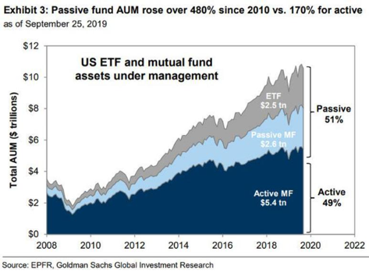

Jean-Marie Choffray @JMChoffray 18 janv. 2020
A close friend - professor of medicine - told me recently that death is a process, not an event. So, when does it start? When does it end? Same thing for a business. Think FCEL :-)!

Jean-Marie Choffray @JMChoffray 18 janv. 2020
The lesson of the market... Chance and necessity explain the behavior of the market no more than they explain life :-)!

Jean-Marie Choffray @JMChoffray 18 janv. 2020
"Court documents revealed emails from city officials that shed light on the real motivations behind the City’s ban on Bloom’s technology – to stop Bloom Energy Servers from impacting its own revenue forecast of sales of electricity from its municipal utility."

Jean-Marie Choffray @JMChoffray 17 janv. 2020
Microsoft will be carbon negative by 2030 https://t.co/rKKHhpZBxr

Jean-Marie Choffray @JMChoffray 7 janv. 2020
"God laughs at men who deplore the effects whose causes they cherish." (J-B Bossuet)

Jean-Marie Choffray @JMChoffray 6 janv. 2020
"A prince ought to inspire fear in such a way that, if he does not win love, he avoids hatred." The Prince, Machiavelli.

Jean-Marie Choffray @JMChoffray 28 déc. 2019
«Arcana principis silentio obvolvuntur». (Carlo Ossola)

Jean-Marie Choffray @JMChoffray 28 déc. 2019
“Hope is a force that creates the very conditions of its fulfillment.” (Alain Peyrefitte)

Jean-Marie Choffray @JMChoffray 28 déc. 2019
“They did not know it was impossible, so they did it.” (Mark Twain)

Jean-Marie Choffray @JMChoffray 28 déc. 2019
Market prices apparent irrationality (volatility) is at least partly the result of Arrow’s impossibility theorem which states that a collective value function cannot be devised while adhering to a some basic principles of individual freedom and rationality.

Jean-Marie Choffray @JMChoffray 28 déc. 2019
As long as politicians and central bankers are ready to do “whatever it takes” to… save their job, don’t expect the market to tumble.

Jean-Marie Choffray @JMChoffray 28 déc. 2019
The world (the market ?) is, has always been, and will always be, at the edge of collapse (Chaos). It’s some kind of a “steady state”!

Jean-Marie Choffray @JMChoffray 28 déc. 2019
All investing is based upon an act of faith – faith in the validity of financial statements, faith in the ultimate growth of the economy, faith that the principles of finance represent the laws of value creation…

Jean-Marie Choffray @JMChoffray 28 déc. 2019
Businesses have no intrinsic value… Their market capitalization is the fuzzy reflection of collective (mostly irrational) dreams and hopes.

Jean-Marie Choffray @JMChoffray 27 déc. 2019
Overall, holiday e-commerce sales grew 18.8% over last year, on top of an 18.4% advance holiday 2018. @forbes https://t.co/PRboHqs7xA

Jean-Marie Choffray @JMChoffray 26 déc. 2019
"The average U.S. investment-grade corporate bond yields 2.87%, or about 1 percentage point more than Treasuries. In Europe, absolute yields on company bonds sit at just 0.47%, similar to the 0.46% that Japanese corporate debt pays." https://t.co/pyrxo5azHQ via @markets

Jean-Marie Choffray @JMChoffray 24 déc. 2019
"In certain segments, particularly in the ETF market, there’s over-promised liquidity... Markets overshoot on the way up and on the way down. Sell-offs offer opportunities to take advantage of distressed situations trading at bargain prices." (M. El-Erian)

Jean-Marie Choffray @JMChoffray 24 déc. 2019
"At some point, negative rates become counterproductive. Savers save more because they’re not getting paid on their savings. You encourage risk taking in the financial world. You depress productivity (zombie companies). And, you encourage inequality of wealth." (M. El-Erian)

Jean-Marie Choffray @JMChoffray 24 déc. 2019
How block trades might be affecting the price discovery mechanism... https://t.co/mpJVqr0NCG
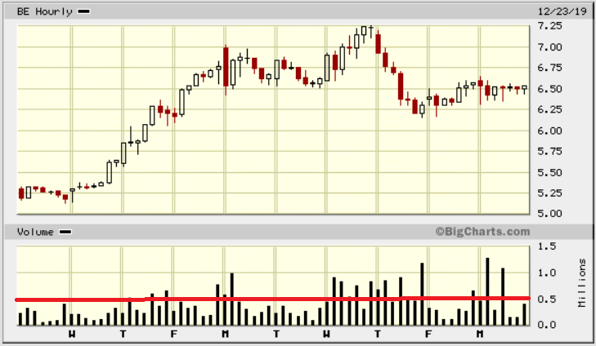

Jean-Marie Choffray @JMChoffray 24 déc. 2019
"Negative rates are a huge transfer of wealth from savers and real wages to the government and the indebted. A tax on caution. The destruction of the perception of risk that always benefits the most reckless. The bailout of the inefficient." | Zero Hedge https://t.co/mycEdECDqz

Jean-Marie Choffray @JMChoffray 24 déc. 2019
Is there a pilot in the plane? https://t.co/EI6GsxPqkA

Jean-Marie Choffray @JMChoffray 24 déc. 2019
In a ZIRP environment, capital misallocation makes an economic bust inevitable! When? That is the question.

Jean-Marie Choffray @JMChoffray 24 déc. 2019
Forgive them, for they don't know what they are doing :-)! https://t.co/zea6KsI8OS

Jean-Marie Choffray @JMChoffray 23 déc. 2019
Tesla Is the Decade's Best-Performing Auto Company https://t.co/hhfOhxBCZM via @YahooFinance

Jean-Marie Choffray @JMChoffray 23 déc. 2019
Boeing CEO out following 737 Max fiasco, will be replaced by current board chairman https://t.co/pCAkDuzPBL via @techcrunch

Jean-Marie Choffray @JMChoffray 23 déc. 2019
U.S. core capital goods orders tepid; shipments drop https://t.co/sc8oQ1WFFb via @YahooFinance

Jean-Marie Choffray @JMChoffray 23 déc. 2019
"The US economy is largely a mirage produced by official statistics that have long been unreliable." (P. Craig Roberts)

Jean-Marie Choffray @JMChoffray 22 déc. 2019
The biggest "lies" are always the "truths" that others want to impose on us...

Jean-Marie Choffray @JMChoffray 22 déc. 2019
"Electricity, and the access it provides to our digital world is a basic human need, on the order of water, nutrition, oxygen and fire. It is a super resource, the power that energizes myriad products and services that enhance the quality of human life." (KR Sridhar, CEO $BE)

Jean-Marie Choffray @JMChoffray 22 déc. 2019
"Capital, or hardware costs, have dropped by ~27% as cumulative production volume doubles, (in line or better than wind and solar). The latest generation Energy Server delivers 5 times the electricity output of the 1st generation in a constant footprint."

Jean-Marie Choffray @JMChoffray 22 déc. 2019
"By 2050 most of the increase in population, ~2 billion, will occur in low-income parts of the world that will need significant growth in affordable electricity. Another 4 billion will aspire to climb the economic ladder and will expect the energy to create economic wealth."

Jean-Marie Choffray @JMChoffray 22 déc. 2019
"Over 1 billion people on the planet are without access to electricity and more than double that number cannot afford it." (KR Sridhar, CEO BloomEnergy)

Jean-Marie Choffray @JMChoffray 20 déc. 2019
Reality, as simple as it gets! Managers want to spend money today, to make more tomorrow. Investors want to make money today, to spend more tomorrow :-)!

Jean-Marie Choffray @JMChoffray 18 déc. 2019
By far... my best investment in 2019 (>15 x P)! https://t.co/OvwKmOQxp4

Jean-Marie Choffray @JMChoffray 18 déc. 2019
To print, or not to print, that is the question... https://t.co/YOimML2zti

Jean-Marie Choffray @JMChoffray 17 déc. 2019
"No philosophy [i.e. theory of life] is completely disinterested." (Aldous Huxley, Ends and Means, 1937) ... Familiar Cognitive Dissonance Theory unbridled :-)!

Jean-Marie Choffray @JMChoffray 17 déc. 2019
"All science is based upon an act of faith – faith in the validity of the mind’s logical processes, faith in the ultimate explicability of the world, faith that the laws of thought are laws of things." (Aldous Huxley, Ends and Means, 1937)

Jean-Marie Choffray @JMChoffray 17 déc. 2019
“The body politic is subject to two grave diseases in the head, madness and imbecility.” (Aldous Huxley, Ends and Means, 1937)

Jean-Marie Choffray @JMChoffray 17 déc. 2019
Keep in mind... Besides real inflation, the only practical solutions to an exponential accumulation of debt are its cancellation or collapse.

Jean-Marie Choffray @JMChoffray 17 déc. 2019
In a financialized world, the Price to Assets ratio (Market cap/Total assets) is a particularly revealing measure of how "expensive" a business is relative to its "cost of production".

Jean-Marie Choffray @JMChoffray 16 déc. 2019
Just kidding! If I was sure that God didn't exist, I would believe in the markets. Why? They assess creative human endeavors; they reward hard work and honesty; they offer an alternative to violence and war.

Jean-Marie Choffray @JMChoffray 16 déc. 2019
$PCG In a non-parametric world, investors typically "don't know what they don't know." So, YOUR short term investment time horizon becomes MY long term!

Jean-Marie Choffray @JMChoffray 15 déc. 2019
$GPRO "For Q4 of 2019, we expect revenue in the range of $550 million to $585 million; gross margin in the range of 40%, +/- 50 basis points; operating expenses of $105 million, +/- $2 million; non-GAAP earnings of $0.74 to $0.84/share; GAAP earnings of $0.65 to $0.75/share."

Jean-Marie Choffray @JMChoffray 15 déc. 2019
"To be looked upon as a fool by an idiot is a true gourmet's delight." (Georges Courteline, 1868-1929)

Jean-Marie Choffray @JMChoffray 15 déc. 2019
Inefficiency does not mean irrationality. The rational intelligibility of the markets is proof that their behavior is not the simple product of randomly generated investment decisions.

Jean-Marie Choffray @JMChoffray 15 déc. 2019
I have no doubt that the markets are AT LEAST marginally inefficient, and that's what makes investing fun...

Jean-Marie Choffray @JMChoffray 15 déc. 2019
If you liked the FAANG song (Price to Assets and Price to Sales ratios), will you like the sobs? https://t.co/U15MziEiiH
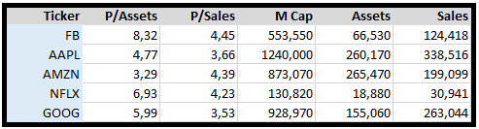

Jean-Marie Choffray @JMChoffray 15 déc. 2019
Whatever the INVESTMENT HORIZON and the GROWTH RATE (the Money Supply?) current market valuations are WAAAAAY overstretched! But..., nobody knows WHEN the music will stop 😉!

Jean-Marie Choffray @JMChoffray 13 déc. 2019
There is no "final victory," and no "final defeat" either. It's never over... (George Galloway)

Jean-Marie Choffray @JMChoffray 13 déc. 2019
US-China trade deal: "When, in politics, you leave the realm of the ambiguous, you surely will suffer from it." (Cardinal de Retz, 1613-1679)

Jean-Marie Choffray @JMChoffray 13 déc. 2019
“Who controls the past controls the future. Who controls the present controls the past.” (George Orwell)

Jean-Marie Choffray @JMChoffray 2 mai 2019
Life is an unlikely succession of unlikelihoods... https://t.co/7NT8T8QScM https://t.co/lclEEFq2mi

Jean-Marie Choffray @JMChoffray 8 févr. 2019
Major historic event... Real sign of hope... At last! https://t.co/A2A0QdnOGv

Jean-Marie Choffray @JMChoffray 3 févr. 2019
A dirty little secret… From where he is, Charles Ponzi (1882-1949) must be laughing at the way the world economy has been managed over the last ten years! https://t.co/v27PimeoB7

Jean-Marie Choffray @JMChoffray 3 févr. 2019
“There is nothing more practical than a good theory…” (Explaining the most, using the least!) So, is it the right time to “Milk and go”? https://t.co/nB5krBT5GI
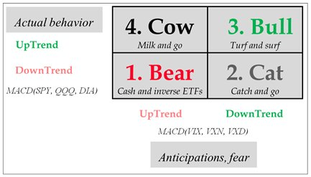

Jean-Marie Choffray @JMChoffray 3 févr. 2019
S&P500 (SPX: monthly, last 5 years): decelerating (?) uptrend! https://t.co/Pf6LMlqcYQ
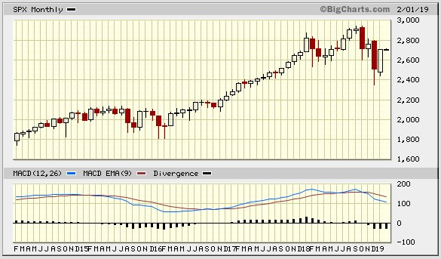

Jean-Marie Choffray @JMChoffray 3 févr. 2019
Volatility (VIX: monthly, last 5 years): accelerating (?) uptrend! https://t.co/4ytRF68vlW
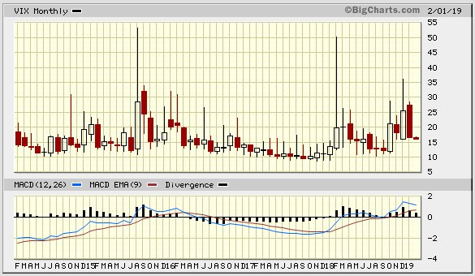

Jean-Marie Choffray @JMChoffray 3 févr. 2019
Easy! A market TOP/BOTTOM is forming when prices tend to go DOWN/UP on GOOD/BAD news…

Jean-Marie Choffray @JMChoffray 2 févr. 2019
Evidently, cannabis businesses live twice :-)! https://t.co/x9Aa4uQvbv via @markets

Jean-Marie Choffray @JMChoffray 1 févr. 2019
Japan's pension fund, the world's biggest, fell 9.1% in the final quarter of last year — a record loss of $136 billion https://t.co/ScVnwAU8ts via @markets

Jean-Marie Choffray @JMChoffray 31 janv. 2019
Silence, Absence, Defense (S.A.D.)... In a "non-parametric" world, never ever announce an investment strategy. By the time you implement it, you might have to adapt it :-)!

Jean-Marie Choffray @JMChoffray 31 janv. 2019
Apple bans Facebook's Research app that paid users for data https://t.co/eT8OL5vP1L via @techcrunch

Jean-Marie Choffray @JMChoffray 31 janv. 2019
Jerome Powell gives the financial markets just about everything they wanted https://t.co/sz6YoTupt8

Jean-Marie Choffray @JMChoffray 29 janv. 2019
PG&E Files for Bankruptcy With More Than $50 Billion in Debt. (Bloomberg) https://t.co/ov7uMgJoBv
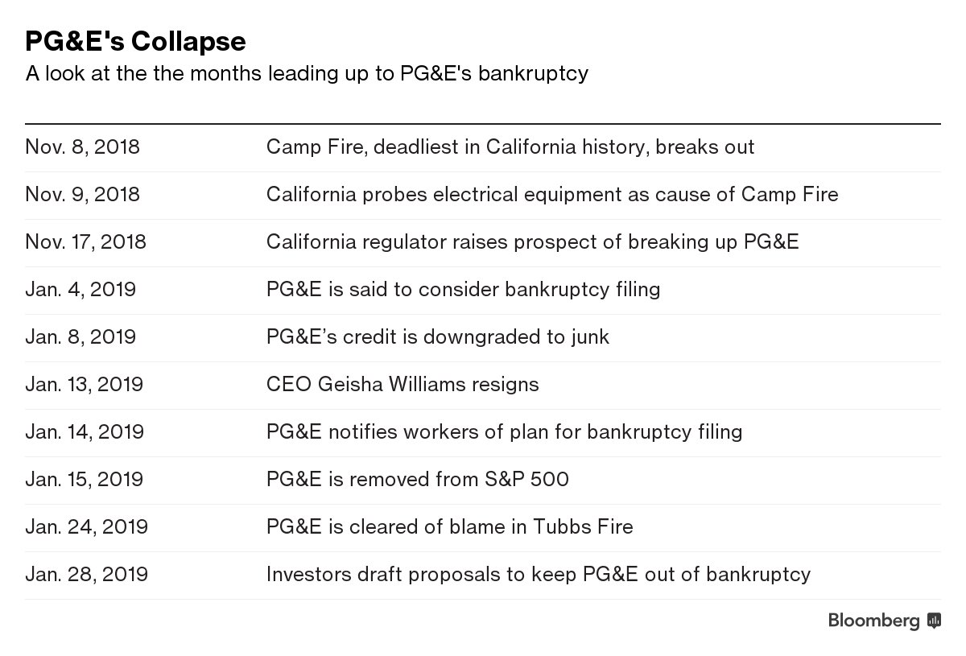

Jean-Marie Choffray @JMChoffray 28 janv. 2019
The way the markets react has not changed fundamentally in the last thirty years, except that what happened in three months now happens in three seconds...

Jean-Marie Choffray @JMChoffray 28 janv. 2019
When someone tells me – or writes – that he knows of an interesting investment opportunity, I know with certainty that it is not an opportunity!

Jean-Marie Choffray @JMChoffray 26 janv. 2019
"Trump Signs Spending Bill, Ending Longest Government Shutdown in U.S. History." (WSJ)

Jean-Marie Choffray @JMChoffray 26 janv. 2019
"We want a reasonable solution to the shutdown and want to see it end immediately." (Jamie Dimon, CEO J.P. Morgan Chase)

Jean-Marie Choffray @JMChoffray 26 janv. 2019
“U.S. energy firms this week increased the number of oil rigs, but the rig count in January fell the most in a month since April 2016, as the boom in the Permian, the nation's biggest shale oil formation, cools.” (Reuters) https://t.co/P7jFc6LECw
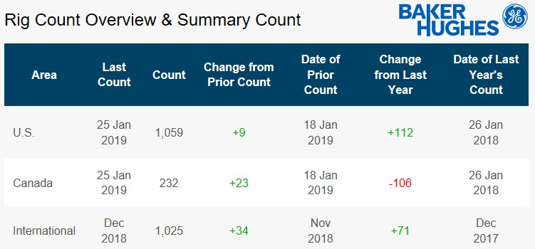

Jean-Marie Choffray @JMChoffray 26 janv. 2019
“Healthcare workers, including nurses, medical doctors and pharmacists, continue to earn the highest ratings from Americans for their honesty and ethical standards.” https://t.co/Z2uH5YZHcK
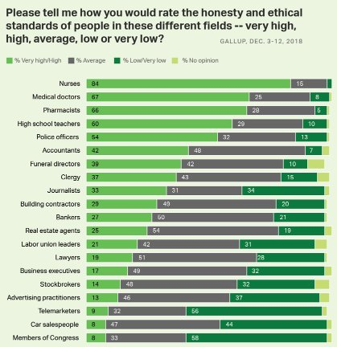

Jean-Marie Choffray @JMChoffray 26 janv. 2019
At any point in time, the market is not efficient. And, it never will! Stock prices are always above, or under, intrinsic (purely economic) value. The key question is for how long…

Jean-Marie Choffray @JMChoffray 26 janv. 2019
Truths & fake truths, news & fake news, lies & fake lies have always existed on the market. They represent different levels of sophistication in the way operators react rationally – and, often, irrationally! – to uncertainty.

Jean-Marie Choffray @JMChoffray 26 janv. 2019
To assume that managers and/or board members are competent and accountable is a strong hypothesis. My experience as a modest investor suggests the opposite!

Jean-Marie Choffray @JMChoffray 18 janv. 2019
China has offered to go on a six-year buying spree to ramp up imports from the U.S. as a path to eliminate the trade imbalance https://t.co/GX9z5iZh1o via @bpolitics

Jean-Marie Choffray @JMChoffray 18 janv. 2019
Volkswagen to offer diesel trade-in incentives in all of Germany: Bild https://t.co/GVXfatT3IZ

Jean-Marie Choffray @JMChoffray 18 janv. 2019
Practicing "The art of the deal"... https://t.co/Ca9yHWN5oF

Jean-Marie Choffray @JMChoffray 18 janv. 2019
To live humanely, people need “certainties”. History has a sense. It can be discovered in the succession of events that did not… occur! Chance and necessity will never explain people’s awareness of the existence of truth.

Jean-Marie Choffray @JMChoffray 18 janv. 2019
In the market, without a “theory”, you are lost! With a “bad” theory, you are dead… So, if you survive, “your” theory must be right. Keep it jealously for yourself!

Jean-Marie Choffray @JMChoffray 17 janv. 2019
“The facts are: (a) most professional managers fail to outpace appropriate market indexes, and (b) those who do so rarely repeat in the future their success in the past.” https://t.co/iwCw7nUykR

Jean-Marie Choffray @JMChoffray 17 janv. 2019
"Shares of Morgan Stanley fell 24 percent last year, worse than the 20 percent decline of the KBW Bank Index." https://t.co/iVTdHKIzKg

Jean-Marie Choffray @JMChoffray 17 janv. 2019
"The Brits were dealt a bad hand and they played it badly... A hard Brexit will be a disaster for Great Britain... We don't think it will happen because it's bad for Europe too." (Jamie Dimon) https://t.co/zj5zHViigB

Jean-Marie Choffray @JMChoffray 17 janv. 2019
“In investing, you get what you don’t pay for... Don’t be foolish enough to think that you can consistently outsmart the market...” https://t.co/qm5PK9RhCd

Jean-Marie Choffray @JMChoffray 16 janv. 2019
“The State may well promise, but not hold. More benefits and less taxation are conflicting goals. Debt - i.e. hypothecating the future - is a tentative way of reconciling them. Doing some good today at the expense of a lot of evil tomorrow." (Frédéric Bastiat, 1801-1850)

Jean-Marie Choffray @JMChoffray 16 janv. 2019
"Is this not the cause of all revolutions? Between the State, which lavishes promises which it is impossible to keep, and the public, which has conceived hopes which can never be realized, two classes of men interpose: the ambitious and the utopians."

Jean-Marie Choffray @JMChoffray 16 janv. 2019
"It is radically impossible for the Sate to confer a particular benefit upon any one of the individualities which constitute the community, without inflicting a greater injury upon the community as a whole."

Jean-Marie Choffray @JMChoffray 16 janv. 2019
"The State is the great fiction through which everybody endeavors to live at the expense of everyone else." (Frédéric Bastiat, 1801-1850)

Jean-Marie Choffray @JMChoffray 16 janv. 2019
Smell of stagflation...? https://t.co/5ykODb5NVn

Jean-Marie Choffray @JMChoffray 16 janv. 2019
"We are entering a period of profound global instability brought on by the technological disruption of the Fourth Industrial Revolution and the realignment of geo-economics and geopolitical forces," (Klaus Schwab, World Economic Forum - WEF)

Jean-Marie Choffray @JMChoffray 15 janv. 2019
BBC News - German economic growth slowest for five years https://t.co/CiKr1Ics9r

Jean-Marie Choffray @JMChoffray 15 janv. 2019
“Black holes” form when massive businesses collapse at the end of their lifecycle. They grow by absorbing other failed businesses and merging with other black holes. Their “event horizon” delimit the region from which no escape is possible…

Jean-Marie Choffray @JMChoffray 15 janv. 2019
Let's stay humble! The Uncertainty Principle (Heisenberg, 1901-1976) states that the more precisely the “position” of some object is determined (e.g. Stage in Business Lifecycle?), the less precisely its “momentum” (e.g. Assets Growth Rate?) can be known, and vice versa…

Jean-Marie Choffray @JMChoffray 15 janv. 2019
I completely disagree with those who say and/or write that History is the history of stupidity and human madness... If they studied it more carefully, they would understand that it’s quite the opposite!

Jean-Marie Choffray @JMChoffray 14 janv. 2019
Top U.S. utility PG&E says it is preparing bankruptcy filing https://t.co/c88smEtSfw via @YahooFinance

Jean-Marie Choffray @JMChoffray 14 janv. 2019
Newmont to buy Goldcorp in deal valued at $10 billion https://t.co/rFG2CzPLH2 via @business

Jean-Marie Choffray @JMChoffray 14 janv. 2019
An interesting reminder from Chateaubriand (1768-1848)... https://t.co/EbYa4WZaDF
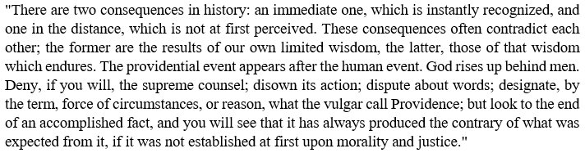

Jean-Marie Choffray @JMChoffray 14 janv. 2019
"Latest data from China showed imports fell 7.6 percent year-on-year in December when analysts had predicted a 5 percent rise, while exports dropped 4.4 percent, confounding expectations for a 3 percent gain." https://t.co/PFJ9jPN5Po

Jean-Marie Choffray @JMChoffray 14 janv. 2019
From bad to worse... https://t.co/l4fxwiIUiH

Jean-Marie Choffray @JMChoffray 14 janv. 2019
A lesson of realpolitik... https://t.co/vRwGEzJwDU

Jean-Marie Choffray @JMChoffray 14 janv. 2019
"China car sales fell 13 percent in December, the sixth straight month of declines, bringing annual sales to 28.1 million, down 2.8 percent from a year earlier." https://t.co/B5bsBWVB94

Jean-Marie Choffray @JMChoffray 14 janv. 2019
PG&E Chief Is Out as Utility Faces California Fire Liability https://t.co/t78FtqMrjT

Jean-Marie Choffray @JMChoffray 14 janv. 2019
Get ready! It can happen anytime. “Tel qu’en Lui-même enfin l’éternité le change » (Mallarmé, 1842-1898)

Jean-Marie Choffray @JMChoffray 14 janv. 2019
Freedom (self-interest) without responsibility (accountability) leads to anarchy (decay). Always! In the world of investing, as F. Bastiat observed elsewhere: “That which is not seen” is most important. “Broken windows” are... more that broken windows! https://t.co/2BD6RPbMLF

Jean-Marie Choffray @JMChoffray 14 janv. 2019
I tend to smile diplomatically at people who talk about things that they do not know, and/or books that they have not read!

Jean-Marie Choffray @JMChoffray 13 janv. 2019
"An economy with sound money and tight credit is industrious, thrifty, and honest. Whereas an economy with fake money and cheap credit is slothful, gluttonous, and deceitful." https://t.co/Bjpo4QW1id

Jean-Marie Choffray @JMChoffray 13 janv. 2019
If you like Volatility (“Singular” or “Perfect” uncertainty) fasten your seat belt... This earnings season – starting tomorrow – should serve you well!

Jean-Marie Choffray @JMChoffray 13 janv. 2019
One of my friends was recently invited by his doctor to live... not to live! Like Louis XIV, he showed him the door...

Jean-Marie Choffray @JMChoffray 13 janv. 2019
"Equity returns tend to be strongest at the end of a bull market"… https://t.co/bYCnv9wtEc https://t.co/YmD6wfRMWy
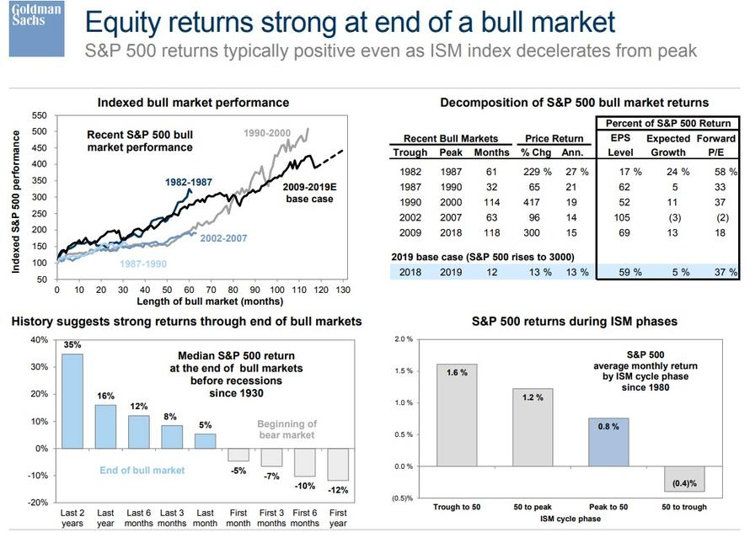

Jean-Marie Choffray @JMChoffray 13 janv. 2019
“The company (PG&E) is increasingly reliant on extraordinary intervention by legislators and regulators, which may not occur soon enough or be of sufficient magnitude to address adverse developments.” (J. Cassella, Moody’s)

Jean-Marie Choffray @JMChoffray 13 janv. 2019
The fall of a Titan? https://t.co/oLPGb9GXvv via @markets

Jean-Marie Choffray @JMChoffray 13 janv. 2019
In my life as a professor and/or director, I noticed that most people do not want to learn; they do not want to work; and, they certainly do not want to face the consequences of their choices... They just want to be “free riders”!

Jean-Marie Choffray @JMChoffray 12 janv. 2019
"Money matters in matrimony as much as love." https://t.co/DPRb6xS9yu

Jean-Marie Choffray @JMChoffray 12 janv. 2019
For those in need of a “Reality Check”… the US/World Debt Clock! https://t.co/RWuLfFkHeV

Jean-Marie Choffray @JMChoffray 12 janv. 2019
When I analyze what happens today in the market, I can only conclude that Laurence J. Peter (from "The Peter Principle") was optimistic :-)!

Jean-Marie Choffray @JMChoffray 12 janv. 2019
It doesn't take a PhD in economics to understand that if the world's largest central banks reduce their balance sheets (likely!), without a comparable increase in global debt (unlikely!), this will have a significant impact on the level of activity.

Jean-Marie Choffray @JMChoffray 12 janv. 2019
It’s not the economy, stupid… It’s the – relative – debt level (leverage)!

Jean-Marie Choffray @JMChoffray 12 janv. 2019
When they close their margin positions, speculators usually sell their shares to “new” margin buyers…

Jean-Marie Choffray @JMChoffray 12 janv. 2019
When they cover their short positions, speculators usually buy the needed shares from “new” short sellers…

Jean-Marie Choffray @JMChoffray 12 janv. 2019
Most investors (speculators) don't sell assets because they want it, or like it... But, because they are, directly or indirectly, forced to!

Jean-Marie Choffray @JMChoffray 11 janv. 2019
Weight Watchers falls on Friday, after JPMorgan downgraded the stock on weak New Year enrollment https://t.co/RtfjQNRVJ6 via @markets

Jean-Marie Choffray @JMChoffray 11 janv. 2019
Buffett-backed solar farm is cut to junk as PG&E crisis deepens https://t.co/LJIpnuc198 via @markets

Jean-Marie Choffray @JMChoffray 11 janv. 2019
Honest & true! A few years ago, a family member invited me to invest in a start-up that was selling a revolutionary way to grow hair. I declined. The inventor/CEO was bald!

Jean-Marie Choffray @JMChoffray 11 janv. 2019
Based on more than forty years of observation, I don't think that most (political, business, academic...) "leaders" are pathological liars. It's much simpler: they refuse to admit publicly that they just "don't know" :-)!

Jean-Marie Choffray @JMChoffray 11 janv. 2019
As a modest investor, I am more concerned about "fake truths" and "fake lies" than about "fake news"!

Jean-Marie Choffray @JMChoffray 10 janv. 2019
BBC News - Jaguar Land Rover confirms 4,500 job cuts https://t.co/ToLtaQwrSM

Jean-Marie Choffray @JMChoffray 10 janv. 2019
Ghosn's Renault lieutenant drew extra salary via holding: documents https://t.co/V3t5Z8ROaH

Jean-Marie Choffray @JMChoffray 10 janv. 2019
Ford Plans to Cut Thousands of Jobs Across Europe https://t.co/6iKSpCzbbE

Jean-Marie Choffray @JMChoffray 10 janv. 2019
BlackRock is cutting 3% of its global workforce, the largest reduction in its headcount since 2016 https://t.co/xJTrh5zNY1 via @markets

Jean-Marie Choffray @JMChoffray 10 janv. 2019
Stagflation ahead...? https://t.co/VhlcCjLhnF

Jean-Marie Choffray @JMChoffray 9 janv. 2019
My friend, François Kasbi, did it again! His "Bréviaire capricieux" is an exceptional source of French literary culture. Long life to it! https://t.co/uc6huNr45F

Jean-Marie Choffray @JMChoffray 9 janv. 2019
Mastering volatility is one thing... Enjoying the many presents of life is quite another :-)! https://t.co/ZdkHXpbhKh

Jean-Marie Choffray @JMChoffray 9 janv. 2019
Above average intraday volume variation is the closest you can get to the "Truth"! https://t.co/IYTdQO0sAW
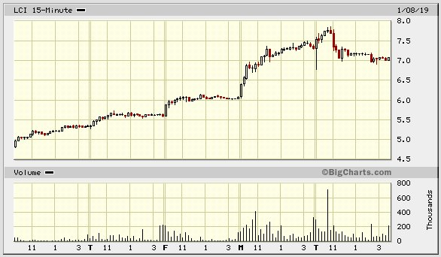

Jean-Marie Choffray @JMChoffray 8 janv. 2019
Analysts looking at signals embedded in the stock market are coming up with some worrisome numbers for corporate profit growth https://t.co/aEyvNw0AVv via @markets

Jean-Marie Choffray @JMChoffray 8 janv. 2019
Dynamics of a "short squeeze" ($LCI)... https://t.co/DWh9zGcHVs
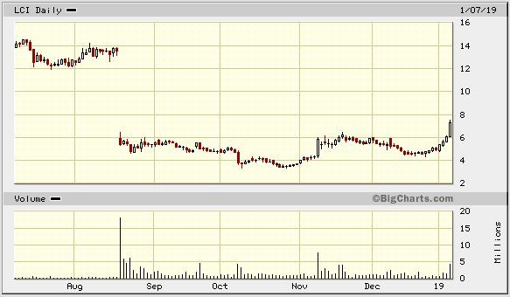

Jean-Marie Choffray @JMChoffray 8 janv. 2019
Investors financial leverage (~ tolerance for risk) is the reason why markets ALWAYS over-react (“actual” top >> “natural” top; “actual” bottom << “natural” bottom); “natural” meaning based on “intrinsic” value.

Jean-Marie Choffray @JMChoffray 7 janv. 2019
Jerome Powell manages to calm markets for now by muddying the Fed's monetary message https://t.co/Ui7lYWW2U8 via @markets

Jean-Marie Choffray @JMChoffray 7 janv. 2019
Ben Bernanke isn't worried, or even surprised, about the recent stocks selloff https://t.co/nM1ag2CWLg via @markets

Jean-Marie Choffray @JMChoffray 7 janv. 2019
"Broad" US Patent in the CCS space granted to Fuelcell Energy (1/1/19). IFF enforceable, it might be a REAL game changer... https://t.co/jifuoCcyw4

Jean-Marie Choffray @JMChoffray 5 janv. 2019
This year's fintech predictions, from the company powering most of the industry https://t.co/AZiJRIvmDk

Jean-Marie Choffray @JMChoffray 5 janv. 2019
Tesla urges tariff exemption for Chinese-made car computer 'brain' https://t.co/sr69W4U7QB

Jean-Marie Choffray @JMChoffray 5 janv. 2019
Wonkish! On the natural tendency of markets to go down… My "adaptation" of Newton's Law of Universal Gravitation: F ∝ M / A**2 (M = Market Cap; A = Total Assets).

Jean-Marie Choffray @JMChoffray 5 janv. 2019
The key to successful investing is to learn to fail better, to fail smarter. The next few months should provide ample additional validation.

Jean-Marie Choffray @JMChoffray 5 janv. 2019
According to Clausewitz, in case of conflict, the best (long term) strategy is usually a defensive one. Same in the markets!

Jean-Marie Choffray @JMChoffray 5 janv. 2019
Peter’s Principle applied to the markets! At any given point in time, the most successful investors are the most incompetent – luckiest?

Jean-Marie Choffray @JMChoffray 4 janv. 2019
Discovering the risk associated with “Bumpitrage” (Buying a stake in a bid target to bump up the deal price) the hard way... https://t.co/Nx8zuytzZ0 via @YahooFinance

Jean-Marie Choffray @JMChoffray 3 janv. 2019
Decelerating global growth. Weakness in interest-sensitive and economically-sensitive industries. Tighter financial conditions... https://t.co/VWKXSKM3QK via @markets

Jean-Marie Choffray @JMChoffray 3 janv. 2019
AAPL: “Be skeptical of company buybacks. They are often executed poorly (near the highs) and they are almost always a signpost of a maturing company.” (Doug Kass)

Jean-Marie Choffray @JMChoffray 3 janv. 2019
China’s Chang’e 4 makes first-ever soft landing on moon’s far side - Global Times https://t.co/qskbrc99Fi

Jean-Marie Choffray @JMChoffray 3 janv. 2019
History repeats itself… For the “game” to continue, we need a few big winners and many small losers... Sector rotation welcome!

Jean-Marie Choffray @JMChoffray 3 janv. 2019
AAPL: Another $50B… gone with the wind ??? https://t.co/TnITfnP6sM
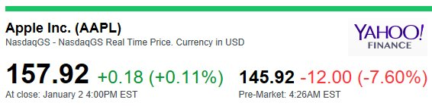

Jean-Marie Choffray @JMChoffray 3 janv. 2019
“When Jim Cramer screamed “they know nothing, they know nothing”, he was being a little unfair, but not by much.” (Bill Gross) :-)! https://t.co/FschUIHHli via @markets

Jean-Marie Choffray @JMChoffray 3 janv. 2019
"The stock market has reached a permanently high plateau." (Irving Fisher, Oct. 1929) :-)! https://t.co/blWUVXPDmS

Jean-Marie Choffray @JMChoffray 2 janv. 2019
“QE has changed the very nature of the market, destroying the diversity of its ecosystem, and making it incredibly vulnerable to the smallest change in the macro environment." https://t.co/5XFJp6RZlY

Jean-Marie Choffray @JMChoffray 2 janv. 2019
Daimler delivers its first Mercedes GLC F-CELL vehicles to select German markets https://t.co/WKA2xt5goB

Jean-Marie Choffray @JMChoffray 2 janv. 2019
“Anyone can build a decent model with great data. The hard part is knowing what to do with bad or incomplete data.” (Lindsay Politi)

Jean-Marie Choffray @JMChoffray 2 janv. 2019
“I will remind myself not to listen to company management’s forecasts; they are like ministers of finance on the eve of devaluation, rarely admitting to problems or challenges.” (Doug Kass)

Jean-Marie Choffray @JMChoffray 1 janv. 2019
“He’s stubborn. He will never admit he’s made a big mistake…It just makes me crazy.” https://t.co/2vtYn0BAyP

Jean-Marie Choffray @JMChoffray 1 janv. 2019
The best and worst stocks of 2018 https://t.co/FvHBQpoPfv

Jean-Marie Choffray @JMChoffray 1 janv. 2019
New Year... Old world... Sticky problems... Lying does not work as it used to be!

Jean-Marie Choffray @JMChoffray 31 déc. 2018
BBC News - Global markets in worst year since 2008 https://t.co/iz5llqSf2S

Jean-Marie Choffray @JMChoffray 31 déc. 2018
"Time stops for no one, and the seasons keep changing… China's doors will only open wider… We're facing a period of change never seen in a century… China will advocate for a community of shared future, and for a more prosperous and beautiful world.” https://t.co/35Ybcgu2kB

Jean-Marie Choffray @JMChoffray 31 déc. 2018
“What doesn’t make sense is how the man with a preternatural talent for seeing around every corner didn’t see this coming.” https://t.co/9mFYSbL6Ay

Jean-Marie Choffray @JMChoffray 31 déc. 2018
Forgiving is not forgetting! The key to successful investing is to put aside your dreams of riches and work hard & smart to deserve what you want.

Jean-Marie Choffray @JMChoffray 31 déc. 2018
The lesson of the Markets in 2018: “Never ever trust anyone who tells you that he knows – and proposes to sell you... – what you don’t know.”

Jean-Marie Choffray @JMChoffray 31 déc. 2018
My best “AVM” Model (Assets Valuation Multiple: Market Cap/Total Assets) barely explains forty percent of observed variations… There is a real need for better Theories & Models of Stock Market Response!

Jean-Marie Choffray @JMChoffray 30 déc. 2018
But… “The great virtue of a free market system is that it only cares whether people can produce something you want to buy. It is the most effective system we have discovered to enable people who hate one another to deal with one another and help one another.” (Milton Friedman)

Jean-Marie Choffray @JMChoffray 30 déc. 2018
I didn’t know this trick :-)! How some might have covered unrealized losses from speculative transactions ($16.7m) in 2008. https://t.co/zGK1ThcOxR via @financialtimes

Jean-Marie Choffray @JMChoffray 30 déc. 2018
“All financial innovation involves, in one form or another, the creation of debt secured in greater or lesser adequacy by real assets.” (John K. Galbraith)

Jean-Marie Choffray @JMChoffray 30 déc. 2018
“It is a fallacy to associate unusual intelligence with the leadership of the great (financial) institutions.” Usually, leaders “are there because they are the most predictable.” Their authority “encourages acquiescence and applause from their acolytes.” (John K. Galbraith)

Jean-Marie Choffray @JMChoffray 29 déc. 2018
A little perspective on the markets and "intelligent" trading systems... https://t.co/TUZPEWzj4B via @markets

Jean-Marie Choffray @JMChoffray 29 déc. 2018
Trade protectionism (deglobalization) probably makes FAANG stocks valuation unsustainable... https://t.co/rSwUqfYtph
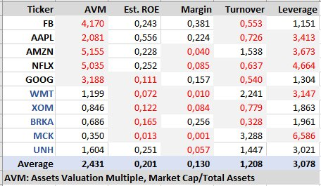

Jean-Marie Choffray @JMChoffray 24 déc. 2018
Back to October 2008? Hope not!

Jean-Marie Choffray @JMChoffray 24 déc. 2018
"If these expectations begin to shift, then we would expect to see more downward pressure on sentiment and spending patterns in early 2019," https://t.co/Hg9YAr1Rfg

Jean-Marie Choffray @JMChoffray 24 déc. 2018
China just announced that it would adopt favorable tariff rates on hundreds of foreign goods next year, https://t.co/AAgfhwnTeD

Jean-Marie Choffray @JMChoffray 24 déc. 2018
No comment... https://t.co/qa7SI18irO

Jean-Marie Choffray @JMChoffray 19 avr. 2018
Exactly one thousand Tweets on the “Art & Science of Investing”! Time to take a rest. To “Shut up, Sit down, and Think…” while enjoying Mozart’s Concerto 21! https://t.co/EAbug1nm71

Jean-Marie Choffray @JMChoffray 19 avr. 2018
Undoubtedly, the most important “Lesson of the Markets”, as enunciated more than one hundred years ago by H. Clews... https://t.co/5aXVLsP40S
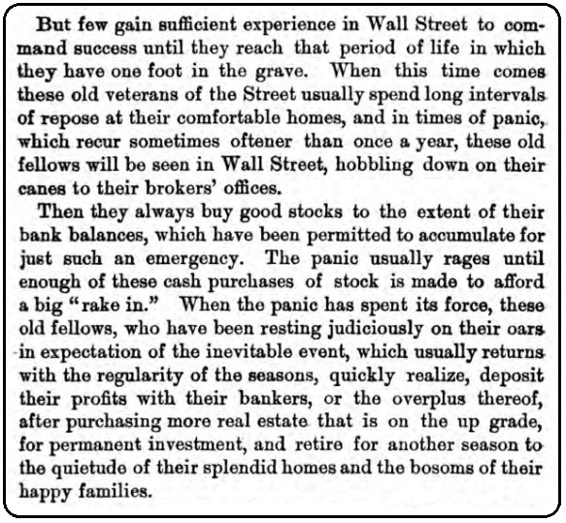

Jean-Marie Choffray @JMChoffray 19 avr. 2018
Seven heuristics to protect assets under adverse (non-parametric) market conditions… (J.M. Choffray & C. Pahud de Mortanges) https://t.co/OH5VPAfFtC
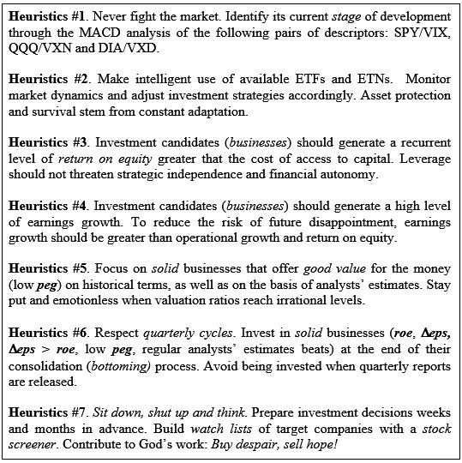

Jean-Marie Choffray @JMChoffray 19 avr. 2018
Stand up and… invest smarter! The markets are waiting for you. It’s only a question of time and intelligent work. “We are what we repeatedly do. Excellence, therefore, is not an act, but a habit.” (W. Durant)

Jean-Marie Choffray @JMChoffray 19 avr. 2018
“Singularity” is the point in time when humans can create machines that are smarter than them. But…, will a machine ever know, as humans do, that they will never know?

Jean-Marie Choffray @JMChoffray 1 févr. 2018
“LIPA & CT business may be enough to improve FCEL's Op_Cost_Flow. Two years is an estimate of the time it will take to achieve positive Op_Cash_Flow. If not, an acquisition by a player with deep pockets and the ability to execute seems likely.” https://t.co/twqpzrD82m

Jean-Marie Choffray @JMChoffray 1 févr. 2018
“Understanding the nature of intelligence stands as one of the great problems in science. AI will soon be a dominant source of new wealth, and therefore a new source of inequality, both between nations and within them.” (L. R. Reif) https://t.co/7cbLmupXxv

Jean-Marie Choffray @JMChoffray 31 janv. 2018
"The recent changes to the U.S. corporate tax rate coupled with smarter regulation create an environment for future capital investments." (D. Woods)

Jean-Marie Choffray @JMChoffray 31 janv. 2018
Beware of the tactics of option and warrant holders who depress the price of a stock by taking advantage of a short sale in anticipation of a decline and convert their options and warrants later.

Jean-Marie Choffray @JMChoffray 30 janv. 2018
"Bubble, Bubble, Fraud and Trouble" (P. Krugman) https://t.co/32adWfvv7q

Jean-Marie Choffray @JMChoffray 29 janv. 2018
"The short-seller’s report contains a number of unsubstantiated forward-looking statements, assumptions and opinions, as well as other statements and assertions that are simply false." https://t.co/TNYU59WHjM

Jean-Marie Choffray @JMChoffray 27 janv. 2018
If confirmed, the theft will be the largest involving digital currency. https://t.co/eQL2HazJFL

Jean-Marie Choffray @JMChoffray 27 janv. 2018
“We are living in a revolutionary period. All our established institutions are in a state of flux and in these circumstances both fallibility and reflexivity are operating at full force.” (G. Soros)

Jean-Marie Choffray @JMChoffray 25 janv. 2018
“Dollar weakness is a hidden tax on people who are holding $-denominated assets and a benefit to those who have $-denominated liabilities.” (R. Dalio)

Jean-Marie Choffray @JMChoffray 25 janv. 2018
$BLCN $BLOK https://t.co/ybzJP00E09

Jean-Marie Choffray @JMChoffray 24 janv. 2018
“A 1.45% 10 year (July 2016) can legitimately be cited as the end of the bond bull market which began at 15.8% in 1981… The diminution of QE check writing and a 5% nominal GDP should be enough to produce higher 10 year Treasury yields (currently ~ 2.62%)” (Bill Gross)

Jean-Marie Choffray @JMChoffray 24 janv. 2018
On the “robustness” of business strategies in a “non-parametric” world... 11/01/17: “Karma is a terrific platform as we further our value proposition with our next-generation drone offerings.” 01/08/18: “GoPro will exit the aerial market after selling its Karma inventory.”

Jean-Marie Choffray @JMChoffray 21 janv. 2018
Certainly true for the markets too... Especially in a world of algorithmic trading! "Young people run fast, but old people know the way." (African proverb quoted by Jorge Bergoglio)

Jean-Marie Choffray @JMChoffray 18 janv. 2018
Hard-learned lesson: on the markets, the “best” decision is most often to avoid making a “bad” one.

Jean-Marie Choffray @JMChoffray 18 janv. 2018
On the relevance of a Nobel Prize for predicting the market's reaction to unexpected political events ... Paul Krugman is the winner of the 2017 Fake News Awards.

Jean-Marie Choffray @JMChoffray 18 janv. 2018
Sound investing requires incorruptible judgment, insensitive to destabilizing rumors and the illusions of crowds.

Jean-Marie Choffray @JMChoffray 18 janv. 2018
Short term price discovery around positive quarterly reporting… late (no?) anticipation, early sell-off. https://t.co/3IOnnC6EYZ
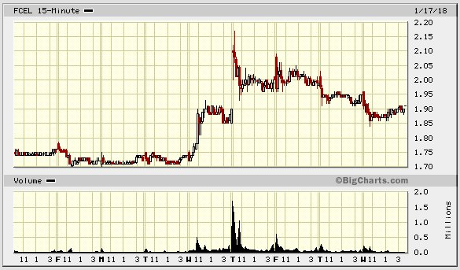

Jean-Marie Choffray @JMChoffray 18 janv. 2018
Easy: uncertainty arises from a lack of certainty; certainty comes from knowledge; knowledge comes from hard work…

Jean-Marie Choffray @JMChoffray 15 janv. 2018
Wake up! Financial markets are waiting for you to help them identify the most promising businesses and finance those whose profitable growth is managed intelligently and responsibly.

Jean-Marie Choffray @JMChoffray 11 janv. 2018
Could FuelcellEnergy (FCEL) be getting out of the woods?

Jean-Marie Choffray @JMChoffray 11 janv. 2018
KodakCoin: the power of dreams...? https://t.co/EeTniBevb5
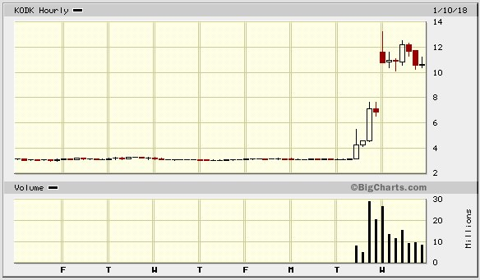

Jean-Marie Choffray @JMChoffray 5 janv. 2018
Market miner or cryptocurrency miner? That is the question!

Jean-Marie Choffray @JMChoffray 4 janv. 2018
Are “unexpected” events unexpected for all? https://t.co/p2RIls6twv

Jean-Marie Choffray @JMChoffray 4 janv. 2018
As democratic forms of government are intrinsically bound to stable ethical values, efficient price formation requires market participants honesty and accountability.

Jean-Marie Choffray @JMChoffray 4 janv. 2018
“The secret of a great fortune without apparent cause is usually a crime that has been properly committed.” (H. de Balzac)

Jean-Marie Choffray @JMChoffray 3 janv. 2018
“God laughs at men who deplore the effects of which they cherish the causes.” (J.-B. Bossuet)

Jean-Marie Choffray @JMChoffray 3 janv. 2018
“When we remember we are all mad, the mysteries disappear and life stands explained.” (Mark Twain) 🤪!

Jean-Marie Choffray @JMChoffray 3 janv. 2018
A few rules worth remembering, even if our world has become more unpredictable than ever… https://t.co/zlJqzlNZE6

Jean-Marie Choffray @JMChoffray 2 janv. 2018
For 2018 and beyond, my strategy is to buy value & growth on breakdowns and to sell dreams & hopes on breakouts. All in less than three months…

Jean-Marie Choffray @JMChoffray 2 janv. 2018
Welcome to a “non-parametric” world, where the predictive power of the past is close to zero!

Jean-Marie Choffray @JMChoffray 12 déc. 2017
"Good luck to all of you seeking your fortune betting on bitcoin's rapid rise or those that cannot wait to profit on its demise. We will gladly own the exchanges, generating pennies per transaction, but hopefully on millions of transactions." $GBTC $COIN https://t.co/uQuQqZ1501

Jean-Marie Choffray @JMChoffray 10 déc. 2017
"So much of the investment business is show business: analysts in fancy suits, in elegant office suites, sporting fancy graphs and charts, and the folks in the audience who... want to believe that somebody knows what will happen." https://t.co/iSE7q6Lq4t

Jean-Marie Choffray @JMChoffray 31 août 2017
By far the hardest part of investing is to learn to sit down, shut up, think, and concentrate on short-term asset growth.

Jean-Marie Choffray @JMChoffray 31 août 2017
“All intelligent (wise) thoughts have already been thought. What is necessary is only to try to think them again.” (Goethe)

Jean-Marie Choffray @JMChoffray 31 août 2017
“Work – invest? – while you have the light.” (Multiple sources)

Jean-Marie Choffray @JMChoffray 31 août 2017
Financial markets regularly remind investors how little they know about what they believe they know.

Jean-Marie Choffray @JMChoffray 25 août 2017
This is not the actual “story” of a business that matters, but “how” it ignites and nurtures the imagination of investors!

Jean-Marie Choffray @JMChoffray 23 août 2017
Investors are just like professors. They are paid to do “nothing”: read, think, coach, evaluate, reward… sanction!

Jean-Marie Choffray @JMChoffray 23 août 2017
As in the academic world, on the markets, it’s always comforting to be considered a fool by some idiots ;-)!

Jean-Marie Choffray @JMChoffray 23 août 2017
Most philosophers have little doubt as to the influence of the “future” on the “past” and the “present” (reflexivity?)

Jean-Marie Choffray @JMChoffray 23 août 2017
The defects of free markets are preferable to the qualities of centralized planning…

Jean-Marie Choffray @JMChoffray 23 août 2017
As an investor, the problem is not so much to "succeed" as to "deserve" to succeed!

Jean-Marie Choffray @JMChoffray 22 août 2017
It’s impossible to invest wisely without learning to fail intelligently and without working consistently towards your goals!

Jean-Marie Choffray @JMChoffray 22 août 2017
Markets are to economics what democracy is to politics: a bottom-up process to delegate and control decision-making.

Jean-Marie Choffray @JMChoffray 22 août 2017
The PRESENT (value) of a business is an unknown function of its PAST (fundamentals) AND of its FUTURE (ambition).

Jean-Marie Choffray @JMChoffray 20 août 2017
A simple truth… You start losing money in the markets by the minute you have a doubt as to your ability to beat them.

Jean-Marie Choffray @JMChoffray 20 août 2017
“Crises come from a fall in certainty.” (J. Guitton)

Jean-Marie Choffray @JMChoffray 19 août 2017
During periods of political hysteria, financial markets remain one of the last indicators of public sanity.

Jean-Marie Choffray @JMChoffray 19 août 2017
MACD (S&P 500 Index): Searching for an exit? https://t.co/RiH9KGAOwd
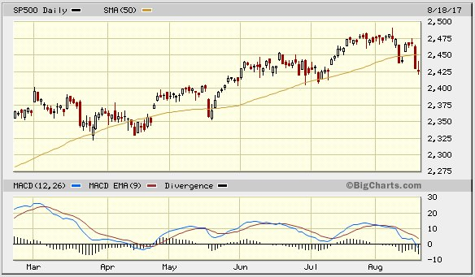

Jean-Marie Choffray @JMChoffray 19 août 2017
MACD (VIX Index): Warning sign of storm? https://t.co/X8RvjUqdva
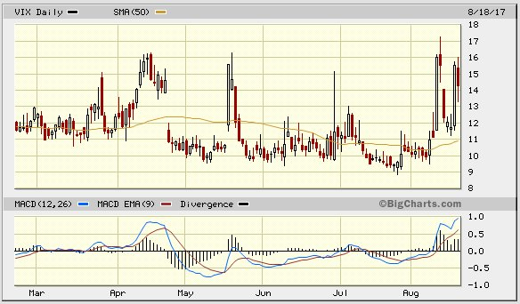

Jean-Marie Choffray @JMChoffray 19 août 2017
Business fundamentals can be ignored for a while, but the consequences of ignoring fundamentals can never be avoided.

Jean-Marie Choffray @JMChoffray 18 août 2017
“Difficult times attract a man of character, for it is by confronting them that he realizes himself.” (Ch. de Gaulle)

Jean-Marie Choffray @JMChoffray 17 août 2017
As any non-deterministic process degenerates over time, what is gained in the market will ultimately be lost.

Jean-Marie Choffray @JMChoffray 15 août 2017
Market prices provide as efficient a valuation as possible of fundamentals (reality) AND hopes (dreams).

Jean-Marie Choffray @JMChoffray 15 août 2017
If faith is the substance of hope, market prices are an act of faith :-)!

Jean-Marie Choffray @JMChoffray 13 août 2017
What if “Black Swans” were only scapegoats intended to cover investor incompetence?

Jean-Marie Choffray @JMChoffray 13 août 2017
For the game to continue, you need a few participants who earn a lot of money from time to time, randomly.

Jean-Marie Choffray @JMChoffray 10 août 2017
What is not in the news is what really matters.

Jean-Marie Choffray @JMChoffray 8 août 2017
Better than passive investments… “White Swans”, businesses that offer credible stories (dreams?) of profitable growth. https://t.co/H6E3SJd8kq
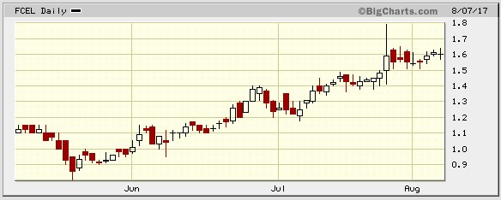

Jean-Marie Choffray @JMChoffray 8 août 2017
On the markets, only fools, thieves and swindlers believe they know the future with some degree of certainty.

Jean-Marie Choffray @JMChoffray 5 août 2017
“Everyone has a plan until they get punched in the face.” (M. Tyson) https://t.co/uajUx7TR8I
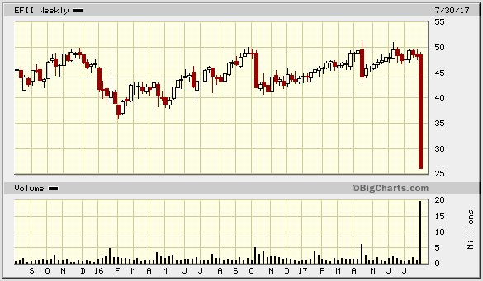

Jean-Marie Choffray @JMChoffray 5 août 2017
$1T from active to passive funds in 18 months. “Passive investing and its apparent stability, is unsustainable and brittle.” (P. Singer)

Jean-Marie Choffray @JMChoffray 5 août 2017
Crisis of truth? “Political correctness requires to silence it, to deny by omission what one sees.” (R. Halévi)

Jean-Marie Choffray @JMChoffray 1 août 2017
When markets are out of control, concentrate on what you control: short-term (quarterly) performance.

Jean-Marie Choffray @JMChoffray 1 août 2017
“When a true genius appears in this world…, the dunces are all in confederacy against him.” (J. Swift)

Jean-Marie Choffray @JMChoffray 30 juil. 2017
Catches of the weekend… Anything of value here? I bet. https://t.co/qNTxcceOcj
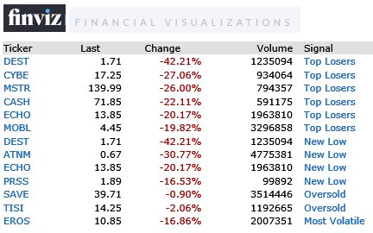
0 1
Voir sur Twitter
Jean-Marie Choffray @JMChoffray 29 juil. 2017
As simple as the “Art & Science” of strategic management gets :-)! https://t.co/bnMHYQc2Qj
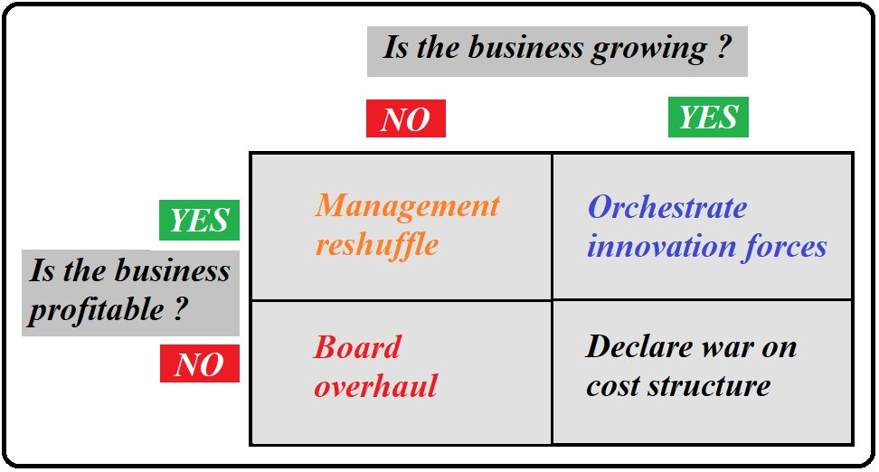

Jean-Marie Choffray @JMChoffray 26 juil. 2017
Probably as true today as it was then… https://t.co/VmT2NcPmnS
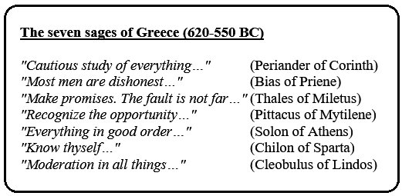

Jean-Marie Choffray @JMChoffray 22 juil. 2017
VIX: CBOE Volatility Index (INDEX)… Outlier? https://t.co/9mAdlFsYpa
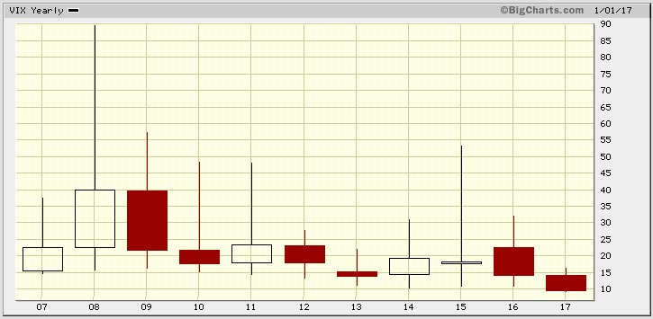

Jean-Marie Choffray @JMChoffray 30 mars 2017
The lesson of recent elections is that traditional political parties are no longer able to generate skilled and respectable candidates.

Jean-Marie Choffray @JMChoffray 22 mars 2017
Welcome to the desert of the markets, where businesses are playthings for bigger forces.

Jean-Marie Choffray @JMChoffray 18 mars 2017
"DON’T LOSE IT… Our levered financial system (~350% of GDP) is like a truckload of nitro glycerin on a bumpy road.” https://t.co/JtHnuPFL2X

Jean-Marie Choffray @JMChoffray 26 févr. 2017
In 2016 again, leverage included, “blind” monkeys did beat ukulele players… 🙂!

Jean-Marie Choffray @JMChoffray 22 févr. 2017
Beware! The most critical lesson that I learned was perfectly stated by H. Clews, more than one hundred years ago. https://t.co/kraZ77QqPg

Jean-Marie Choffray @JMChoffray 22 févr. 2017
Aside from leverage, smart & hard work is obviously not the only way to succeed as an investor. https://t.co/cZ1neYiLA4

Jean-Marie Choffray @JMChoffray 22 févr. 2017
Experts often tend to hide their ignorance behind formal or analytical jargon.

Jean-Marie Choffray @JMChoffray 22 févr. 2017
History teaches that power (wealth?) usually rests upon lies and is preserved through some form of corruption.

Jean-Marie Choffray @JMChoffray 21 févr. 2017
“The major benefits of mergers and acquisitions appear to accrue financially to corporate insiders, bankers, and consultants.” (S. Das)

Jean-Marie Choffray @JMChoffray 21 févr. 2017
"Nothing has changed since 2008. Financial engineering masks the true performance & health of companies & nations." https://t.co/Boh3WVj0k5

Jean-Marie Choffray @JMChoffray 21 févr. 2017
Crude oil prices > $50/b & increasing rig counts in several onshore basins, suggest U.S. production will likely continue to increase. https://t.co/x2pQZjGbqa
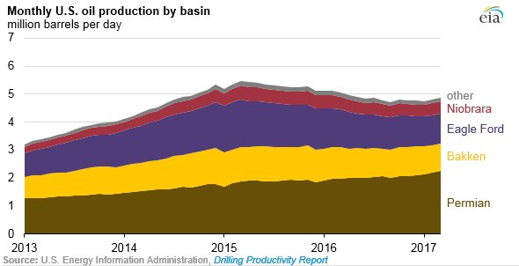

Jean-Marie Choffray @JMChoffray 21 févr. 2017
U.S. crude oil production averaged an estimated 8.9 million barrels per day (b/d) in 2016. https://t.co/Ou7Zi7LoTV https://t.co/Bq4rHQfMBU
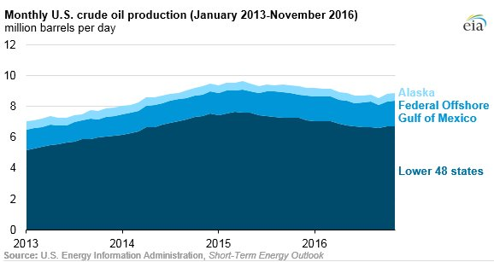

Jean-Marie Choffray @JMChoffray 21 févr. 2017
CYH: When the market attention switches from this quarter “Known unknown” to next quarter “Unknown known”… https://t.co/liAKFgiMwA
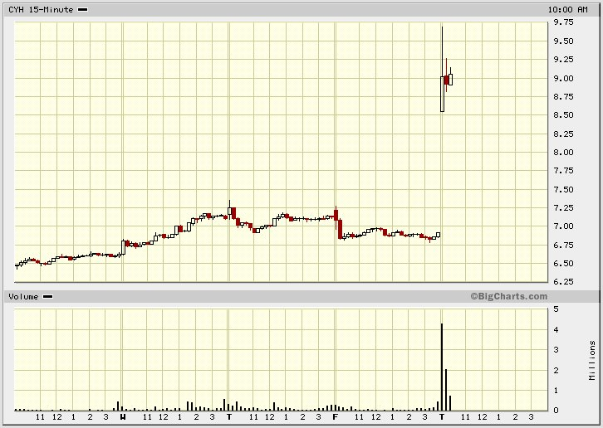

Jean-Marie Choffray @JMChoffray 21 févr. 2017
I know you believe you understand financial statements, but I am not sure you realize that those who produce them usually don’t.

Jean-Marie Choffray @JMChoffray 21 févr. 2017
Watch out for “Unknown unknowns”! Facts and events that can only be recognized after they have happened. https://t.co/4rqmoQiiuW

Jean-Marie Choffray @JMChoffray 21 févr. 2017
Financial history repeats itself, first as a tragedy (crash/meltdown), second as a comedy (bubble/run-up).

Jean-Marie Choffray @JMChoffray 21 févr. 2017
Under “normal” conditions, markets regularly cycle through four stages, corresponding to different risk conditions that require adaptation. https://t.co/6gYH9jrscE
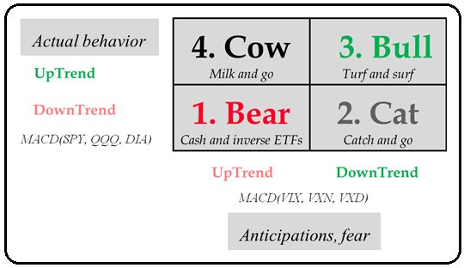

Jean-Marie Choffray @JMChoffray 21 févr. 2017
Even a cursory knowledge of history reminds us that unpredictable, impossible, and unthinkable events can happen anytime.

Jean-Marie Choffray @JMChoffray 21 févr. 2017
As most investors learn the hard way, it’s much, much, harder to stay wealthy than to get wealthy.

Jean-Marie Choffray @JMChoffray 20 févr. 2017
In this case again, the market valuation was completely wrong... As to who is right: KHC or UL? Your guess! https://t.co/Ti2b2JNcAJ

Jean-Marie Choffray @JMChoffray 19 févr. 2017
US share of solar PV shipments (2015: 2% vs 1995: 40%). Today, China, Malaysia, Mexico & Singapore > 70% of the US market.

Jean-Marie Choffray @JMChoffray 19 févr. 2017
Demography and full employment might constrain US future growth to <= 2%, unless… driverless or flying cars happen! https://t.co/yW6kfM59FT

Jean-Marie Choffray @JMChoffray 18 févr. 2017
Mass production of lower-cost fuel cell systems for FCVs is expected to begin around 2020. https://t.co/K4eSPK42iK

Jean-Marie Choffray @JMChoffray 18 févr. 2017
Bipartisan bill seeks to restore parity in the tax code for fuel cells and other technologies. https://t.co/GLJ2GGJSGq

Jean-Marie Choffray @JMChoffray 18 févr. 2017
VP Mike Pence said the U.S. would be "unwavering" in its commitment to trans-Atlantic institutions like NATO. https://t.co/izz4KvaOzO

Jean-Marie Choffray @JMChoffray 18 févr. 2017
Household debt balance. https://t.co/ctJgHNEt4u

Jean-Marie Choffray @JMChoffray 18 févr. 2017
In the current political maelstrom, the truth is inevitably where most people don’t want to see it.

Jean-Marie Choffray @JMChoffray 18 févr. 2017
As most of the time, isn’t the answer in the question? https://t.co/ZuGXeCLWeg

Jean-Marie Choffray @JMChoffray 17 févr. 2017
Beware! If your telephone doesn’t ring…, it’s probably an investor. (And, quite certainly, me!)

Jean-Marie Choffray @JMChoffray 8 févr. 2017
“Speculation brings into play the best intelligence as to the future of value.” (H. Clews)

Jean-Marie Choffray @JMChoffray 8 févr. 2017
People – experts? – hate to learn that you know that they don’t know!

Jean-Marie Choffray @JMChoffray 7 févr. 2017
“The best way to shun danger is to meet it half way.” (Sir Boyle Roche)

Jean-Marie Choffray @JMChoffray 7 févr. 2017
“No great business can be built up except upon honest and moral principles.” (H. Clews)

Jean-Marie Choffray @JMChoffray 7 févr. 2017
“Making money becomes a matter of calculation, depending on the number of squalls that may occur during any particular year.” (H. Clews)

Jean-Marie Choffray @JMChoffray 7 févr. 2017
In a “Non-Parametric” world… “No past event has any intrinsic importance.” (Lord Macaulay)

Jean-Marie Choffray @JMChoffray 7 févr. 2017
“This company owns probably 90% of the intellectual property in the fuel cell industry in the world.” (C. Bottone) https://t.co/zvS8loOf0n

Jean-Marie Choffray @JMChoffray 7 févr. 2017
The law of unintended consequences is a powerful determinant of history… Hence, of asset valuation too!

Jean-Marie Choffray @JMChoffray 7 févr. 2017
In today’s world, investing is not for the faint of heart. It’s all about turning CHAOS into GOLD 😋!

Jean-Marie Choffray @JMChoffray 7 févr. 2017
In the "new paranormal", fundamentals have zero impact on asset prices. Only central bank balance sheets matter. https://t.co/75bEoyvtuj

Jean-Marie Choffray @JMChoffray 7 févr. 2017
Hedge funds underperform the market (12%), which is managed by central banks, does not request "2-20", and has no min capital requirements. https://t.co/0E1GCRdn7k
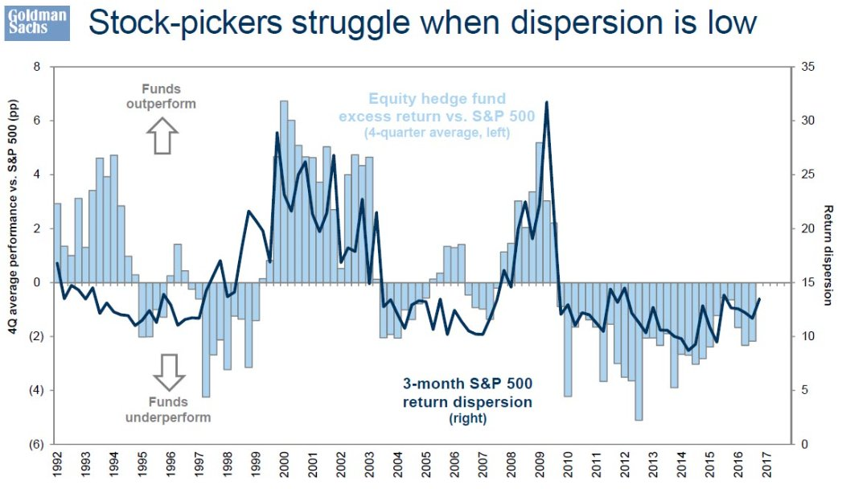

Jean-Marie Choffray @JMChoffray 6 févr. 2017
“ECB & BOJ are buying $150B a month of their own bonds. Much of that flows from 10 BP JGB's and 45 BP Bunds into 2.45% U.S. 10Y.” (B. Gross)

Jean-Marie Choffray @JMChoffray 6 févr. 2017
“A $12T global central bank balance sheet is PERMANENT - and growing at over $1T a year, thanks to the ECB and the BOJ.” (B. Gross)

Jean-Marie Choffray @JMChoffray 6 févr. 2017
The expansion of central bank balance sheets from $2T in 2003 to $12T at the end of 2016 is remarkable. https://t.co/JtHnuPXlUv

Jean-Marie Choffray @JMChoffray 5 févr. 2017
Protecting Assets Under Non-Parametric Market Conditions. https://t.co/uLMwHuS1sN https://t.co/KqncmI2oSt
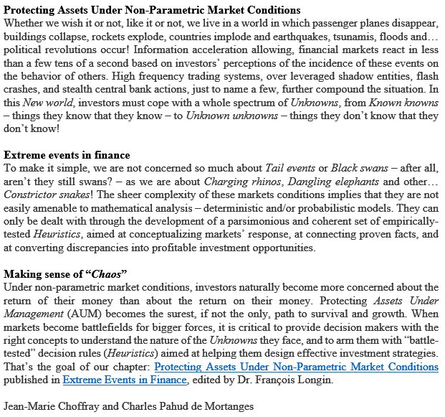

Jean-Marie Choffray @JMChoffray 5 févr. 2017
Global electricity demand will rise 60% by 2040. https://t.co/yklg7X8DF4

Jean-Marie Choffray @JMChoffray 1 févr. 2017
Is this a smell of inflation? https://t.co/0YYN6UvEFm
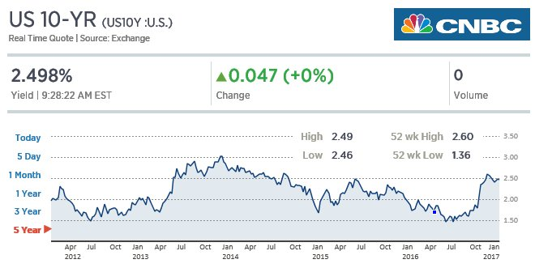

Jean-Marie Choffray @JMChoffray 1 févr. 2017
“Euro-area sovereign debt handed a 2.1 % loss in January, the worst start to a year in data going back to 1998.” https://t.co/qN1d235ZCE

Jean-Marie Choffray @JMChoffray 1 févr. 2017
“Times of panic recur oftener than once a year… with the regularity of the seasons…” (Henry Clews)

Jean-Marie Choffray @JMChoffray 1 févr. 2017
Any religion that denounces and renounces violence is potentially credible and useful.

Jean-Marie Choffray @JMChoffray 1 févr. 2017
Under stress conditions, refer to history... “The farther back you can look, the farther forward you are likely to see.” (Winston Churchill)

Jean-Marie Choffray @JMChoffray 31 janv. 2017
“We need to imagine a shared future together, if we hope to have one.” L. Rafael Reif, MIT

Jean-Marie Choffray @JMChoffray 7 oct. 2016
« But my words like silent raindrops fell / And echoed in the wells of silence. » (Paul Simon) https://t.co/AKSkElHSjb

Jean-Marie Choffray @JMChoffray 7 oct. 2016
When you have seen what I have seen. When you have learned what I have learned. You think what I think, and stay silent!

Jean-Marie Choffray @JMChoffray 7 oct. 2016
Investing is neither a Science, nor an Art… It’s a very painful lesson of humility!

Jean-Marie Choffray @JMChoffray 7 oct. 2016
One life. Two shots... Make the second count!

Jean-Marie Choffray @JMChoffray 7 oct. 2016
Protecting assets, against all “extreme events”, is the key to success. https://t.co/j9uuf4sSQJ

Jean-Marie Choffray @JMChoffray 7 oct. 2016
Financial markets don’t lie. Never. That’s why people – leaders of all sorts – hate them!

Jean-Marie Choffray @JMChoffray 7 oct. 2016
The best way to avoid my mistakes is probably to study them! https://t.co/UhYjuV2gGp

Jean-Marie Choffray @JMChoffray 23 sept. 2016
BOJ expands monetary base until inflation rate > 2% & targets the ten-year JGB yield… https://t.co/ZAJr4YaqSL

Jean-Marie Choffray @JMChoffray 23 sept. 2016
Commercial paper outstanding drops... https://t.co/6AUxRrjrLI

Jean-Marie Choffray @JMChoffray 23 sept. 2016
FRBNY Nowcast pushed down 0.5 percentage point for both Q3 and Q4. https://t.co/Nwa6kPMDLW

Jean-Marie Choffray @JMChoffray 23 sept. 2016
Total capacity of natural gas microturbines grows by 8%/year and total capacity of fuel cells grows by 7%/year. https://t.co/7q4TrIC6zT

Jean-Marie Choffray @JMChoffray 23 sept. 2016
Proposed new requirements and limitations on the physical commodity activities of financial holding companies. https://t.co/nNNsZ0rpFO

Jean-Marie Choffray @JMChoffray 23 sept. 2016
TWTR: Analyst downgrade, but... buyout speculation!

Jean-Marie Choffray @JMChoffray 23 sept. 2016
A drone is the most efficient way to deliver a package in a medical emergency in a remote location. https://t.co/NBLIXdMv7g

Jean-Marie Choffray @JMChoffray 23 sept. 2016
And the winner is… coal! https://t.co/rwsV4fWx2H https://t.co/1FSra5oDQD
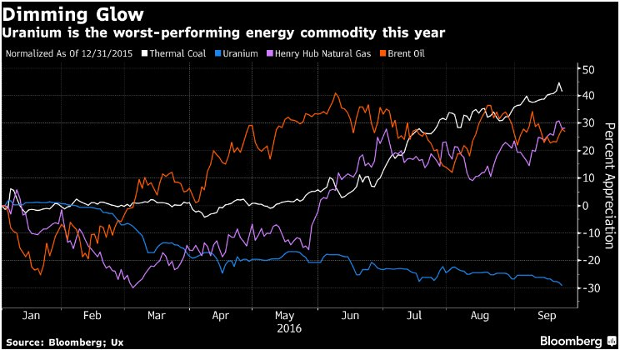

Jean-Marie Choffray @JMChoffray 22 sept. 2016
You can’t fight central banks… https://t.co/CkA0sX8wqB https://t.co/UQ2VHCxoAp
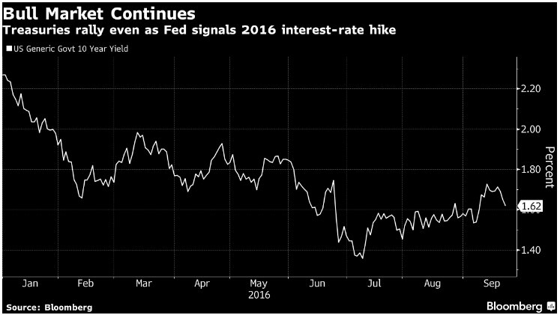

Jean-Marie Choffray @JMChoffray 22 sept. 2016
VIX slammed to 12… https://t.co/50lt24x2bx
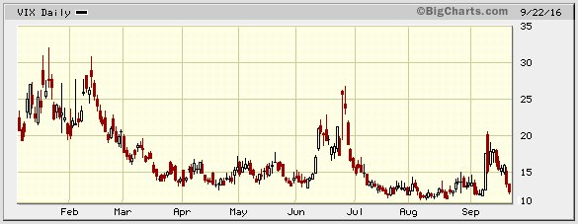

Jean-Marie Choffray @JMChoffray 22 sept. 2016
ECB handed 45.3 B euros ($51 B) to euro-area lenders at a zero interest rate. (Maturity date:30/09/2020) https://t.co/6J2I5npWoS

Jean-Marie Choffray @JMChoffray 22 sept. 2016
Permian basin rig count https://t.co/i36M19rRtr

Jean-Marie Choffray @JMChoffray 22 sept. 2016
Summary of economic projections https://t.co/4UNLPISzmP https://t.co/oeqfi7i38L
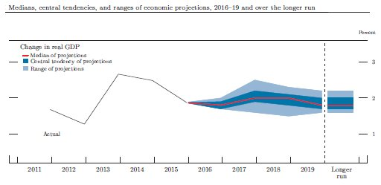

Jean-Marie Choffray @JMChoffray 21 sept. 2016
Committee decided to maintain the target range for the federal funds rate at 1/4 to 1/2 percent. https://t.co/uQFEp68ytL

Jean-Marie Choffray @JMChoffray 20 sept. 2016
Warren Says Wells Fargo's Stumpf Should Resign, Face Criminal Investigation https://t.co/l5KBUZjOht via @markets

Jean-Marie Choffray @JMChoffray 20 sept. 2016
WFC: "... We failed to fulfill our responsibility to our customers, to our team members, and to the American public." (John Stumpf)

Jean-Marie Choffray @JMChoffray 20 sept. 2016
DB: There's a 30 percent probability that the U.S. will succumb to a recession over the next 12 months. https://t.co/okE4xeedud https://t.co/f3MFY86RyM
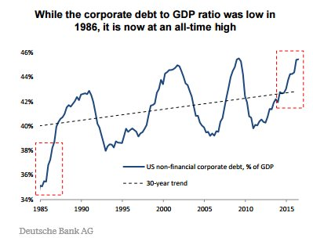

Jean-Marie Choffray @JMChoffray 19 sept. 2016
Will the Tesla-SolarCity deal be delayed by shareholder suits?

Jean-Marie Choffray @JMChoffray 19 sept. 2016
Right time to lever up? https://t.co/4lF3wxfFMA

Jean-Marie Choffray @JMChoffray 19 sept. 2016
DB: Black swan song? https://t.co/1IkM62mbi1
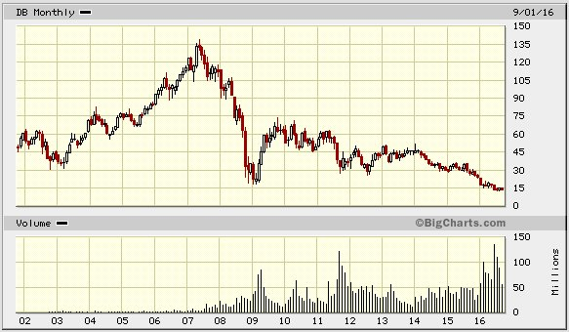

Jean-Marie Choffray @JMChoffray 19 sept. 2016
Was WFC experimenting with virtual reality? More than 2 million unauthorized accounts… https://t.co/LlB1LZmms7

Jean-Marie Choffray @JMChoffray 19 sept. 2016
Bentley, Lamborghini, Aston Martin… skip Paris show amid cost-cutting drive.

Jean-Marie Choffray @JMChoffray 18 sept. 2016
But… the lesser of two evils (negative rates vs higher inflation) is still evil !

Jean-Marie Choffray @JMChoffray 18 sept. 2016
Negative rates and higher inflation targets are alternative methods for pushing the real interest rate further below zero. (Ben Bernanke)

Jean-Marie Choffray @JMChoffray 18 sept. 2016
If central bk could count on fiscal policy to share the burden of stabilizing the economy during the next recession? https://t.co/6hS0Y9raCN

Jean-Marie Choffray @JMChoffray 18 sept. 2016
“The FOMC’s plan to return to a pre-2008 balance sheet needs more thought.” (Ben Bernanke) https://t.co/eWivldZF5Y https://t.co/rMQzZ0M7xE
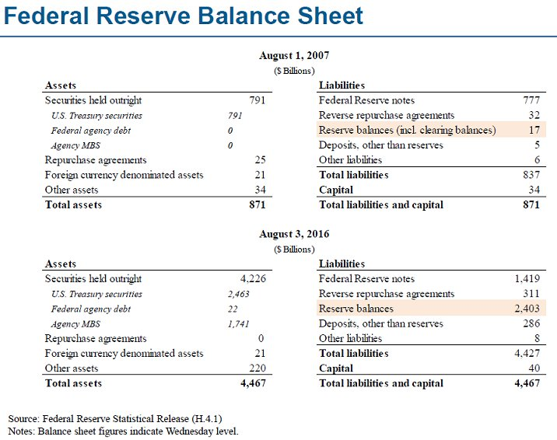

Jean-Marie Choffray @JMChoffray 18 sept. 2016
“It is the worst economic and political environment that I’ve ever been remotely related to,” (Alan Greenspan) https://t.co/qzXaDcCo0e

Jean-Marie Choffray @JMChoffray 14 sept. 2016
Ce que je ne savais pas… que je ne savais pas ! https://t.co/sQxpwUQdoj https://t.co/Bsc34nRdzd

Jean-Marie Choffray @JMChoffray 10 sept. 2016
FCEL: Q4 revenue guidance ($56 - $86 M) & cash flow positive... https://t.co/Em1omJqKzF

Jean-Marie Choffray @JMChoffray 10 sept. 2016
Leverage soars to new heights. https://t.co/dTbgwGjmzo https://t.co/wBWYhEYGHv
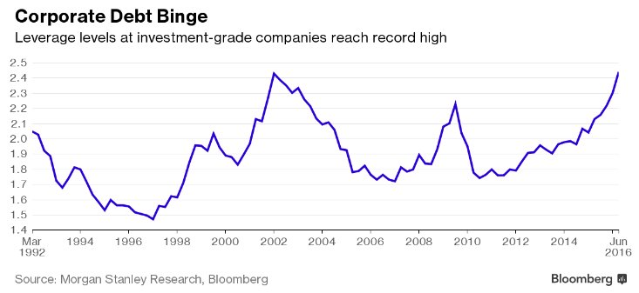

Jean-Marie Choffray @JMChoffray 10 sept. 2016
Despite the mistrust and attempts to disrupt what was agreed upon…, Russia and the US have agreed on a new ceasefire plan on Syria.

Jean-Marie Choffray @JMChoffray 10 sept. 2016
Another victim of the monkey! https://t.co/MBTqugSy9V

Jean-Marie Choffray @JMChoffray 8 sept. 2016
ECB interest rates to remain at present or lower levels for an extended period of time. https://t.co/D7az2sHjhg

Jean-Marie Choffray @JMChoffray 8 sept. 2016
ONVO: Begins commercial contracting for its second tissue service, the ExViveTM Human Kidney. https://t.co/Lvxl5o8JEQ

Jean-Marie Choffray @JMChoffray 8 sept. 2016
FCEL: Earnings miss. Choppy times ahead. But… strategic change! https://t.co/izPxiMLnD2 https://t.co/n8BFTOLAdn
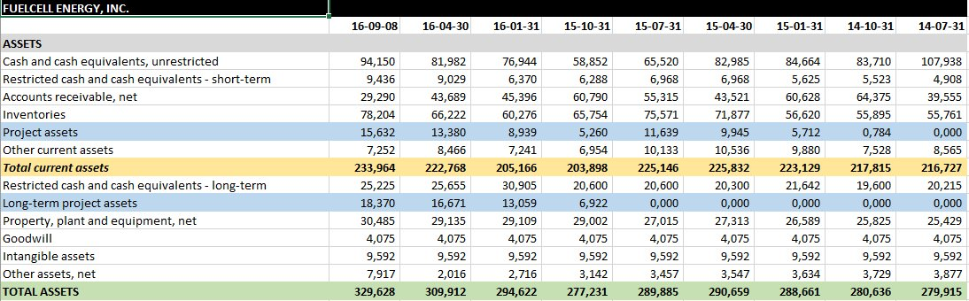

Jean-Marie Choffray @JMChoffray 6 sept. 2016
And…, the winner is the monkey! https://t.co/9DOnZTLi5b https://t.co/w1w9YiK4RC
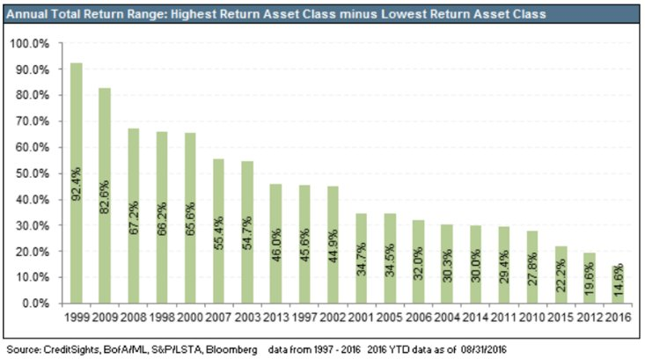

Jean-Marie Choffray @JMChoffray 6 sept. 2016
GE is offering ~10x revenues to acquire European 3D-printing businesses. https://t.co/1DZlFvSpHD

Jean-Marie Choffray @JMChoffray 6 sept. 2016
Most European banks not able to rely on retained earnings nor on raising capital to meet new capital rules. https://t.co/hJ9SRhu9PY

Jean-Marie Choffray @JMChoffray 4 sept. 2016
“The answer is blowin' in the wind.” https://t.co/HdPCPnbLRq

Jean-Marie Choffray @JMChoffray 4 sept. 2016
Plain and simple. The only way to boost productivity is to work longer, harder, smarter. Most people won’t like it!

Jean-Marie Choffray @JMChoffray 4 sept. 2016
The final choice: lower standard of living vs higher standards of education?

Jean-Marie Choffray @JMChoffray 4 sept. 2016
If governments, independent of their political inclination, accept to pay people to do nothing, they will be amazed at how well they do it.

Jean-Marie Choffray @JMChoffray 4 sept. 2016
According to my estimates, current monetary policy amounts to ($3T-$4T/yr.) in asset (capital) destruction. It won’t last!

Jean-Marie Choffray @JMChoffray 2 sept. 2016
A glimmer of hope… https://t.co/9rWATkqYDz

Jean-Marie Choffray @JMChoffray 1 sept. 2016
“Right now you have to find information on the market through rumors and various angles…” https://t.co/TVBGnd8QVx

Jean-Marie Choffray @JMChoffray 1 sept. 2016
CLNE: https://t.co/nFMN48f9yk

Jean-Marie Choffray @JMChoffray 1 sept. 2016
When the time comes, central banks will make perfect scapegoats.

Jean-Marie Choffray @JMChoffray 1 sept. 2016
100 years of clean energy. https://t.co/K8PDGQpKIj

Jean-Marie Choffray @JMChoffray 1 sept. 2016
CPST: Hard work isn’t usually enough to buy you a hole in one. https://t.co/hIWeEeAWew

Jean-Marie Choffray @JMChoffray 1 sept. 2016
And… NIRP deflationary impact is necessarily magnified by leverage -:)!

Jean-Marie Choffray @JMChoffray 1 sept. 2016
$11 trillion of negative yielding bonds are not assets. They are liabilities. https://t.co/JtHnuPXlUv

Jean-Marie Choffray @JMChoffray 28 août 2016
WFE (World Federation of Exchanges): H1 2016 Market Highlights https://t.co/hLgzN0pDrs https://t.co/PL7ksGwQ3p
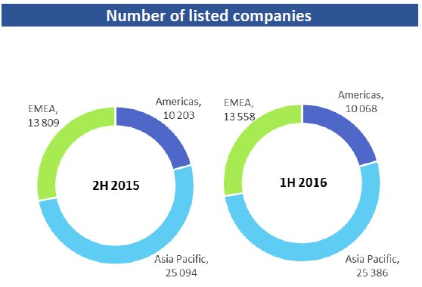

Jean-Marie Choffray @JMChoffray 28 août 2016
A look at a wider picture. https://t.co/EqrCJM1WYx

Jean-Marie Choffray @JMChoffray 28 août 2016
Recent evolution of GDP. https://t.co/OI8fSIiwoO

Jean-Marie Choffray @JMChoffray 28 août 2016
“The lesson of history is that most people don’t learn the lesson of history.” (J. Rogers)

Jean-Marie Choffray @JMChoffray 27 août 2016
At the moment, monetary policy badly needs an assist from fiscal expansion. https://t.co/xtUR6ZMTXy

Jean-Marie Choffray @JMChoffray 27 août 2016
Recent evolution of “Long-run” or “Steady-state” economic conditions. https://t.co/qQuPEo1Qne https://t.co/PBdgUTfBPe
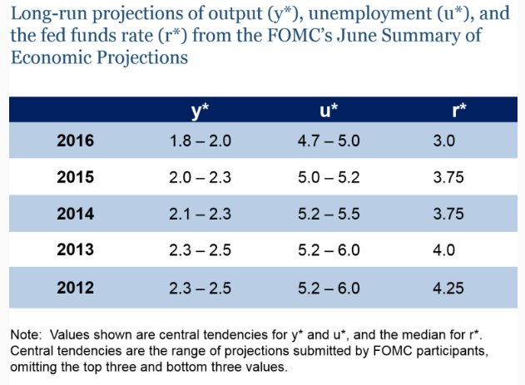

Jean-Marie Choffray @JMChoffray 27 août 2016
People feel about the economy more or less as they have in the past at a similar stage of the business cycle. https://t.co/VetIy67fgj

Jean-Marie Choffray @JMChoffray 27 août 2016
Political self-assertion + delayed outrage & grief is a powerful force that is now surfacing, thirsting for revenge… https://t.co/8RYq25IKKt

Jean-Marie Choffray @JMChoffray 27 août 2016
One of them… Probably both… Must be lying! https://t.co/XMHPyRldTb

Jean-Marie Choffray @JMChoffray 19 août 2016
But, isn’t being right too early... being wrong? https://t.co/srwj6VmP7k https://t.co/0ghvkdBdhq
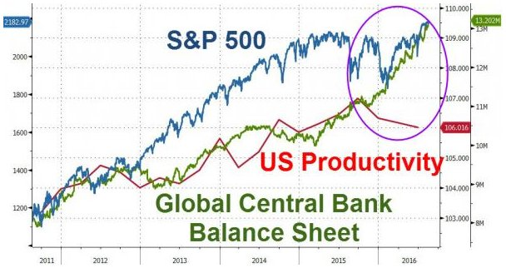

Jean-Marie Choffray @JMChoffray 19 août 2016
The art of the speech... https://t.co/DoPPHeOH6k https://t.co/vnrZLd98mm
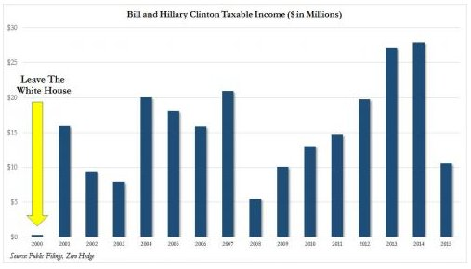

Jean-Marie Choffray @JMChoffray 17 août 2016
Fuel cells could be a fundamental shift in carbon capture because they trap the gas while generating electricity... https://t.co/wVQs8G3UTU

Jean-Marie Choffray @JMChoffray 17 août 2016
Tri-generation fuel cells exceeding expectations... https://t.co/yD7pfkKbzW

Jean-Marie Choffray @JMChoffray 17 août 2016
Greatest experiment in monetary policy in history… Impossible to predict unintended consequences... https://t.co/fPXs1DAWmt

Jean-Marie Choffray @JMChoffray 17 août 2016
New fuel-efficiency standards for trucks... https://t.co/thWePdaVfQ

Jean-Marie Choffray @JMChoffray 15 août 2016
Brexit: Some pound the pound… https://t.co/UQRCUfYGXr

Jean-Marie Choffray @JMChoffray 15 août 2016
Are some ETFs contributing to the reflexivity of their underlying indices? https://t.co/AgmoZTBVpm

Jean-Marie Choffray @JMChoffray 11 août 2016
The art of the steal… https://t.co/CLH2NDHYDX https://t.co/PQ0kJ3zQry
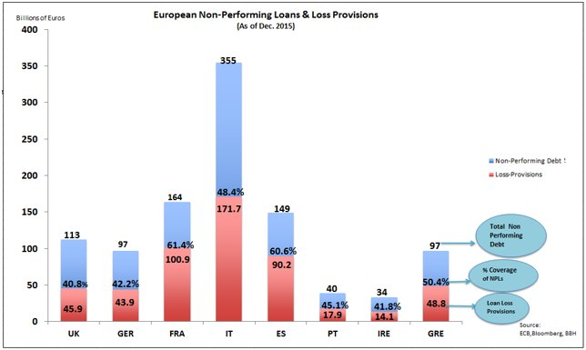

Jean-Marie Choffray @JMChoffray 11 août 2016
The model is wrong...Let's change the data :-)!

Jean-Marie Choffray @JMChoffray 10 août 2016
The greater fool theory… https://t.co/HYuctGlB3y https://t.co/Qj9NS0XGm0
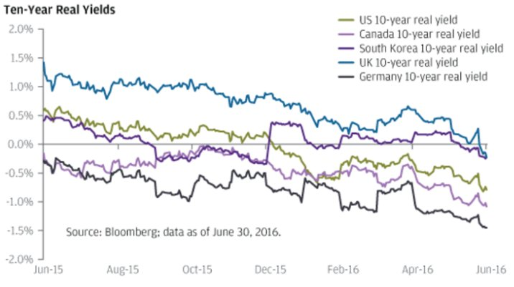

Jean-Marie Choffray @JMChoffray 9 août 2016
Productivity down… Cost inflation up? https://t.co/6Dk2Fx6JmR https://t.co/eb0ZaDLike
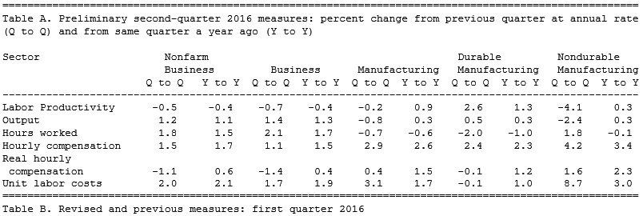

Jean-Marie Choffray @JMChoffray 9 août 2016
A reality slap… https://t.co/C74lwggiNL

Jean-Marie Choffray @JMChoffray 5 août 2016
Paradigm shift? https://t.co/mSLVpjYN23 https://t.co/rxa9SSTrtV
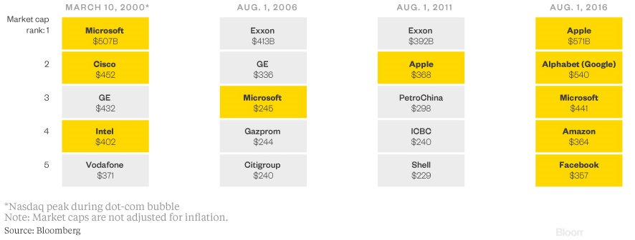

Jean-Marie Choffray @JMChoffray 4 août 2016
Bank of England cuts Bank Rate to 0.25% and increases the total stock of asset purchases to £435 billion. https://t.co/g9NzahV5rY

Jean-Marie Choffray @JMChoffray 4 août 2016
“She's made a lot of dough out of being a politician.... I'm sure that R. Reagan gave up dough to be a politician.” https://t.co/H40S1aPeKp

Jean-Marie Choffray @JMChoffray 3 août 2016
Plain and simple! PRINT (perpetual rolling of debt…) or WORK (3-4% nominal GDP growth…)? https://t.co/isPWEgvq8e

Jean-Marie Choffray @JMChoffray 2 août 2016
MSFT raises $19.75 billion through a senior unsecured notes offering. https://t.co/uxlx4Qk9QI

Jean-Marie Choffray @JMChoffray 2 août 2016
Japan hopes to spend its way ($274 billion ~5% of GDP!) to growth... https://t.co/64QCNaYyWA

Jean-Marie Choffray @JMChoffray 1 août 2016
BRK.A : (2.262 * 1.097) – 1.262 = 1.219 > 1.192 or 1.208… It’s the leverage stupid !

Jean-Marie Choffray @JMChoffray 1 août 2016
« L’esprit est trop étroit pour se contenir lui-même… » (Augustin d'Hippone)

Jean-Marie Choffray @JMChoffray 1 août 2016
Nietzsche: “God is dead !” God: “Nietzsche is dead !” Who’s right ?

Jean-Marie Choffray @JMChoffray 30 juil. 2016
De la crise à l’entreprise, en passant par vous… https://t.co/Jfqofyp3ku https://t.co/OI6YWTxm04
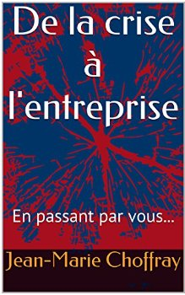

Jean-Marie Choffray @JMChoffray 30 juil. 2016
It’s hard to be wrong when… you are right! https://t.co/24PwqlyWgD

Jean-Marie Choffray @JMChoffray 30 juil. 2016
“When global deflation takes hold, as it has, all interest rates fall, but the spread doesn't.” (A. Greenspan) https://t.co/WTA3uUNapm

Jean-Marie Choffray @JMChoffray 26 juil. 2016
Do earnings persist more than wealth? https://t.co/ftjMXXGlPT

Jean-Marie Choffray @JMChoffray 26 juil. 2016
BNSF used to transport 12 trains daily filled with crude from North Dakota. Now it is down to about five a day. https://t.co/3LtIhSOdJq

Jean-Marie Choffray @JMChoffray 26 juil. 2016
Rajan has often said that central banks are under too much pressure to boost growth. https://t.co/uiYKvjDAG6

Jean-Marie Choffray @JMChoffray 25 juil. 2016
Any value here? https://t.co/jRJ03XmeMJ

Jean-Marie Choffray @JMChoffray 25 juil. 2016
Best-paid CEOs run some of worst-performing companies... https://t.co/NghZnJCM9G

Jean-Marie Choffray @JMChoffray 25 juil. 2016
ECB shores up inflation expectations... https://t.co/acqbW1Bri3 https://t.co/JMXVYlc0fi
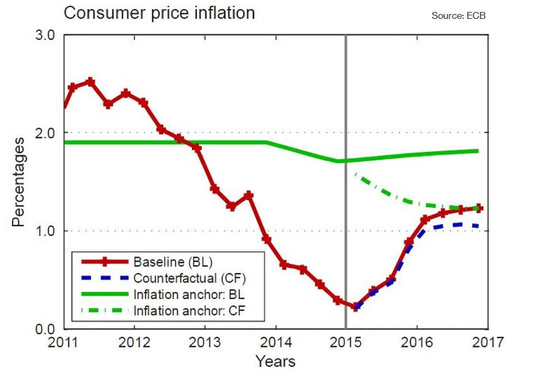

Jean-Marie Choffray @JMChoffray 25 juil. 2016
Negative interest on deposits? https://t.co/Pkp5vyueji https://t.co/4MOjsg0MRN
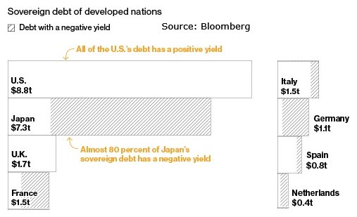

Jean-Marie Choffray @JMChoffray 23 juil. 2016
Investir ou mourir ? Il faut choisir… https://t.co/JPq6VEYzxu https://t.co/XTVMpSycDK
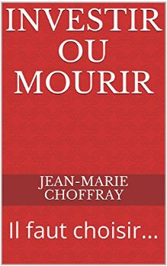

Jean-Marie Choffray @JMChoffray 21 juil. 2016
JOY: Just explain to me why Japan’s Komatsu didn’t try to buy them out six months ago…? https://t.co/PhrILwLHbQ
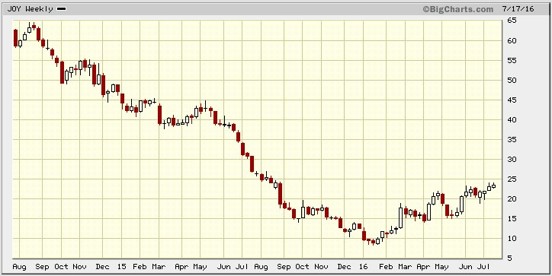

Jean-Marie Choffray @JMChoffray 20 juil. 2016
OPTT: Dreams are my reality :-) ! https://t.co/GotxiOwsaZ
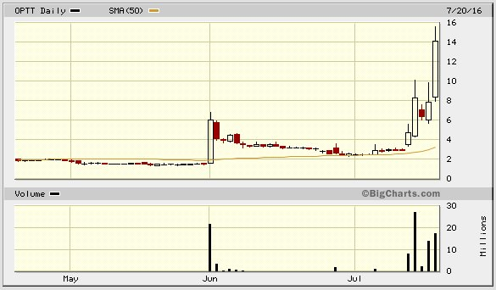

Jean-Marie Choffray @JMChoffray 19 juil. 2016
Is it just too good to be true? https://t.co/ohJ1MSXt6s

Jean-Marie Choffray @JMChoffray 16 juil. 2016
In our “world of appearances”, the most impossible, unthinkable, and unlikely events tend to become the most probable ones...

Jean-Marie Choffray @JMChoffray 14 juil. 2016
Germany becomes the second G7 nation after Japan to issue 10-year bonds with a negative yield. https://t.co/AoDuwcDLB5
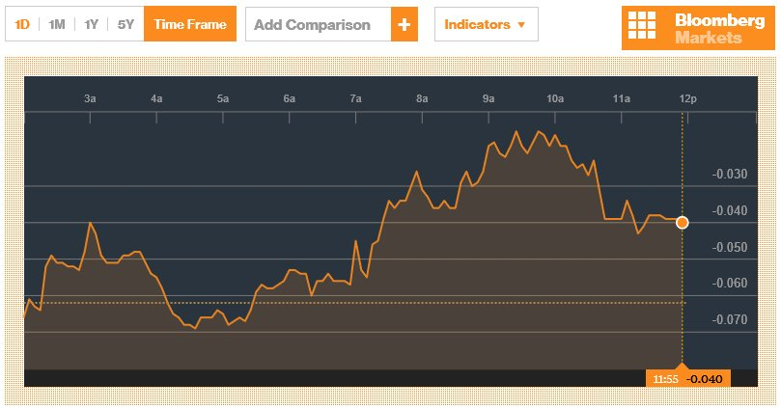

Jean-Marie Choffray @JMChoffray 14 juil. 2016
Perpetual bonds in the air… Public debt does not all have to be repaid. Some of it can be permanently monetized. https://t.co/vSCMeEQBnu

Jean-Marie Choffray @JMChoffray 13 juil. 2016
Markets close at all time high… Garden of delights, Augmented reality, or Pyrrhic victory? https://t.co/88O8jXovr2
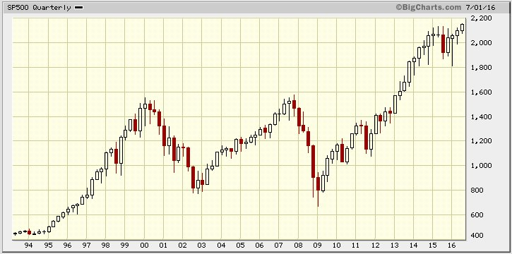

Jean-Marie Choffray @JMChoffray 13 juil. 2016
“History is a test. Mankind is failing it… We must give up violence once and for all.” (R. Girard) https://t.co/59gfmTsSNr

Jean-Marie Choffray @JMChoffray 12 juil. 2016
“We cannot stand as observers and accept a future of escalating violence and divisiveness.” (R. Reif, MIT) https://t.co/mVsx7kAqwE

Jean-Marie Choffray @JMChoffray 24 juin 2016
UK’s EU referendum opens new page of history. Right time to sit down, shut up, observe, think and… adapt!

Jean-Marie Choffray @JMChoffray 24 juin 2016
“Mr Cameron should reflect with a heavy heart on what he unleashed.” https://t.co/f22VzVVf6a

Jean-Marie Choffray @JMChoffray 24 juin 2016
Welcome to the desert of the real… https://t.co/jUxzxn5npv
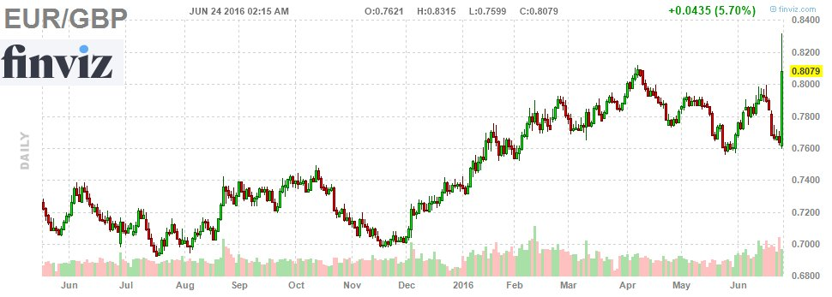

Jean-Marie Choffray @JMChoffray 24 juin 2016
The most frustrating thing about the EU: Nobody ever seems to acknowledge or learn from mistakes. (P. Krugman) https://t.co/w0wWDro9li

Jean-Marie Choffray @JMChoffray 24 juin 2016
BREXIT… “Dieu se rit des hommes qui déplorent les effets dont ils chérissent les causes.” (Bossuet)

Jean-Marie Choffray @JMChoffray 23 juin 2016
This is not a Belgian joke... https://t.co/Lfy1DXfVy3

Jean-Marie Choffray @JMChoffray 23 juin 2016
Even the best bite the dust! https://t.co/jMsCFNQRty

Jean-Marie Choffray @JMChoffray 22 juin 2016
When 9.2 billion barrels of oil and gas proven reserves disappear... (~$450 billion of assets) https://t.co/YTvZHKmzts

Jean-Marie Choffray @JMChoffray 22 juin 2016
TSLA + SCTY? Under NIRP, excessive leverage is probably irrelevant.

Jean-Marie Choffray @JMChoffray 21 juin 2016
FCEL ** XOM: Should we expect the unexpected? https://t.co/P2PBvTuNNU

Jean-Marie Choffray @JMChoffray 21 juin 2016
Stupid sacrifice? “A scapegoat remains effective as long as we believe in its guilt.” (R. Girard)

Jean-Marie Choffray @JMChoffray 21 juin 2016
Heads of state, bankers, and soldiers claim to be saving us when in fact they are plunging us deeper into devastation each day. (R Girard)

Jean-Marie Choffray @JMChoffray 21 juin 2016
War – economic? – as an act of violence knows no bounds. There arises a sort of escalation to extreme. (R Girard) https://t.co/OIPNgb3qjp

Jean-Marie Choffray @JMChoffray 21 juin 2016
“Financial markets do not play a purely passive role. They also affect the fundamentals they are supposed to reflect.” (G. Soros)

Jean-Marie Choffray @JMChoffray 21 juin 2016
“Financial markets, far from reflecting all available knowledge, provide a distorted view of reality” (G. Soros) https://t.co/sv96y5zMji

Jean-Marie Choffray @JMChoffray 18 juin 2016
Plain and simple. On a zero growth battlefield, the intelligent choice is to free up the private sector and unleash entrepreneurial forces.

Jean-Marie Choffray @JMChoffray 18 juin 2016
“Governments never learn. Only people learn.” (Milton Friedman)

Jean-Marie Choffray @JMChoffray 18 juin 2016
Is the market skeptical about the MSFT/LNKD deal? https://t.co/G0QENZGB50
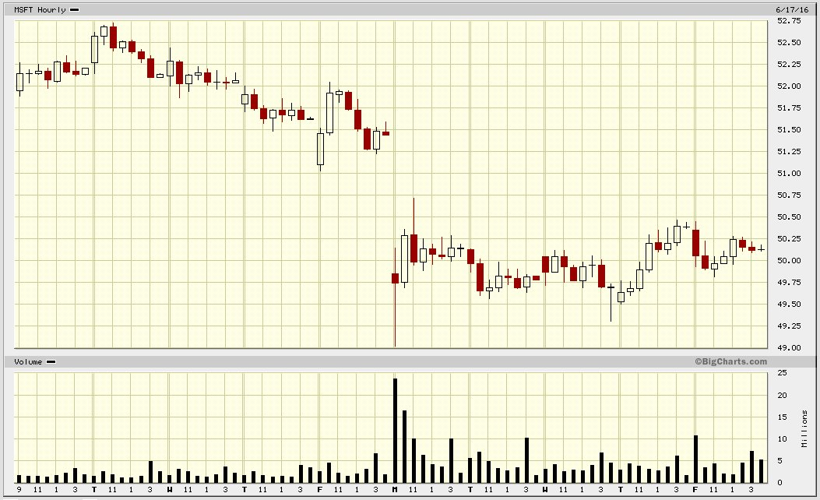

Jean-Marie Choffray @JMChoffray 18 juin 2016
“If you don’t know where you’re going, any road will get you there.” (Lewis Carroll)

Jean-Marie Choffray @JMChoffray 18 juin 2016
Let’s see the world as being full of people – often smarter than we are – who would be delighted to work for us.

Jean-Marie Choffray @JMChoffray 18 juin 2016
China’s rise as an industrial power. https://t.co/IZhKdMZXuR

Jean-Marie Choffray @JMChoffray 18 juin 2016
Economic projections of the Federal Reserve members, June2016. https://t.co/rZKQ5a5tKn https://t.co/Q1FaUJASiX
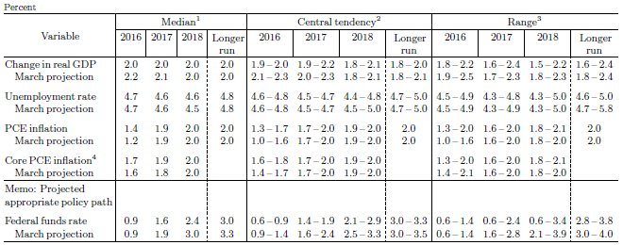

Jean-Marie Choffray @JMChoffray 17 juin 2016
Life is all about dreams. Investing is all about turning them into reality.

Jean-Marie Choffray @JMChoffray 17 juin 2016
BrExit or BrEndure? Who cares. Markets will reevaluate assets and adjust financing costs in no time.

Jean-Marie Choffray @JMChoffray 17 juin 2016
“Success is a science. If you create the conditions, you get the results.” (O. Wilde).

Jean-Marie Choffray @JMChoffray 17 juin 2016
Second quarter’s third Option Expiration Friday. Time to wake up?

Jean-Marie Choffray @JMChoffray 17 juin 2016
In today’s markets, advising others to invest in the long run is most of the time a fraud.

Jean-Marie Choffray @JMChoffray 17 juin 2016
Good investors follow the crowd. Great investors lead it.

Jean-Marie Choffray @JMChoffray 17 juin 2016
There is hardly anything new on the market. Most often, what happened in the past will happen again.

Jean-Marie Choffray @JMChoffray 17 juin 2016
In a digital world, markets swing from extreme hope to extreme despair in real time.

Jean-Marie Choffray @JMChoffray 17 juin 2016
Good investors know what and when to buy. Great investors know what and when to sell.

Jean-Marie Choffray @JMChoffray 17 juin 2016
Avoiding losses is the safest route to growing assets.

Jean-Marie Choffray @JMChoffray 17 juin 2016
I know of an investor who recently bought a Smart with his gains. He could have bought a Veyron with his losses.

Jean-Marie Choffray @JMChoffray 16 juin 2016
Last two weeks’ flight to safety… https://t.co/zYgAFaceAJ
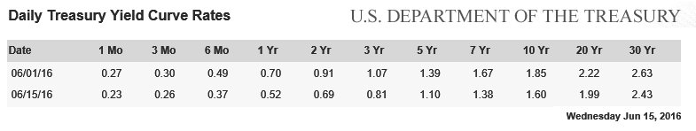

Jean-Marie Choffray @JMChoffray 16 juin 2016
Monetary policy remains accommodative. https://t.co/rKRXlIQ3wc

Jean-Marie Choffray @JMChoffray 16 juin 2016
No other choice than to work more, and/or more productively (intelligently?), or accept lower standards of living.

Jean-Marie Choffray @JMChoffray 16 juin 2016
World’s largest economies. https://t.co/z1rH8p2Tjn
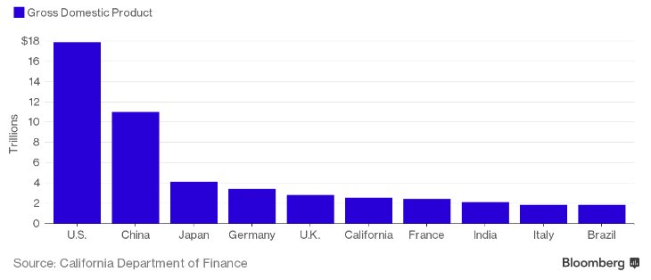

Jean-Marie Choffray @JMChoffray 16 juin 2016
Easy… Negative bond yields = Deflation expectations.

Jean-Marie Choffray @JMChoffray 16 juin 2016
Around 16% of the 2.8 trillion euros of IG corporate bonds now yield less than zero.

Jean-Marie Choffray @JMChoffray 14 juin 2016
Germany’s 10-year government bond yields below zero for the first time on record… https://t.co/ktyZRKDwwG

Jean-Marie Choffray @JMChoffray 14 juin 2016
“J’écris… / Dans ce théâtre vide où les usurpateurs / Ânonnent de grands mots pour les seuls ignorants” (Aragon) https://t.co/w6cANPFoKt

Jean-Marie Choffray @JMChoffray 14 juin 2016
MSFT/LNKD deal: from ZIRP to NIRP to… capital misallocation? https://t.co/GljePJoVGt
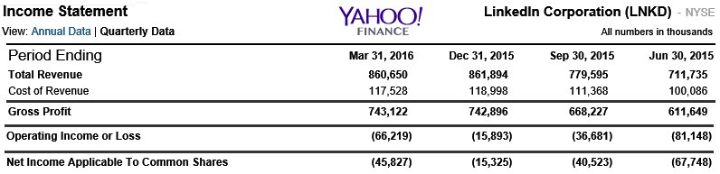

Jean-Marie Choffray @JMChoffray 13 juin 2016
“The old world is dying. The new one struggles to be born. Now is the time of monsters.” (A. Gramsci) https://t.co/xMWnwP40cr

Jean-Marie Choffray @JMChoffray 10 juin 2016
Short term – long term? – market efficiency is an illusion. Impossible & unthinkable events happen relentlessly.

Jean-Marie Choffray @JMChoffray 9 juin 2016
European Central Bank (ECB) starts purchases under its corporate sector purchase program (CSPP). https://t.co/b4E84e9Ig4

Jean-Marie Choffray @JMChoffray 9 juin 2016
FCEL: Earnings miss, but $ 30M of project assets... https://t.co/I123Zjkmbk

Jean-Marie Choffray @JMChoffray 9 juin 2016
Right… But, being right too early is as bad as being wrong! https://t.co/pmxnTYc2dX

Jean-Marie Choffray @JMChoffray 6 juin 2016
European coal prices highest in 10 months. https://t.co/oE8Hm33KTl
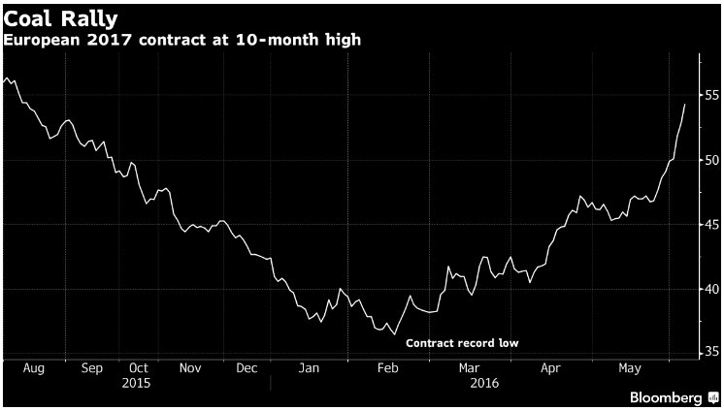

Jean-Marie Choffray @JMChoffray 6 juin 2016
Global government spending might grow more quickly than global GDP. https://t.co/nmRohS45Tn https://t.co/aj140Njvy8
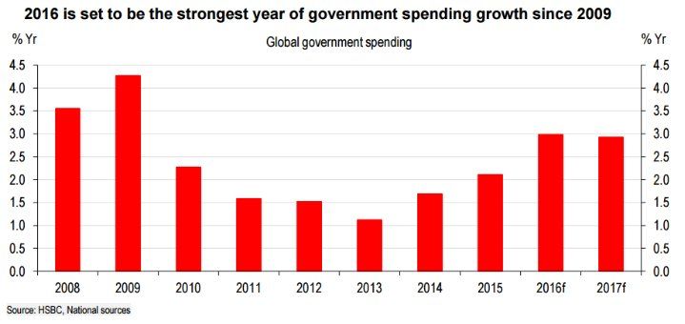

Jean-Marie Choffray @JMChoffray 3 juin 2016
In the last quarter of 2015 investment > consumption as the main driver of growth in the euro area. (M. Draghi) https://t.co/GhoZ7ghBEt

Jean-Marie Choffray @JMChoffray 3 juin 2016
Today, 18% of the global economy, weighted by GDP, operates in an environment of negative policy rates. (M. Draghi) https://t.co/g5uwJqmqYb

Jean-Marie Choffray @JMChoffray 3 juin 2016
Free to invest… but : “Je n’ai que l’idée que je me fais de moi-même pour me soutenir sur les mers du néant.” (Montherlant)

Jean-Marie Choffray @JMChoffray 2 juin 2016
In a ZIRP environment, the 40-year historical 7.5% “bond return” and 3% “equity premium” is just that… history! https://t.co/Pl49l9YZ1n

Jean-Marie Choffray @JMChoffray 2 juin 2016
ECB keeps interest rates unchanged at 0.00%, 0.25% and -0.40%. https://t.co/xVD7wTXJXE

Jean-Marie Choffray @JMChoffray 2 juin 2016
FCEL: Is this a… XOM effect? https://t.co/12P41Lmgru https://t.co/OVK6mgtWku
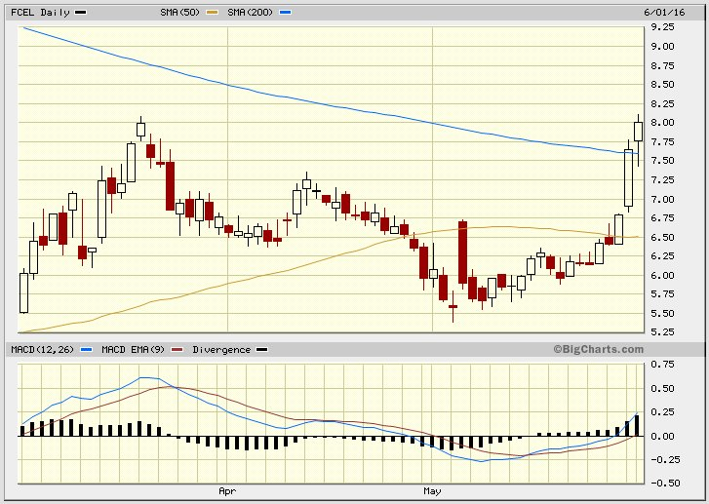

Jean-Marie Choffray @JMChoffray 1 juin 2016
In the fog of political war… https://t.co/GOBMo0G22J

Jean-Marie Choffray @JMChoffray 1 juin 2016
This is something we could have anticipated 25 years ago and in fact we did, but nobody's done anything about it... https://t.co/rWZKmPH6DG

Jean-Marie Choffray @JMChoffray 1 juin 2016
Foreign trade helped growth all the way back to 1790. The presumption that we’re turning off on trade is narrow-minded. (A. Greenspan)

Jean-Marie Choffray @JMChoffray 1 juin 2016
With two percent economic growth, we’re not going to be able to fund what we are already legally obligated to spend. (A. Greenspan)

Jean-Marie Choffray @JMChoffray 1 juin 2016
Capital investment = critical issue in productivity growth, and productivity growth = crucial issue in economic growth. (A. Greenspan)

Jean-Marie Choffray @JMChoffray 1 juin 2016
“The question is not to regret the past, but to accomplish its premises.” (Attributed to F. Nietzsche)

Jean-Marie Choffray @JMChoffray 24 mai 2016
Monthly Snapshot of the U.S. Economy... https://t.co/YrX4gJcNht

Jean-Marie Choffray @JMChoffray 23 mai 2016
Business-jet sales tumbled 16 percent to $3.53 billion in the first quarter, the biggest drop in almost five years… https://t.co/kVZvXtlZRj

Jean-Marie Choffray @JMChoffray 23 mai 2016
Searching for growth? https://t.co/D33KX4QNC8

Jean-Marie Choffray @JMChoffray 23 mai 2016
Industrial Production and Capacity Utilization. https://t.co/MeDFIQG1X5 https://t.co/kNnfcZAiDZ
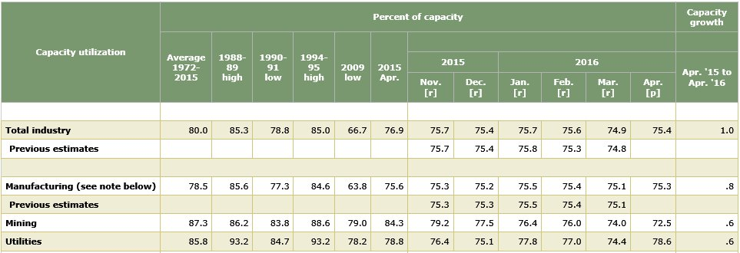

Jean-Marie Choffray @JMChoffray 20 mai 2016
The more things change the more they stay the same! Henry Hazlitt: Inflation, Deflation, Confusion… https://t.co/tNV23braVq

Jean-Marie Choffray @JMChoffray 30 avr. 2016
Sell in May & go away… Time has come for me to sit down, shut up, and think!

Jean-Marie Choffray @JMChoffray 27 avr. 2016
“L’homme n’a point de port, le temps n’a point de rive ; Il coule et nous passons.” (A. de Lamartine) https://t.co/MMntmeGy2q

Jean-Marie Choffray @JMChoffray 27 avr. 2016
Monetary policy close to its limits... Political & fiscal leadership? https://t.co/8Ee6q53nN0

Jean-Marie Choffray @JMChoffray 27 avr. 2016
“Le destin n’est… que notre démence. L’inévitable fatalité ne prend racine qu’en des fautes qu’on pouvait éviter.” (M. Maeterlinck)

Jean-Marie Choffray @JMChoffray 27 avr. 2016
AAPL: Earnings miss... Market Cap loss in ONE minute GREATER THAN Lehman Brothers Market Cap loss in TWO years! https://t.co/U5AKMS5uB0
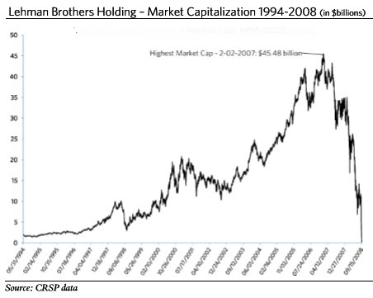

Jean-Marie Choffray @JMChoffray 26 avr. 2016
“The advantage of being smart is that you can always make the fool, while the opposite is impossible.” (Woody Allen).

Jean-Marie Choffray @JMChoffray 26 avr. 2016
Never lose and you will end up… always wining! Protecting assets at the edge of Chaos is THE rule of the game. https://t.co/fCu645CgAJ

Jean-Marie Choffray @JMChoffray 26 avr. 2016
Don’t fool yourself. Your only goal as an investor is quarterly Assets Under Management (AUM) GROWTH.

Jean-Marie Choffray @JMChoffray 26 avr. 2016
TIMING is everything. Buy at bottom of quarterly cycles. Avoid being heavily invested when earnings are released.

Jean-Marie Choffray @JMChoffray 26 avr. 2016
“Car jamais aucun ne me réconforta ; Ni de son bien rien ne m’apporta.” (Rutebeuf)

Jean-Marie Choffray @JMChoffray 26 avr. 2016
Learn to identify and know your adversaries. As a rule, on the markets, never ever trust anyone!

Jean-Marie Choffray @JMChoffray 26 avr. 2016
Markets never lie... Let them help you identify potential opportunities. https://t.co/nhm6NqWQHM

Jean-Marie Choffray @JMChoffray 26 avr. 2016
Concentrate on VALUE creating (ROE, ROA) and/or GROWTH generating (EPS, OCF) businesses. Leave dreams to others…

Jean-Marie Choffray @JMChoffray 26 avr. 2016
Some are trying to keep their brain cells busy… https://t.co/h7MzutZfix

Jean-Marie Choffray @JMChoffray 26 avr. 2016
“Ô mondaine inconstance ! Ce qui est ferme est par le temps détruit ; Et ce qui fuit au temps fait résistance.” (J. Du Bellay)

Jean-Marie Choffray @JMChoffray 26 avr. 2016
“Cognitive Dissonance Reduction” is the painful psychological process underlying seemingly erratic market moves.

Jean-Marie Choffray @JMChoffray 26 avr. 2016
Market prices are the rational reflection of investors’ irrational perceptions of the economic reality.

Jean-Marie Choffray @JMChoffray 26 avr. 2016
In a ZIRP/NIRP environment, managers/directors have no incentive to work hard and favor endogenous growth.

Jean-Marie Choffray @JMChoffray 25 avr. 2016
The Tokyo whale… https://t.co/LPVmpMgS3w via @business https://t.co/52JAuOcRbB
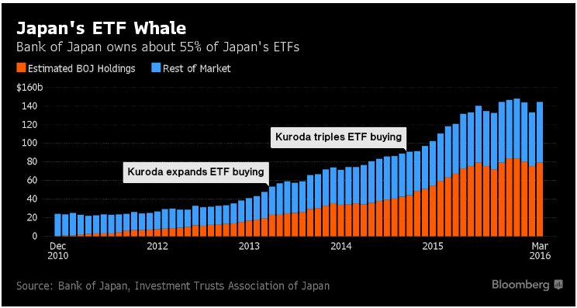

Jean-Marie Choffray @JMChoffray 25 avr. 2016
Free lunch for some! The “ZIZI” (Zero-Interest, Zero-Investment) bond wave… https://t.co/CdMBObfPwg

Jean-Marie Choffray @JMChoffray 25 avr. 2016
Democracy at its best. https://t.co/tcfDV3HdMA

Jean-Marie Choffray @JMChoffray 25 avr. 2016
World economic slowdown: the calm before the storm? Easy to diagnose, only painful treatments…

Jean-Marie Choffray @JMChoffray 25 avr. 2016
ETFs… Hit hard, rather than aim precisely!

Jean-Marie Choffray @JMChoffray 25 avr. 2016
“You can only share what you have...” (Attributed to Aristotle)

Jean-Marie Choffray @JMChoffray 25 avr. 2016
Killing golden geese (profitable and growing businesses) is no smart economic policy!

Jean-Marie Choffray @JMChoffray 25 avr. 2016
Sad Belgian joke... Banks whose assets were greater than GDP collapsed. Hundreds of years of growth in smoke. Nobody responsible :-)!

Jean-Marie Choffray @JMChoffray 25 avr. 2016
“Nous ne sommes pas au niveau de la chance que nous avons de vivre dans nos vieilles démocraties.” (Luc Ferry)

Jean-Marie Choffray @JMChoffray 25 avr. 2016
Singapore consumer prices decline in longest slump on record. https://t.co/DFCp7F90V9 via @business

Jean-Marie Choffray @JMChoffray 25 avr. 2016
Economic growth continues to disappoint globally. https://t.co/282u4LlnEJ via @business https://t.co/BkN6GL7uSK
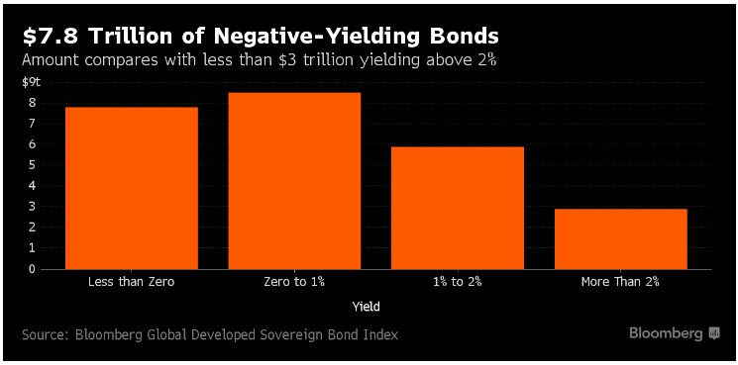

Jean-Marie Choffray @JMChoffray 25 avr. 2016
SHCOMP: Shanghai Composite Index. https://t.co/nLo2B9PMv2
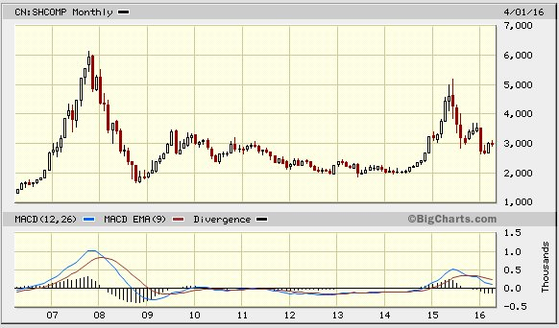

Jean-Marie Choffray @JMChoffray 25 avr. 2016
The haves and the have nots. A global crisis of forced displacement. https://t.co/MMNGJL0XTt

Jean-Marie Choffray @JMChoffray 25 avr. 2016
SUNE, TERP, GLBL… For the rest of your investor’s life: accounting is an ART & financial reporting is ADVERTISING!

Jean-Marie Choffray @JMChoffray 24 avr. 2016
Is the 3D-Printing space waking up? https://t.co/3dQO5SQSrq
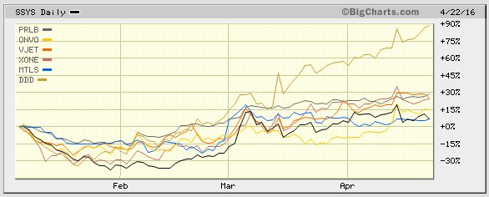

Jean-Marie Choffray @JMChoffray 24 avr. 2016
Banks… Anything right on the left side? Anything left on the right side? What about Foreign-Related Institutions? https://t.co/6YOh3LY7xC

Jean-Marie Choffray @JMChoffray 24 avr. 2016
Better keep in mind… Business credit is growing! https://t.co/Tawk1fkMLm

Jean-Marie Choffray @JMChoffray 24 avr. 2016
A very significant opportunity… https://t.co/lQK1HZKpwC

Jean-Marie Choffray @JMChoffray 24 avr. 2016
The hard reality as it probably is… https://t.co/eGQEQIGLnm

Jean-Marie Choffray @JMChoffray 24 avr. 2016
USO: Maybe? worth having a look at... https://t.co/G8McYIHuJG
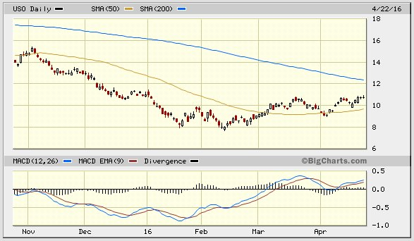

Jean-Marie Choffray @JMChoffray 24 avr. 2016
Stop “yelling”. Start “acting”. The only time you cannot make money on the markets is when they are closed!

Jean-Marie Choffray @JMChoffray 23 avr. 2016
There is opportunity in adversity. https://t.co/L2IT6nyVXp

Jean-Marie Choffray @JMChoffray 23 avr. 2016
On the importance of teaching children about economics and personal finance… https://t.co/PtyHciryYv

Jean-Marie Choffray @JMChoffray 23 avr. 2016
The proof of the pudding is in the eating! https://t.co/7vLhEXwRlO

Jean-Marie Choffray @JMChoffray 23 avr. 2016
Making money on the markets is incredibly difficult. Has always been... But, by essence, it’s not impossible!

Jean-Marie Choffray @JMChoffray 23 avr. 2016
Lack of understanding and respect of the role of capital as THE driver of productivity is why advanced economies don’t grow.

Jean-Marie Choffray @JMChoffray 23 avr. 2016
The solution is neither “crony capitalism” nor “utopian socialism”. It lies in the responsible behavior of free markets participants…

Jean-Marie Choffray @JMChoffray 23 avr. 2016
“The critics of capitalism are right when they reject policies that accept hunger today while promising affluence tomorrow.” (P. Berger)

Jean-Marie Choffray @JMChoffray 23 avr. 2016
“The critics of socialism are right when they reject policies that accept terror today on the promise of a humane order tomorrow” (P Berger)

Jean-Marie Choffray @JMChoffray 23 avr. 2016
BUT… This should result in production declines in the back half of 2016. Then, North America will offer the greatest upside…

Jean-Marie Choffray @JMChoffray 23 avr. 2016
HAL: “Disruptive market conditions… Unsustainable… U.S. & worldwide rig counts lowest since 1999.” https://t.co/pifg2bPdmI

Jean-Marie Choffray @JMChoffray 23 avr. 2016
In a deflationary environment (NIRP), people – and/or businesses – tend to buy only… what’s "free"!

Jean-Marie Choffray @JMChoffray 22 avr. 2016
MSFT: Earnings miss… No QOQ growth... $35 Billion drop (~8%) in market cap! https://t.co/T7o7Y1vLuW

Jean-Marie Choffray @JMChoffray 22 avr. 2016
APC: Debt for debt swap. Lower rates, longer term to maturity. https://t.co/uPZeb534E0

Jean-Marie Choffray @JMChoffray 22 avr. 2016
CAT: “Sales declined across the company with substantial reductions in construction, oil and gas, mining and rail.” https://t.co/3s2PfvmlTz

Jean-Marie Choffray @JMChoffray 22 avr. 2016
“Now is a time for friends and allies to stick together.” https://t.co/1THYYu9rJM

Jean-Marie Choffray @JMChoffray 22 avr. 2016
“There are only two avenues out of a debt crisis – default or inflate – and inflation is just a slow-motion default.” (H. Bassman)

Jean-Marie Choffray @JMChoffray 22 avr. 2016
Monetary policy unbridled… from bubbles to fairy tales! https://t.co/8T60LBNnFE

Jean-Marie Choffray @JMChoffray 21 avr. 2016
After all…, aren’t we working hard and taking risks to protect the freedom of our “Little Swans”? https://t.co/fYCzPysKxE

Jean-Marie Choffray @JMChoffray 21 avr. 2016
To the best of my understanding… Economic future = (BenBernanke + PaulKrugman) ** (RayDialo / RonPaul)

Jean-Marie Choffray @JMChoffray 21 avr. 2016
The cost of cheating and/or lying in a “perfectly” informed world… https://t.co/DTU7yoiyBT via @business

Jean-Marie Choffray @JMChoffray 21 avr. 2016
The joy of biotech investing… Or, what "intrinsic volatility" is for the presumptuous investor! https://t.co/PJ2mZeWhPk
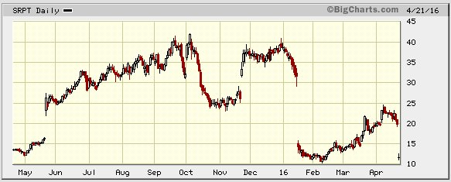

Jean-Marie Choffray @JMChoffray 21 avr. 2016
What does deleverage mean? Lenders prefer to have a little of something than a lot of nothing… https://t.co/t5aoMdXOnp via @technology

Jean-Marie Choffray @JMChoffray 21 avr. 2016
ECB leaves rates unchanged, expands monthly asset purchases https://t.co/NG1fEC5HNJ

Jean-Marie Choffray @JMChoffray 21 avr. 2016
Did you hear the sound of a “money” helicopter? https://t.co/0aOLRgdNZO

Jean-Marie Choffray @JMChoffray 21 avr. 2016
Worth listening to again: “How the economic machine works.” https://t.co/V7HSECVi8h

Jean-Marie Choffray @JMChoffray 21 avr. 2016
“We are witnessing the end of an era, but since denial and ignorance prevail few are aware of it.” https://t.co/zcXDraPppQ

Jean-Marie Choffray @JMChoffray 21 avr. 2016
“It is not the strongest that survives, nor the most intelligent. It is the one that is most adaptable to change.”

Jean-Marie Choffray @JMChoffray 21 avr. 2016
GDX, XAU… Gold, as a barometer of expected inflation. https://t.co/GVsYxCgEEB
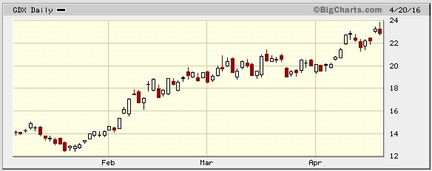

Jean-Marie Choffray @JMChoffray 21 avr. 2016
SCTY, VSLR, RUN… San Francisco requires new buildings to install solar panels. https://t.co/wGca6LlndJ

Jean-Marie Choffray @JMChoffray 21 avr. 2016
From ZIRP to NIRP to… pension CUTS! https://t.co/oX3nem0wHa

Jean-Marie Choffray @JMChoffray 20 avr. 2016
ILMN: Weakness in Europe = $6 Billion drop (~20%) in market cap! https://t.co/LB4UqRAWe6

Jean-Marie Choffray @JMChoffray 20 avr. 2016
LNG: U.S. Shale gas goes global… https://t.co/VFLxFYrxof via @business https://t.co/KZX3Bwk3sS
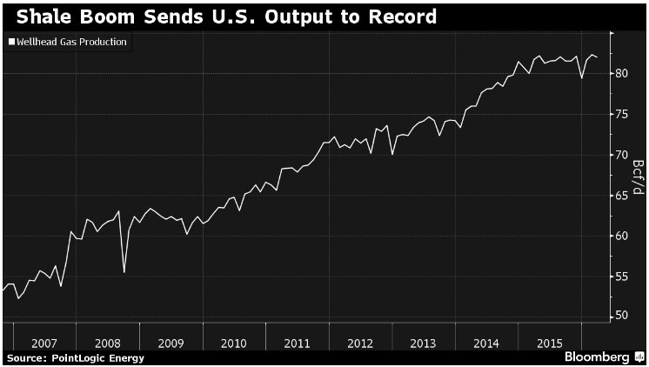

Jean-Marie Choffray @JMChoffray 20 avr. 2016
UA >< FIT: From smart clothes to smart devices… Or the opposite? https://t.co/WsEOVgJyZR

Jean-Marie Choffray @JMChoffray 20 avr. 2016
HLX: Earnings miss… Sit down, shut up and think! https://t.co/GCHAscB063

Jean-Marie Choffray @JMChoffray 20 avr. 2016
CLNE: Equity for debt swap! https://t.co/vIcvCF3L7x

Jean-Marie Choffray @JMChoffray 19 avr. 2016
Stock prices do not usually change in an evolutionary way. Shocks are not merely possible, or even probable, they are certain.

Jean-Marie Choffray @JMChoffray 19 avr. 2016
“At the end of the day, it is the perception of what happened that matters more than what actually happened.” https://t.co/12LOjE194k

Jean-Marie Choffray @JMChoffray 19 avr. 2016
The dogs bark, but the market moves on...

Jean-Marie Choffray @JMChoffray 19 avr. 2016
"Ceux qui s’enorgueillissent de revitaliser la démocratie réinventent, dans l’innocence de l’oubli, le totalitarisme.” (A. Finkielkraut)

Jean-Marie Choffray @JMChoffray 19 avr. 2016
CPST: The market reaction will tell more about “What we don’t know that we don’t know…” https://t.co/XTwTNzaTaI

Jean-Marie Choffray @JMChoffray 18 avr. 2016
FCEL: Additional long-term loan facility to support the development of fuel cell projects. https://t.co/13t6AmunLZ

Jean-Marie Choffray @JMChoffray 18 avr. 2016
Another lousy movie, but… Bach’s Concerto N°5 https://t.co/agPwcJR1WW

Jean-Marie Choffray @JMChoffray 18 avr. 2016
Major policy changes to come? Society and economy do not behave according to theory…

Jean-Marie Choffray @JMChoffray 17 avr. 2016
Trying to identify THE company that will change the world…, will usually lead you to miss the MANY that do change it every day!

Jean-Marie Choffray @JMChoffray 17 avr. 2016
“Low oil prices were supposed to be a big boost for the world economy; but it didn’t happen.” https://t.co/JBIOzHHsUx

Jean-Marie Choffray @JMChoffray 17 avr. 2016
“Market-based TIPS spreads provide the best measure of inflation expectations.” https://t.co/VyFZj4Y5ML

Jean-Marie Choffray @JMChoffray 17 avr. 2016
Let’s dream big! https://t.co/4BvyJtEQV7

Jean-Marie Choffray @JMChoffray 17 avr. 2016
“More people are discovering that the system is rigged and voting is just pacification…” (Dr. Ron Paul, three-time presidential candidate)

Jean-Marie Choffray @JMChoffray 17 avr. 2016
“Education is the transmission of civilization. Civilization... has to be learned and earned by each generation anew.” (W. & A. Durant)

Jean-Marie Choffray @JMChoffray 17 avr. 2016
“The viability of modern societies will largely hinge on their capacity to take account of the counter-modernizing resistances.” (P. Berger)

Jean-Marie Choffray @JMChoffray 17 avr. 2016
“Human beings have the right to live in a meaningful world” (P. Berger)

Jean-Marie Choffray @JMChoffray 17 avr. 2016
“The most pressing moral imperative in policy making is a calculus of pain.” (P. Berger)

Jean-Marie Choffray @JMChoffray 17 avr. 2016
“Underlying the ideological models of change are the myth of growth and the myth of revolution. Both must be debunked.” (P. Berger)

Jean-Marie Choffray @JMChoffray 17 avr. 2016
As long as many invest in the long run on diversified assets, some will make money in the short run on single assets...

Jean-Marie Choffray @JMChoffray 17 avr. 2016
The THREE drivers of a modern economy: (1) its education system, (2) its education system, and (3) its education system…

Jean-Marie Choffray @JMChoffray 16 avr. 2016
Better late than never… https://t.co/38y0IAQp00

Jean-Marie Choffray @JMChoffray 16 avr. 2016
Total eclipse of the SUNE… https://t.co/Lw5PthYRCU

Jean-Marie Choffray @JMChoffray 16 avr. 2016
CPST: Is this week’s volume trying to tell us something? https://t.co/QduBWGssED
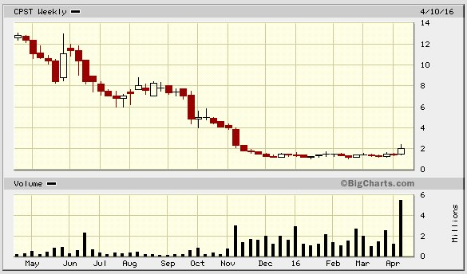

Jean-Marie Choffray @JMChoffray 16 avr. 2016
“Au Crédit Lyonnais, aucun contre-pouvoir n’a fonctionné : ni le conseil d’administration, ni les régulateurs, ni l’Etat…” (J Peyrelevade)

Jean-Marie Choffray @JMChoffray 16 avr. 2016
“Les hommes (les femmes) de pouvoir ont une tendance naturelle à la folie des grandeurs…” (J Peyrelevade)

Jean-Marie Choffray @JMChoffray 15 avr. 2016
Welcome to BATS! https://t.co/9z7n9LBAeS

Jean-Marie Choffray @JMChoffray 15 avr. 2016
If true…??? It unfortunately never happens to "old" university professors :-)! https://t.co/s11WmclVhN

Jean-Marie Choffray @JMChoffray 15 avr. 2016
March industrial production. https://t.co/v8zbsVka7g

Jean-Marie Choffray @JMChoffray 15 avr. 2016
Median Consumer Price Index (CPI)… On target? https://t.co/2B9koRGID9
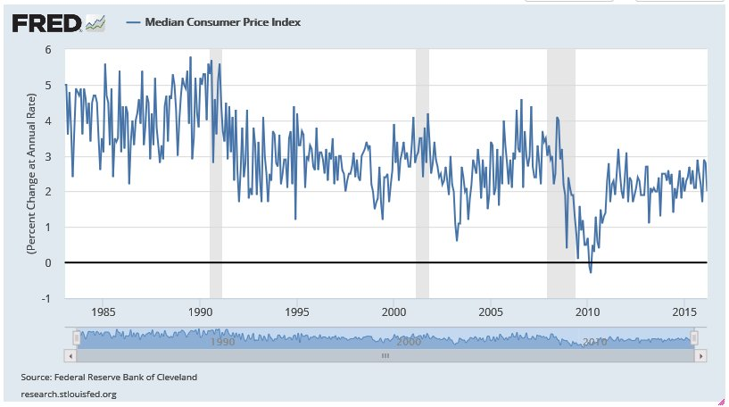

Jean-Marie Choffray @JMChoffray 15 avr. 2016
Net equity flows… https://t.co/zof82CTeF7 https://t.co/Z56GRkNp8y
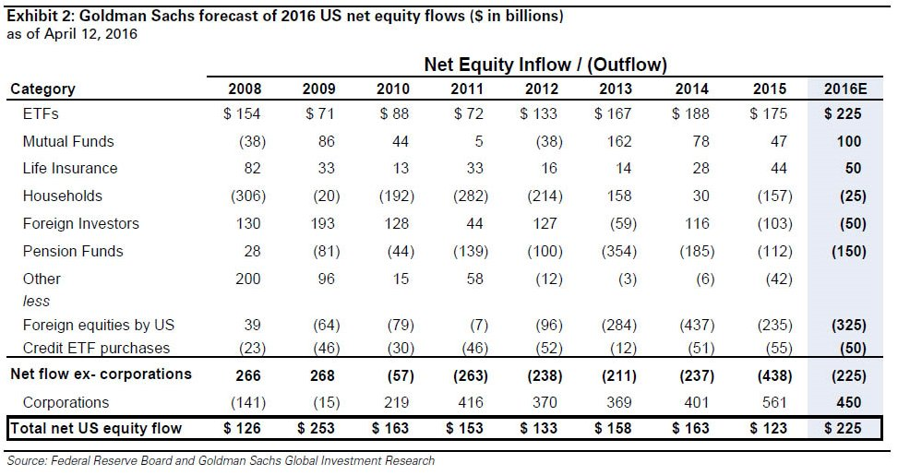

Jean-Marie Choffray @JMChoffray 15 avr. 2016
“La vision sous-jacente au projet européen est le contraire absolu de la vision satanique du monde... des terroristes” (T de Montbrial)

Jean-Marie Choffray @JMChoffray 14 avr. 2016
Investors are rewarded to sit down, shut up, think hard and bet against the crowd… Not to play dead cat bounces.

Jean-Marie Choffray @JMChoffray 14 avr. 2016
IF low productivity growth THEN NOT (higher wages AND steady inflation AND higher profits); https://t.co/MqrL1WG4tY

Jean-Marie Choffray @JMChoffray 14 avr. 2016
“Le temps ne fait rien à l'affaire / Quand on est con, on est con…” (G. Brassens)

Jean-Marie Choffray @JMChoffray 13 avr. 2016
“Money-Financed Fiscal Programs (MFFP) are likely to be effective even when debt is high and/or rates <= 0.” https://t.co/2qUFlvFJaW

Jean-Marie Choffray @JMChoffray 13 avr. 2016
“Educating about “radical” monetary policy alternatives might help ensure that they are never needed…” https://t.co/LZKihvtwY6

Jean-Marie Choffray @JMChoffray 13 avr. 2016
During recessions, the Fed typically lowers real interest rates to spur recovery. https://t.co/mkYWO2H8HM https://t.co/SjXdGFEMJF
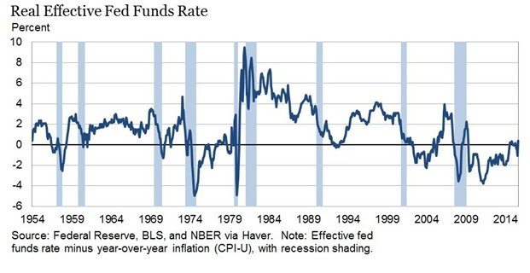

Jean-Marie Choffray @JMChoffray 13 avr. 2016
“Litanies, liturgie et léthargie, le FMI prêche dans le désert…” (J.P. Robin)

Jean-Marie Choffray @JMChoffray 13 avr. 2016
BTU, founded in 1883, files for bankruptcy. The rise and fall of the world’s largest privately owned coal producer. https://t.co/JRqWoe5nKW
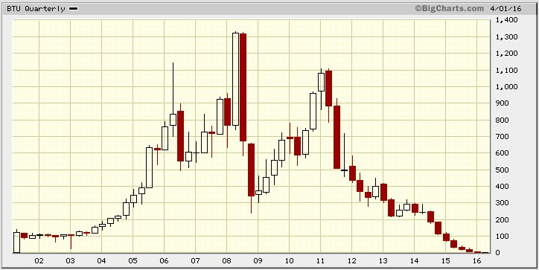

Jean-Marie Choffray @JMChoffray 13 avr. 2016
“Central bank policy is about building confidence so corporates borrow & build things & consumers work & buy things” https://t.co/9acGbWU6e4

Jean-Marie Choffray @JMChoffray 12 avr. 2016
“With central banks in Europe and Japan struggling to reach inflation targets, MFPPs may receive more attention.” (B. Bernanke)

Jean-Marie Choffray @JMChoffray 11 avr. 2016
MFPPs provide an option iff… deficient demand, exhausted monetary policy, and refusal of debt-financed fiscal policies.

Jean-Marie Choffray @JMChoffray 11 avr. 2016
Money-financed fiscal programs (MFFPs) – “helicopter drops” –, are very unlikely to be needed. But… https://t.co/CJ16NOzoJ7

Jean-Marie Choffray @JMChoffray 10 avr. 2016
Infrastructure investment under current conditions – low rates & economies under capacity – might enhance growth. https://t.co/ZnmuNTF0vA

Jean-Marie Choffray @JMChoffray 10 avr. 2016
Depression economics – liquidity traps – is deeply counterintuitive to many people, including economists. https://t.co/IzD3JUXFlD

Jean-Marie Choffray @JMChoffray 9 avr. 2016
But… U.S. natural gas rig count down! https://t.co/8alkGEZTYz

Jean-Marie Choffray @JMChoffray 9 avr. 2016
W.C. Dudley (NY Fed) expects that the U.S. economy will expand at a pace slightly above its long-term trend. https://t.co/UhIn22TV7n

Jean-Marie Choffray @JMChoffray 9 avr. 2016
“L’histoire est une suite de mensonges sur lesquels on est d’accord…” (Napoléon Bonaparte)

Jean-Marie Choffray @JMChoffray 9 avr. 2016
Another sign of… a “Massive Recession” :-)!https://t.co/ntEMPHlmXc

Jean-Marie Choffray @JMChoffray 9 avr. 2016
Thinking about the imminence of … a “Massive Recession”. https://t.co/RSqx2eKdKz

Jean-Marie Choffray @JMChoffray 9 avr. 2016
“L’Histoire n’est qu’une histoire à dormir debout…” (Jules Renard)

Jean-Marie Choffray @JMChoffray 8 avr. 2016
Investing without vision and/or method is a road to serfdom.

Jean-Marie Choffray @JMChoffray 8 avr. 2016
"Concentrated power is not rendered harmless by the good intentions of those who create it." (Milton Friedman)

Jean-Marie Choffray @JMChoffray 7 avr. 2016
Inflation under four Fed chiefs. https://t.co/bFq9TN46Zh https://t.co/IFMBITXP7F
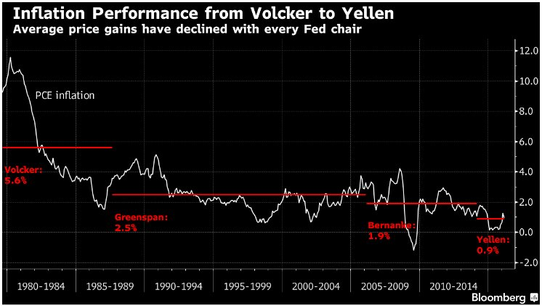

Jean-Marie Choffray @JMChoffray 7 avr. 2016
Unemployment under four Fed chiefs. https://t.co/bFq9TN46Zh via @business https://t.co/u8pLg23bV8
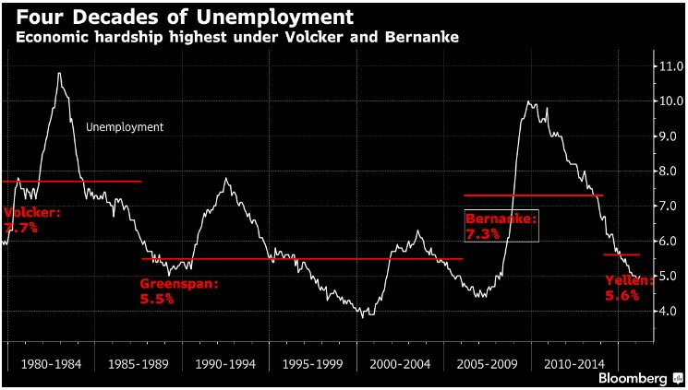

Jean-Marie Choffray @JMChoffray 7 avr. 2016
NASDAQ: If this isn’t a market “TOP”, it sure looks like one! https://t.co/alizYa0t3r
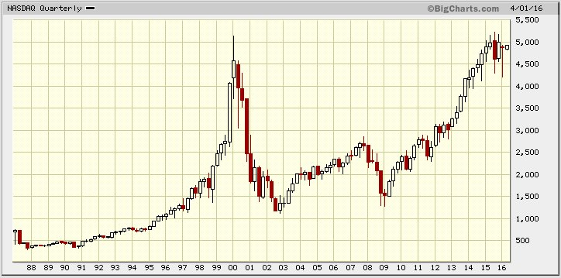

Jean-Marie Choffray @JMChoffray 6 avr. 2016
“Prediction is very difficult, especially if it's about the future.” (Niels Bohr) But… https://t.co/NHCDUyCCpF
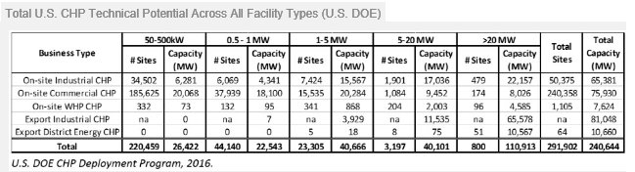

Jean-Marie Choffray @JMChoffray 6 avr. 2016
Our world is mean and full of hardship. But, through dedicated work and risky decisions investors have a chance to make it progress.

Jean-Marie Choffray @JMChoffray 5 avr. 2016
“Welcome to the desert of the real!” https://t.co/ogyguKnPGL

Jean-Marie Choffray @JMChoffray 5 avr. 2016
GLBL: On the markets… only the paranoids survive! https://t.co/lUJAEa3tmr

Jean-Marie Choffray @JMChoffray 5 avr. 2016
AGN, PFE: Get ready for more... Losers, wanting to become winners, may change the rules of the game! https://t.co/RHKF4VqEy5 via @Reuters

Jean-Marie Choffray @JMChoffray 4 avr. 2016
From reality to fiction… https://t.co/jikEbxVnDy

Jean-Marie Choffray @JMChoffray 4 avr. 2016
“Wisdom is to have dreams big enough not to lose sight when we pursue them.” (O. Wilde)

Jean-Marie Choffray @JMChoffray 4 avr. 2016
Imminent… “Massive recession”? https://t.co/7aNmMfd2h0

Jean-Marie Choffray @JMChoffray 4 avr. 2016
At times, even the most emblematic businesses fall in the hellhole of lies.

Jean-Marie Choffray @JMChoffray 4 avr. 2016
Clean “NrgNets”... As scientific/technological revolutions unfold, beliefs always precede facts!

Jean-Marie Choffray @JMChoffray 3 avr. 2016
Imminent... “Massive recession”? “If you can't dazzle them with brilliance, baffle them with bullshit.” (W.C. Fields).

Jean-Marie Choffray @JMChoffray 2 avr. 2016
“History repeats itself, first as tragedy, second as farce." SUNE: a house of cards? https://t.co/59Q9Z1GdM0 https://t.co/wMjvAW0RIB
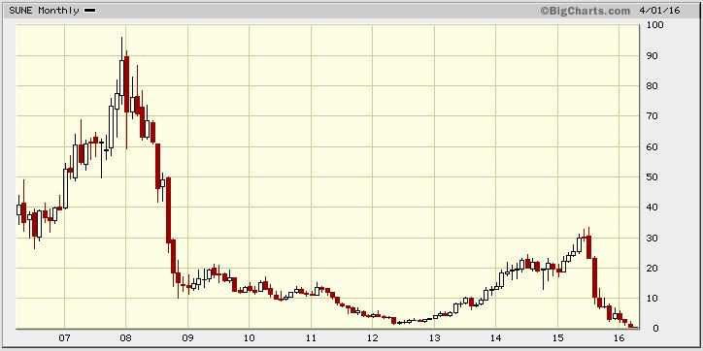

Jean-Marie Choffray @JMChoffray 1 avr. 2016
April Fools’ Day…? https://t.co/7iaCYoEt2n https://t.co/AQq0hbzgSp
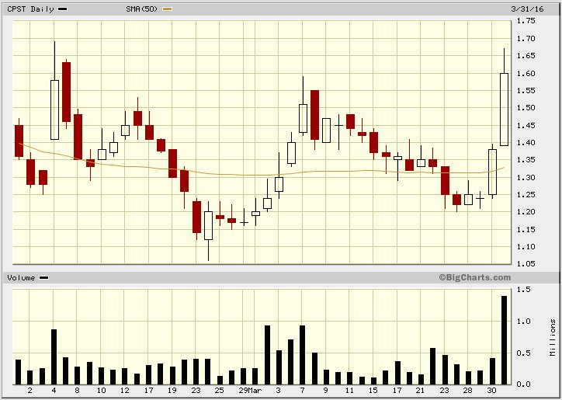

Jean-Marie Choffray @JMChoffray 31 mars 2016
We all know what to invest in (Value creating and growth generating businesses). We just don’t know why today’s markets disagree!

Jean-Marie Choffray @JMChoffray 31 mars 2016
The state of our “Global monetary non-system”. Plain and simple. https://t.co/D5SUvA2qpf

Jean-Marie Choffray @JMChoffray 31 mars 2016
René Girard… all over again! https://t.co/SqrV85bXKu https://t.co/DPphb96K4k

Jean-Marie Choffray @JMChoffray 29 mars 2016
“There are no principles…, only events. There are no laws…, only circumstances.” (H. de Balzac)

Jean-Marie Choffray @JMChoffray 29 mars 2016
XAU (PHLX Gold/Silver Index): An operational measure of risk… https://t.co/YEjy25nCWn
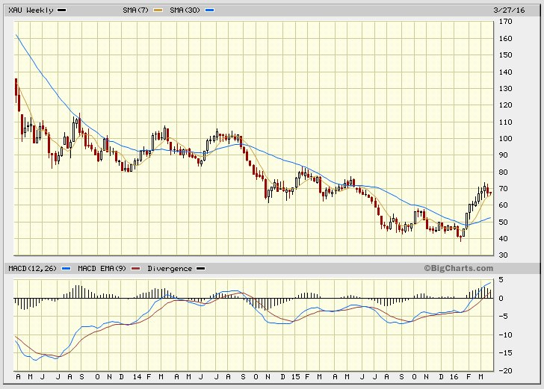

Jean-Marie Choffray @JMChoffray 29 mars 2016
Always expect the unexpected; Stay ahead of the market; Master the art of timing…

Jean-Marie Choffray @JMChoffray 29 mars 2016
The road to hell is paved with fake statements, crooked management, incompetent analysts & hedge fund clowns. https://t.co/m0oCIBwVym
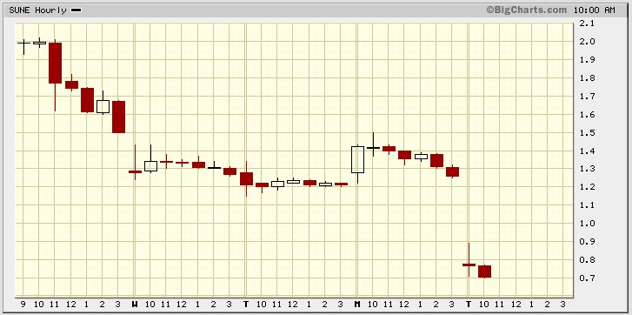

Jean-Marie Choffray @JMChoffray 29 mars 2016
In the fog of economic war it’s easy to complain... The real challenge is to explain and share the reasons to hope.

Jean-Marie Choffray @JMChoffray 29 mars 2016
On the markets, better be pessimistic & right… than optimistic & wrong!

Jean-Marie Choffray @JMChoffray 29 mars 2016
SUNE: So… I guess that’s part of the answer! https://t.co/IzxP6Kf9DM via @Reuters https://t.co/bEEj6PGJrS

Jean-Marie Choffray @JMChoffray 24 mars 2016
AYA: Better than online poker…, play the stock market! https://t.co/y1XdrrFps7 via @business

Jean-Marie Choffray @JMChoffray 24 mars 2016
Where is the error? SUNE appears to be worth much less than the sum of its parts.

Jean-Marie Choffray @JMChoffray 24 mars 2016
I believe that today’s markets are best characterized by their weak efficiency, their poor liquidity, and their limited transparency...

Jean-Marie Choffray @JMChoffray 24 mars 2016
IF (Investing = Financing) AND (Financing = Marketing) THEN (Investing = Marketing)!

Jean-Marie Choffray @JMChoffray 26 févr. 2016
DDD: Record non-cash goodwill and intangibles impairment charge of $510 million to $570 million. https://t.co/Y7dfZu0OEU

Jean-Marie Choffray @JMChoffray 26 févr. 2016
WDC: Alken Asset Management says $19B price for SNDK is too high… Didn’t surprise me! https://t.co/qaC54STsd2

Jean-Marie Choffray @JMChoffray 26 févr. 2016
SCTY: New Fund ($249 Million) to cover the capital cost of solar equipment and installation for homeowners.

Jean-Marie Choffray @JMChoffray 26 févr. 2016
SUNE: Just enjoy… Market’s reaction at open = (China Deal + VSLR Acquisition + Denial of Injunction) ** Short Squeeze!

Jean-Marie Choffray @JMChoffray 26 févr. 2016
Improbable, impossible, unthinkable events happen every day… Profitable Co (RJET) files for bankruptcy! https://t.co/AJOPRKyaqO

Jean-Marie Choffray @JMChoffray 25 févr. 2016
GLBL: Too good to be true… Expected dividend yield > 40%!

Jean-Marie Choffray @JMChoffray 25 févr. 2016
SDRL, RIG… The offshore drilling market continues to be oversupplied with multiple rigs chasing too few opportunities.

Jean-Marie Choffray @JMChoffray 25 févr. 2016
Funny… SUNE up 40% after VSLR shareholders approve acquisition. Death kiss?

Jean-Marie Choffray @JMChoffray 25 févr. 2016
“If you only have one way to think about something, you have no hope if you get stuck.” (M. Minsky)

Jean-Marie Choffray @JMChoffray 25 févr. 2016
“Intelligence doesn't depend on whether the machine is wet or dry inside.” (Ed Fredkin)

Jean-Marie Choffray @JMChoffray 25 févr. 2016
P. Winston, my “old” professor @MIT, was right 40 years ago: computers will someday think & act like us. Meet Atlas https://t.co/9vc0Ua1V7g

Jean-Marie Choffray @JMChoffray 24 févr. 2016
CHK: Quarterly earnings miss. Sit down, shut up, read & think. https://t.co/z71lRlrYNE

Jean-Marie Choffray @JMChoffray 24 févr. 2016
“Markets can stay irrational longer than you can stay solvent.” (Keynes)

Jean-Marie Choffray @JMChoffray 24 févr. 2016
As many investing legends recently learned, financial success is so volatile that you better stay modest!

Jean-Marie Choffray @JMChoffray 24 févr. 2016
But…, nothing prevents us from trying to put the power of the markets to the service of good!

Jean-Marie Choffray @JMChoffray 24 févr. 2016
On the markets, success is often more a function of “leverage”, “luck” and “misconduct” than patient, hard and honest work!

Jean-Marie Choffray @JMChoffray 24 févr. 2016
“Le secret des grandes fortunes sans cause apparente est un crime oublié, parce qu'il a été proprement fait.” (H. de Balzac)

Jean-Marie Choffray @JMChoffray 24 févr. 2016
Some investors are sufficiently stupid to think that they are the only cause of their success…

Jean-Marie Choffray @JMChoffray 24 févr. 2016
“Dieu se rit des hommes qui déplorent les effets dont ils chérissent les causes” (J-B. Bossuet)

Jean-Marie Choffray @JMChoffray 24 févr. 2016
In hindsight, easy to say that what happened, had to! Much harder to know why what could have happened, did not.

Jean-Marie Choffray @JMChoffray 24 févr. 2016
In this period of geopolitical tensions, it’s refreshing to read “La Paix soit avec vous” (Jacqueline de Romilly) https://t.co/8UpkxknOEO

Jean-Marie Choffray @JMChoffray 23 févr. 2016
Being a gifted and hardworking artist or scientist is one thing. Making money out of it is another. Same for… investors!

Jean-Marie Choffray @JMChoffray 23 févr. 2016
Without hesitation, run away from anybody who tells you that he knows how the market will evolve and what to invest in.

Jean-Marie Choffray @JMChoffray 23 févr. 2016
Some companies should spend much more time intelligently marketing their stocks/debts rather than their products/services…

Jean-Marie Choffray @JMChoffray 23 févr. 2016
Nowadays, financial markets are unfortunately also the place where money changes hands until it disappears!

Jean-Marie Choffray @JMChoffray 23 févr. 2016
WDC should buy SNDK iff GROWTH (SNDK) > GROWTH(WDC) & VALUATION(SNDK) < VALUATION(WDC)… NOT the case!

Jean-Marie Choffray @JMChoffray 23 févr. 2016
VRX: Earnings restatement. Reliability & validity of audited results? https://t.co/RvPAisCcKe

Jean-Marie Choffray @JMChoffray 23 févr. 2016
Investments are like buses. When you miss one, you take the next one!

Jean-Marie Choffray @JMChoffray 23 févr. 2016
HLX: Quarterly earnings miss. Sit down, shut up, read & think. https://t.co/5PaPgBdi76

Jean-Marie Choffray @JMChoffray 23 févr. 2016
LL: Expect the… Unexpected. If anything can go wrong, it will! How a Math Blunder Reignited Doubts About LL https://t.co/v5CgaFiBKF

Jean-Marie Choffray @JMChoffray 23 févr. 2016
Reality is neither Black nor White… It’s an infinite number of shades of Grey! https://t.co/wnEWZqsPt5 via @business

Jean-Marie Choffray @JMChoffray 21 févr. 2016
It’s never too early to sell at a loss, nor too late to sell at a profit!

Jean-Marie Choffray @JMChoffray 21 févr. 2016
Mark my words. The US shale gas & fracking revolution is the most important geopolitical event of the last twenty-five years…

Jean-Marie Choffray @JMChoffray 21 févr. 2016
Conflicting views... Managers want to spend today in the hope of making money tomorrow. Intelligent investors prefer the opposite!

Jean-Marie Choffray @JMChoffray 21 févr. 2016
CPST: (17824/20921) ~ 15% shareholder dilution… NO press release! https://t.co/htK7foMWBH

Jean-Marie Choffray @JMChoffray 21 févr. 2016
Better sell early than too late. Better buy late than too early.

Jean-Marie Choffray @JMChoffray 20 févr. 2016
Under heavy stress, don’t expect stakeholders – managers, stockholders, debtholders… – to behave rationally!

Jean-Marie Choffray @JMChoffray 20 févr. 2016
UPL: Management… dreams are NOT my reality! https://t.co/9zuA0wlsZW
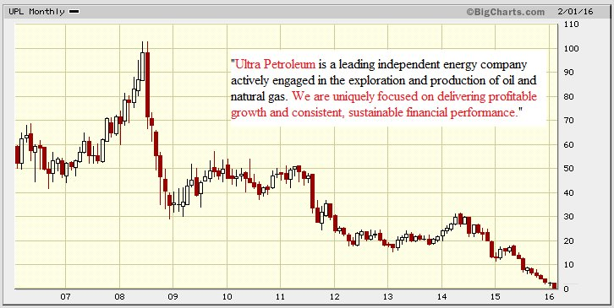

Jean-Marie Choffray @JMChoffray 20 févr. 2016
A world of artificially inflated energy prices is ending. Too bad for those who benefited from it for years.

Jean-Marie Choffray @JMChoffray 20 févr. 2016
When a business is mispriced by the market…, the longer the better!

Jean-Marie Choffray @JMChoffray 20 févr. 2016
As an investor, you better get prepared to educate yourself, and work hard, for the rest of your journey.

Jean-Marie Choffray @JMChoffray 20 févr. 2016
Isn’t it funny? In my life, as a modest investor, every time someone, or some organization, was in a position to rob me, he/she… did it!

Jean-Marie Choffray @JMChoffray 20 févr. 2016
ALWAYS concentrate on the LEFT side of the balance sheet. Quality assets attract quality investors & lenders. Not the opposite.

Jean-Marie Choffray @JMChoffray 20 févr. 2016
My best advice to youngsters for the world to come: get yourself a USEFUL and VALUABLE education.

Jean-Marie Choffray @JMChoffray 20 févr. 2016
NHTC: Those who ignore history are destined to repeat it. https://t.co/gLuOqt46lm
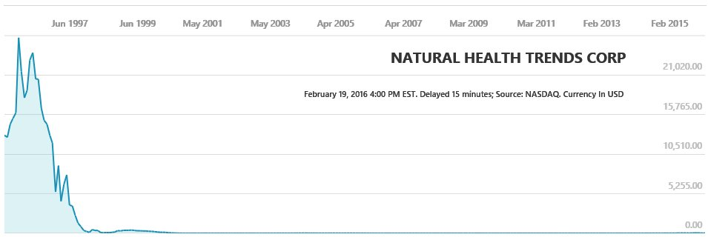

Jean-Marie Choffray @JMChoffray 20 févr. 2016
Investing today is like playing chess on a “flexible” board, with pieces whose relative value changes constantly.

Jean-Marie Choffray @JMChoffray 19 févr. 2016
Financial markets are probably as efficient as they have ever been. “Perfect” information makes “bluffing” worthless. Adapt or die!

Jean-Marie Choffray @JMChoffray 19 févr. 2016
Politicians, managers, leaders of all sorts… you & me, are mere humans: limited competence, bounded rationality & experts at feigning!

Jean-Marie Choffray @JMChoffray 19 févr. 2016
Nothing is perfect on the surface of the economy. Businesses are, and will always be, bags of problems!

Jean-Marie Choffray @JMChoffray 19 févr. 2016
RJET: Indeed… https://t.co/VIHDG1nYw2 https://t.co/BhSr82BlAJ
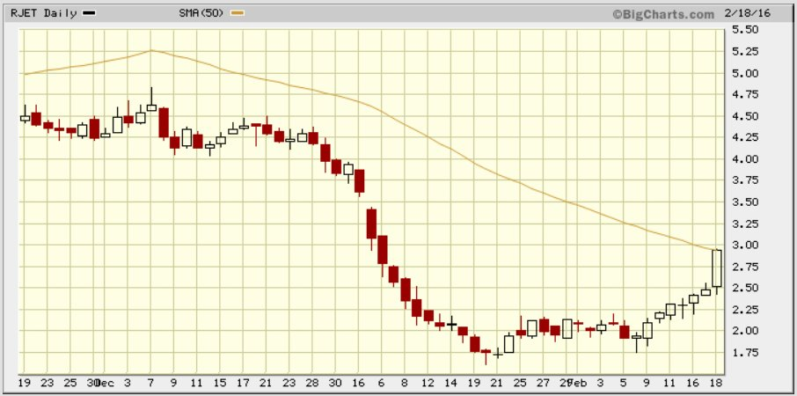

Jean-Marie Choffray @JMChoffray 19 févr. 2016
TK: Earnings beat! Sit down, shut up, read & think. https://t.co/9VJsV3yhHr

Jean-Marie Choffray @JMChoffray 17 févr. 2016
Welcome to Bizarro World… “Doing the opposite of what we recommended would have been better.” https://t.co/EW85cNXTHV

Jean-Marie Choffray @JMChoffray 17 févr. 2016
NBL: Earnings miss! Sit down, shut up, read & think. https://t.co/HeEvbnFeGI

Jean-Marie Choffray @JMChoffray 17 févr. 2016
Marx is completely wrong! Capital is NOT "Dead labour that vampire-like only lives by sucking living labour, and lives the more it sucks."

Jean-Marie Choffray @JMChoffray 17 févr. 2016
FCEL: “They did not know it was impossible, so they did it.” (Mark Twain) https://t.co/9cuHfjYAOV

Jean-Marie Choffray @JMChoffray 17 févr. 2016
The Ten Suggestions… (Ben S. Bernanke) https://t.co/4ryH0UFQX2

Jean-Marie Choffray @JMChoffray 17 févr. 2016
SUNE: Some activists’ bark might be worse than their bite. https://t.co/Wq5bAQXRgE

Jean-Marie Choffray @JMChoffray 17 févr. 2016
Whether people like it or not, Capital (i.e. Savings) - as any economic resource -, will always tend to “follow” its marginal productivity.

Jean-Marie Choffray @JMChoffray 17 févr. 2016
“Je crois à la vertu des petits peuples. Je crois à la vertu du petit nombre. Le monde sera sauvé par quelques-uns.” (A. Gide)

Jean-Marie Choffray @JMChoffray 17 févr. 2016
Those who think they know…, usually don’t know that they think!

Jean-Marie Choffray @JMChoffray 17 févr. 2016
KMI : Warren Buffett gets involved. But…, isn’t bottoming a process? https://t.co/ffjdQAVFyg

Jean-Marie Choffray @JMChoffray 17 févr. 2016
“Qui donne aux pauvres prête à Dieu. Qui donne à l’état, prête à rire.” (P. Bernard)

Jean-Marie Choffray @JMChoffray 16 févr. 2016
Oil prices… lower for longer? https://t.co/GbIC2WeaZZ https://t.co/yz0d3Pg6Q2
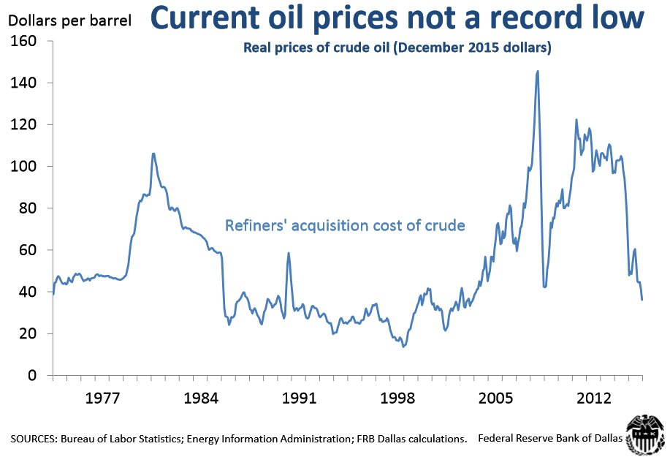

Jean-Marie Choffray @JMChoffray 16 févr. 2016
Don’t pundits claim that we're in recession already? https://t.co/qiN60KWoAt

Jean-Marie Choffray @JMChoffray 16 févr. 2016
SUNE: After NIRP… NMCB (Negative Market Cap Businesses)? SUNE ($ 447M) < TERP Shares ($ 379M) + GLBL Shares ($ 192M)

Jean-Marie Choffray @JMChoffray 16 févr. 2016
UPL: Natural gas producers dilemma (current market price: $ 1.93 Mcfe)… https://t.co/CyM9EiIvSC https://t.co/L9DBd77lNE
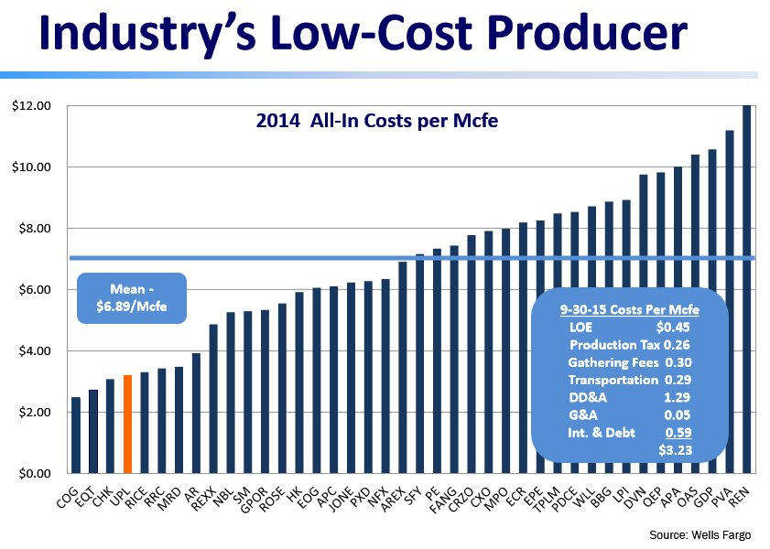

Jean-Marie Choffray @JMChoffray 16 févr. 2016
“The moment you doubt whether you can fly, you cease for ever to be able to do it.” (J.M. Barrie, Peter Pan)

Jean-Marie Choffray @JMChoffray 16 févr. 2016
“Happiness is probably to continue to desire things that you do not really want.” (S. Zizek)

Jean-Marie Choffray @JMChoffray 12 févr. 2016
Silence and absence are… ultimate “tools” of efficient investing.

Jean-Marie Choffray @JMChoffray 11 févr. 2016
The markets today… “Mano A Algo”. Not for the faint of heart!

Jean-Marie Choffray @JMChoffray 10 févr. 2016
Elon Musk’s rough year! He just lost $3.3B on a double whammy https://t.co/XFhvYIRM5Z via @usatoday

Jean-Marie Choffray @JMChoffray 10 févr. 2016
One life. Two shots. Make the second count…

Jean-Marie Choffray @JMChoffray 10 févr. 2016
Your first loss is ALWAYS your best loss!

Jean-Marie Choffray @JMChoffray 10 févr. 2016
When the crunch comes... https://t.co/FpayYmR0gd

Jean-Marie Choffray @JMChoffray 10 févr. 2016
Balance Sheet RISK... "Nothing right on the left side, nothing left on the right side!"

Jean-Marie Choffray @JMChoffray 9 févr. 2016
Negative yields... https://t.co/0rX32HdOYH https://t.co/0qpQzy5Nav
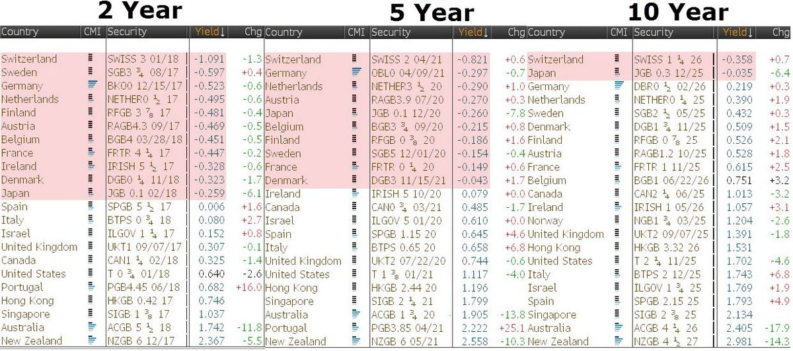

Jean-Marie Choffray @JMChoffray 9 févr. 2016
Some key banks Price/Tangible Book Value. https://t.co/N3ow73Zp3w via @bfly https://t.co/ZKKSUcUYtP
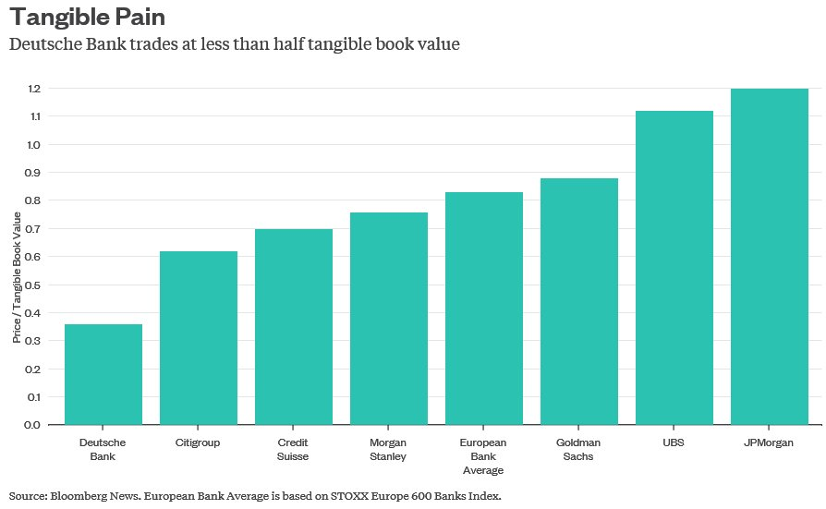

Jean-Marie Choffray @JMChoffray 9 févr. 2016
EQUITY financing in Europe is half of what it is in the USA, and DEBT financing is twice as large.

Jean-Marie Choffray @JMChoffray 9 févr. 2016
“Stronger integration is the obvious way to restore trust in the euro zone…” https://t.co/kqrwUc39wq

Jean-Marie Choffray @JMChoffray 9 févr. 2016
"Under capitalism, man exploits man. Under communism, it's just the opposite." (John Kenneth Galbraith)

Jean-Marie Choffray @JMChoffray 9 févr. 2016
Liquidity Trap. Monetary policy effective insofar as it succeeds in creating expectations of inflation... https://t.co/iz7p1Qx9fE

Jean-Marie Choffray @JMChoffray 9 févr. 2016
EOG, APC, PXD, APA, NBL, DVN, CLR... Probably worth checking their financials. https://t.co/iSQT1mw7gS
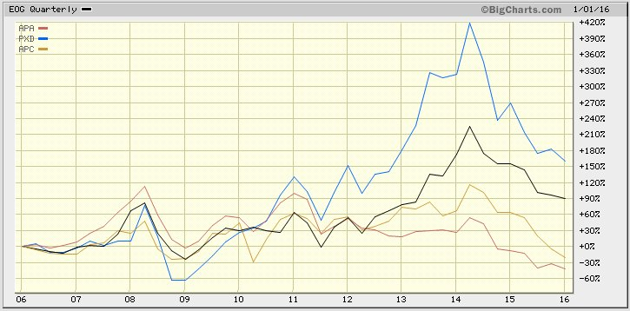

Jean-Marie Choffray @JMChoffray 9 févr. 2016
Tough day for Carl Icahn… https://t.co/KIAHQ48l2Z

Jean-Marie Choffray @JMChoffray 9 févr. 2016
"Quand le mal a toutes les audaces, le Bien doit avoir tous les courages." (P.A. de Beaumarchais)

Jean-Marie Choffray @JMChoffray 8 févr. 2016
DB: Updated information about payment capacity. https://t.co/A3ELKm8tW3 https://t.co/b4skvyoPc8
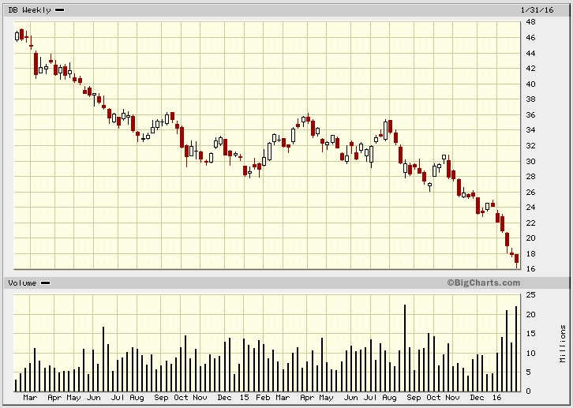

Jean-Marie Choffray @JMChoffray 8 févr. 2016
Consumer credit growth... https://t.co/TkF0YxpcKD

Jean-Marie Choffray @JMChoffray 8 févr. 2016
Is inflation finally picking up? https://t.co/aJQdBYXIO6

Jean-Marie Choffray @JMChoffray 8 févr. 2016
As an investor, if you’re willing to pay managers to do nothing…, you will be surprised how well they’ll do it!

Jean-Marie Choffray @JMChoffray 8 févr. 2016
Good news is bad news! On the markets, it’s just the opposite...

Jean-Marie Choffray @JMChoffray 8 févr. 2016
You never take much risk when you buy CHEAP (in terms of P/B, P/EV, P/EG), but QUALITY, businesses.

Jean-Marie Choffray @JMChoffray 8 févr. 2016
Typically…, refiners act as CALL options on the price of oil. https://t.co/ntBTgJQ2AP
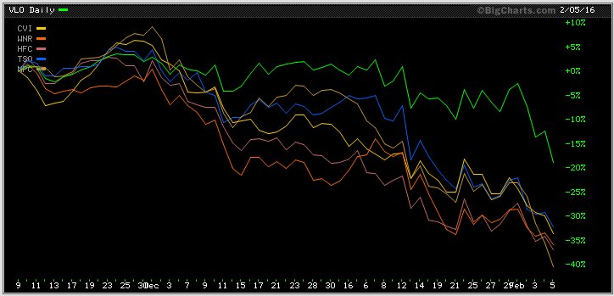

Jean-Marie Choffray @JMChoffray 8 févr. 2016
There is “blood” and pessimism all over the place. Good…, I will very selectively take the other side of the trade!

Jean-Marie Choffray @JMChoffray 7 févr. 2016
“So as crazy as things are, I think this is an incredibly exciting time to be alive.” (C. Powell) https://t.co/x4JjvWf8No

Jean-Marie Choffray @JMChoffray 6 févr. 2016
President Obama’s 21st Century Clean Transportation System https://t.co/saVYSYGkgF

Jean-Marie Choffray @JMChoffray 6 févr. 2016
Expect the unexpected. Think the unthinkable. Admit the impossible. The past is not often a good predictor of the future!

Jean-Marie Choffray @JMChoffray 6 févr. 2016
Laziness, self-indulgence, fear and hope are investors worst enemies.

Jean-Marie Choffray @JMChoffray 6 févr. 2016
The key to success is all about how much you make when you’re right and how much you lose when you’re wrong.

Jean-Marie Choffray @JMChoffray 6 févr. 2016
Financial markets are, and will always be, at the edge of Chaos. You better get used to it!

Jean-Marie Choffray @JMChoffray 6 févr. 2016
A bit of history... https://t.co/OmLaueFymA

Jean-Marie Choffray @JMChoffray 6 févr. 2016
No comment... https://t.co/ie8Qg1UyEt

Jean-Marie Choffray @JMChoffray 6 févr. 2016
Allowing emotions to impact on your investment strategy is the road to hell.

Jean-Marie Choffray @JMChoffray 6 févr. 2016
XAU, GLD, NEM, GDX: Gold Index, Gold ETF (Paper Gold), Gold Miner, Gold Miners ETF (Paper Miners). https://t.co/JzHmIM2JuA
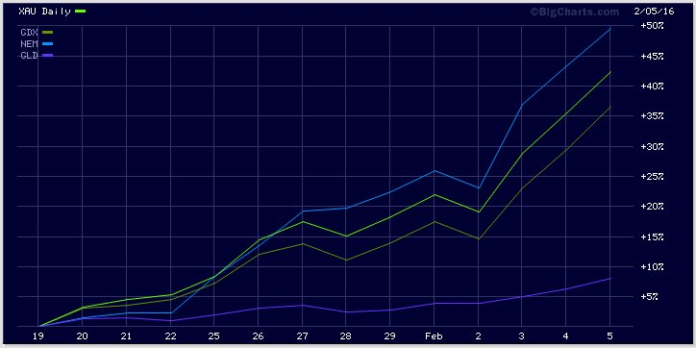

Jean-Marie Choffray @JMChoffray 6 févr. 2016
What difference does it make to your strategy when you finally realize that most market participants… don’t even know that they don’t know!

Jean-Marie Choffray @JMChoffray 5 févr. 2016
“We need some time here to understand what is going on, says Kaplan from the Dallas Fed.” (Bill Gross) https://t.co/Pl49l9YZ1n

Jean-Marie Choffray @JMChoffray 5 févr. 2016
“Il y a plus urgent... On réformera l’orthographe quand la prospérité sera revenue !” (Jean d’Ormesson)

Jean-Marie Choffray @JMChoffray 5 févr. 2016
A non-random walk down the past... https://t.co/tvgjbquhXb

Jean-Marie Choffray @JMChoffray 4 févr. 2016
CS, DB: A good graph is worth a thousand words! https://t.co/m2YqGkhrgq
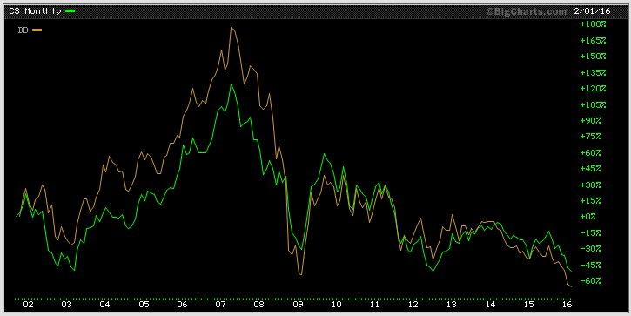

Jean-Marie Choffray @JMChoffray 4 févr. 2016
VALUE is what you get in terms of PROFITABLE GROWTH... PRICE is what you pay in the form of a short term loss of LIQUIDITY…

Jean-Marie Choffray @JMChoffray 4 févr. 2016
Valuation is the closest thing we have to the law of gravity in finance.

Jean-Marie Choffray @JMChoffray 3 févr. 2016
The trick is to take a diversified basket of risks in a portfolio.

Jean-Marie Choffray @JMChoffray 3 févr. 2016
CPST: Those who fail to learn from history are destined to repeat it! https://t.co/qAcoN46GVh
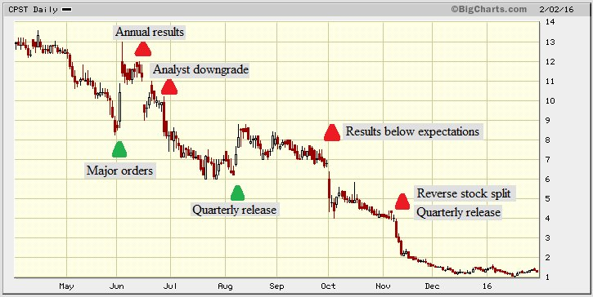

Jean-Marie Choffray @JMChoffray 2 févr. 2016
As an investor, your highest goal should always be to conserve & preserve capital!

Jean-Marie Choffray @JMChoffray 2 févr. 2016
“Ordinary risks that didn’t work out well.” https://t.co/UqHmrKivko via @business https://t.co/JUTzebd95c
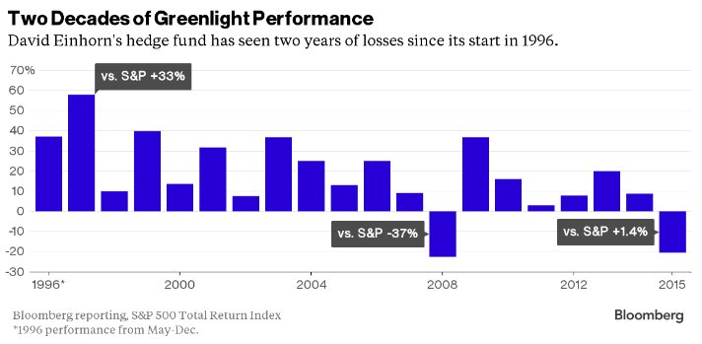

Jean-Marie Choffray @JMChoffray 1 févr. 2016
Is oil divergence (S&P 500 vs XLE) coming to an end? https://t.co/Jwv3qk8aFg
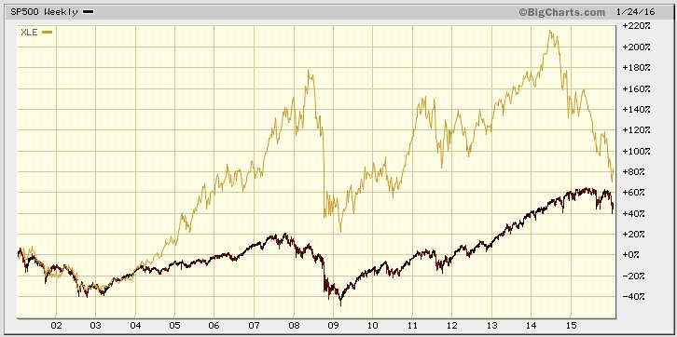

Jean-Marie Choffray @JMChoffray 1 févr. 2016
They have been wrong so many times… Could they be right this time? https://t.co/mxsEQn3Mxq

Jean-Marie Choffray @JMChoffray 31 janv. 2016
Is the S&P 500 expensive? It’s anyone’s guess! https://t.co/8GvcfHfW0C
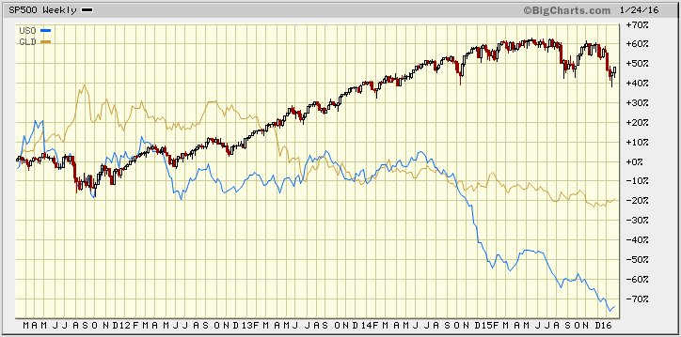

Jean-Marie Choffray @JMChoffray 31 janv. 2016
The end of your story is not written until you decide to write it up!

Jean-Marie Choffray @JMChoffray 31 janv. 2016
“In a democracy, people usually get the opposite of what they voted for…” (Multiple sources)

Jean-Marie Choffray @JMChoffray 31 janv. 2016
“If we want things to stay as they are, things will have to change.” (G. di Lampedusa)

Jean-Marie Choffray @JMChoffray 31 janv. 2016
In a volatile market, cash is king. Always, keep some powder dry.

Jean-Marie Choffray @JMChoffray 31 janv. 2016
PATIENCE is the mother of all virtues. On the markets, it will bring you incredible opportunities.

Jean-Marie Choffray @JMChoffray 31 janv. 2016
Life in society is a comedy. Producers, scriptwriters and actors expect you to pay, lose time, and applaud.

Jean-Marie Choffray @JMChoffray 31 janv. 2016
Financial freedom, in one form or another, is the foundation of most of our liberties.

Jean-Marie Choffray @JMChoffray 30 janv. 2016
FB: sustained growth, but… extreme valuation! https://t.co/bCXvPbmA0O

Jean-Marie Choffray @JMChoffray 30 janv. 2016
Markets are trial & error processes to price businesses equity & growth. At times, errors may be huge!

Jean-Marie Choffray @JMChoffray 29 janv. 2016
A memo from POLITICO's founder and publisher Robert Allbritton https://t.co/l1H95ajd57

Jean-Marie Choffray @JMChoffray 29 janv. 2016
Bank of Japan Adopts Negative Rates, Keeps Asset-Buying Target. https://t.co/NHqSmgkEeL

Jean-Marie Choffray @JMChoffray 28 janv. 2016
FCX: Moody's downgrade. Current environment isn't a cyclical downturn but a fundamental shift for these commodities. https://t.co/e1BsQPGmHB

Jean-Marie Choffray @JMChoffray 28 janv. 2016
Bill Ackman Blames Abysmal Performance On Hedge Fund Groupthink… https://t.co/lVYL7aFHim https://t.co/dhSj7GWqh0
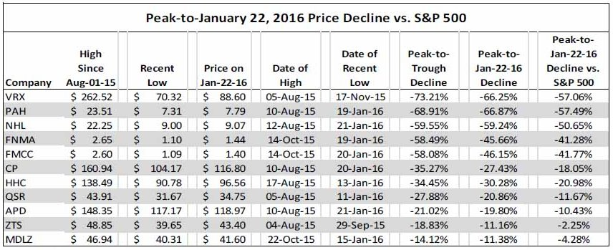

Jean-Marie Choffray @JMChoffray 28 janv. 2016
Federal Reserve issues FOMC statement. https://t.co/54YnnN3a24

Jean-Marie Choffray @JMChoffray 27 janv. 2016
It’s a great time to finally sit down, shut up, and think…

Jean-Marie Choffray @JMChoffray 26 janv. 2016
Paulson Pledges Personal Holdings to Back Firm After Assets Fall https://t.co/T0TD7kPpGQ via @business

Jean-Marie Choffray @JMChoffray 26 janv. 2016
FOMC Meeting. @FederalReserve has a problem. A real one! The least bad option is to do nothing. Strictly nothing!

Jean-Marie Choffray @JMChoffray 25 janv. 2016
Monetary Base. https://t.co/3VT5xWNlJR

Jean-Marie Choffray @JMChoffray 25 janv. 2016
Trade Weighted $ Index. https://t.co/p5IFNFy050

Jean-Marie Choffray @JMChoffray 25 janv. 2016
SSYS, DDD, MTLS, XONE, VJET, ONVO, PRLB... Probably worth checking their financials.

Jean-Marie Choffray @JMChoffray 25 janv. 2016
F.O.M.C. https://t.co/8kaz33JyRP

Jean-Marie Choffray @JMChoffray 25 janv. 2016
DD, MON, SYT, POT, AGU, MOS, CF... Probably worth checking their financials.

Jean-Marie Choffray @JMChoffray 25 janv. 2016
Something might be brewing in the alternative energy space. https://t.co/txaN2Yc8Yh

Jean-Marie Choffray @JMChoffray 24 janv. 2016
“It is not the strongest that survives. Nor the most intelligent. It is the one most adaptable to change.” (Attributed to C. Darwin)

Jean-Marie Choffray @JMChoffray 24 janv. 2016
Whatever the decisions @FederalReserve in terms of #MonetaryPolicy, most foreign countries will always complain.

Jean-Marie Choffray @JMChoffray 24 janv. 2016
The ONLY solution to the endemic European #UnemploymentRate is that people finally get a USEFUL & VALUABLE education. Period!

Jean-Marie Choffray @JMChoffray 24 janv. 2016
NO #EconomicSystem can afford paying people to DO NOTHING!

Jean-Marie Choffray @JMChoffray 24 janv. 2016
“To the extent we move away from #capitalism, we empower the worst people in society to manage what they do not understand.” (F.A. Hayek)

Jean-Marie Choffray @JMChoffray 24 janv. 2016
#MACD (SPY, QQQ, DIA) + #MACD (VIX, VXN, VXD): in all likelihood, a normal market correction, followed by a sector rotation?

Jean-Marie Choffray @JMChoffray 24 janv. 2016
VIX, VXN, VXD: enjoy… the short term #volatility of key volatility indexes. https://t.co/jP1a6Nb2na
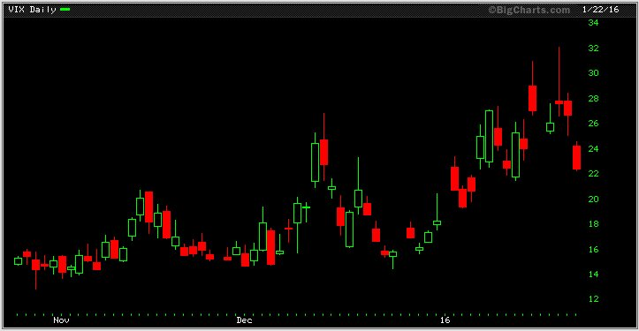

Jean-Marie Choffray @JMChoffray 24 janv. 2016
OIL: what happens when an #ETN and its #NAV diverge.

Jean-Marie Choffray @JMChoffray 23 janv. 2016
Clean Power Plan looks a little more real than it did last week... https://t.co/fQpyyBQv0x via @business

Jean-Marie Choffray @JMChoffray 23 janv. 2016
Businesses are playthings for bigger forces…

Jean-Marie Choffray @JMChoffray 23 janv. 2016
10 hilarious cartoons about the stock market panic https://t.co/9kfar6SRa6

Jean-Marie Choffray @JMChoffray 23 janv. 2016
“Les démocraties ne peuvent pas plus se passer d’être hypocrites que les dictatures d’être cyniques.” (G. Bernanos)

Jean-Marie Choffray @JMChoffray 23 janv. 2016
“Il n'y a d'autre enfer pour l'homme que la bêtise ou la méchanceté de ses semblables. ” (Marquis de Sade)

Jean-Marie Choffray @JMChoffray 23 janv. 2016
“It is difficult to get a man to understand something, when his salary depends on his not understanding it.” (U. Sinclair)

Jean-Marie Choffray @JMChoffray 23 janv. 2016
As an investor – stockholder and/or bondholder –, you should always wonder who’s going to rob you next.

Jean-Marie Choffray @JMChoffray 23 janv. 2016
“Underlying most arguments against the free market is a lack of belief in freedom itself.” (Milton Friedman)

Jean-Marie Choffray @JMChoffray 23 janv. 2016
“History is largely a history of inflation, usually inflations engineered by governments for the gain of governments.” (F.A. Hayek)

Jean-Marie Choffray @JMChoffray 23 janv. 2016
Probably and slowly... https://t.co/d60QYfCAZZ

Jean-Marie Choffray @JMChoffray 23 janv. 2016
Cost of corporate borrowing... https://t.co/PictUG7qMQ

Jean-Marie Choffray @JMChoffray 23 janv. 2016
No boom or bust... https://t.co/GCZXkyP6Ib

Jean-Marie Choffray @JMChoffray 23 janv. 2016
“The Road to Serfdom” (F. A. Hayek) https://t.co/BZLxjzCVjP

Jean-Marie Choffray @JMChoffray 23 janv. 2016
This Is What The Death Of A Nation Looks Like: Venezuela Prepares For 720% Hyperinflation https://t.co/X75SvUUn0c

Jean-Marie Choffray @JMChoffray 23 janv. 2016
As the last few days suggests, in a volatile environment, individual stock prices tend to “bottom” later in their quarterly cycle.

Jean-Marie Choffray @JMChoffray 22 janv. 2016
Severe fog and limited visibility in Shanghai. https://t.co/qNHzQuuOba
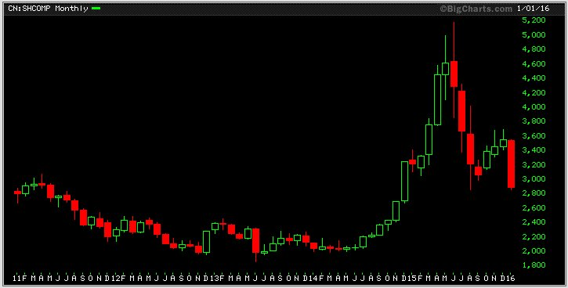

Jean-Marie Choffray @JMChoffray 22 janv. 2016
Markets are under assisted ventilation and intense cardiac monitoring. https://t.co/N7jK3hy1mq
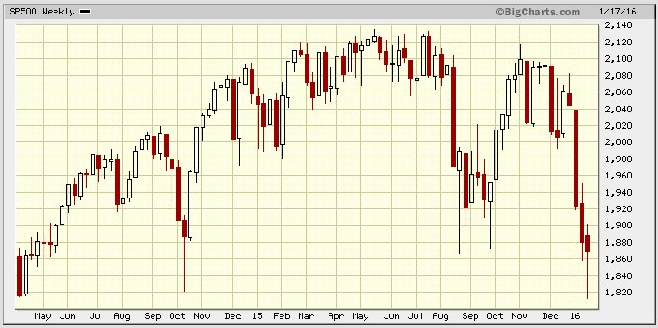

Jean-Marie Choffray @JMChoffray 22 janv. 2016
“When Jim Cramer screamed “they know nothing, they know nothing”, he was being a little unfair but not by much.” (Bill Gross)

Jean-Marie Choffray @JMChoffray 22 janv. 2016
“Faith? What allows intelligence to live beyond its means.” (André Frossard)

Jean-Marie Choffray @JMChoffray 21 janv. 2016
“Communicate plainly what you are trying to do…, and who knows, you might even end up understanding it yourself.” (Stephen Hawking)

Jean-Marie Choffray @JMChoffray 21 janv. 2016
Wake up! The world is waiting for you… https://t.co/xqs3ml4IbK https://t.co/8DvC9YyQIe
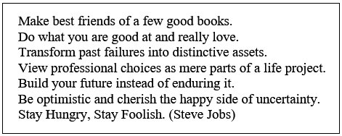

Jean-Marie Choffray @JMChoffray 21 janv. 2016
Seven heuristics to protect assets in adverse market conditions… (Source: J.M. Choffray and C. Pahud de Mortanges) https://t.co/5Qj5bOVwcN
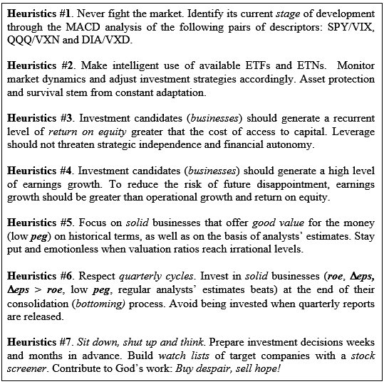

Jean-Marie Choffray @JMChoffray 21 janv. 2016
It’s the psychology, stupid! Free money. Free energy. Free technology. But…, lack of faith? https://t.co/KNVMEH2LSE
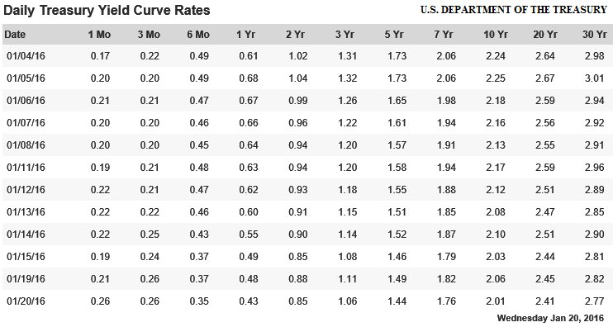

Jean-Marie Choffray @JMChoffray 20 janv. 2016
Always…, trust experienced drivers!https://t.co/Id6outXV9E

Jean-Marie Choffray @JMChoffray 20 janv. 2016
Characteristics of “Bear” and “Bull” markets (Source: JPMorgan & Bloomberg) https://t.co/2zTWPUq5FP
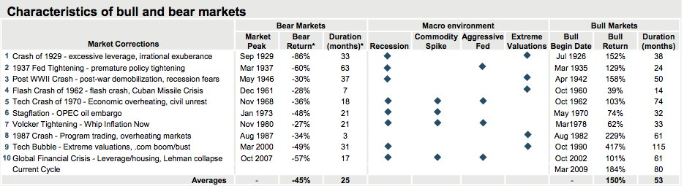

Jean-Marie Choffray @JMChoffray 20 janv. 2016
It better be a spurious correlation! (Source: FRED, Federal Reserve Bank of St. Louis) https://t.co/KzSupgYubi
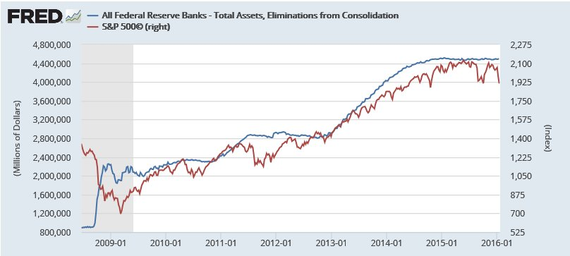

Jean-Marie Choffray @JMChoffray 20 janv. 2016
“People – here, investors? – do not die from debt, but from not being able to make more…” (Oscar Wilde)

Jean-Marie Choffray @JMChoffray 20 janv. 2016
The first wave (2007…) killed the INNOCENT. The second (2011…) killed the BRAVE. Will the third kill the SMART?

Jean-Marie Choffray @JMChoffray 20 janv. 2016
It’s a market without… buyers, aside from a few dangling elephants, constrictor snakes and exhausted rhinos.

Jean-Marie Choffray @JMChoffray 20 janv. 2016
If we reject the third option…, we have a simple choice between “PRINTING” and “WORKING”.

Jean-Marie Choffray @JMChoffray 19 janv. 2016
Today, investors need to DREAM about businesses that offer credible histories of POTENTIAL growth!

Jean-Marie Choffray @JMChoffray 19 janv. 2016
In a “Liquidity Trap”, monetary policy is effective insofar as the central bank succeeds in creating expectations of inflation...

Jean-Marie Choffray @JMChoffray 18 janv. 2016
US oil prices and drilling activity. https://t.co/izCbzDjlCs

Jean-Marie Choffray @JMChoffray 18 janv. 2016
@DallasFed: US oil prices and drilling activity. https://t.co/izCbzDjlCs

Jean-Marie Choffray @JMChoffray 18 janv. 2016
Money is never lost… It changes pocket! S&P 500 ETF (SPY) and Inverse ETF (SH). https://t.co/SOCMAldikh
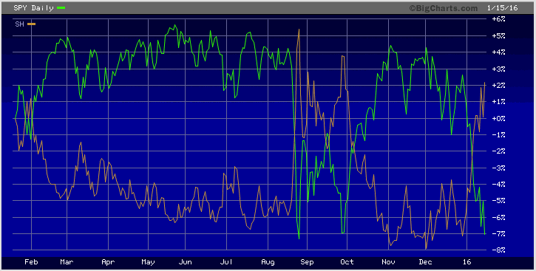

Jean-Marie Choffray @JMChoffray 17 janv. 2016
On the markets, I’ve come to realize that there are lies, big lies, and then financials!

Jean-Marie Choffray @JMChoffray 17 janv. 2016
Seven heuristics that we developed painfully. To be tested thoroughly before adoption... https://t.co/fCu645CgAJ

Jean-Marie Choffray @JMChoffray 17 janv. 2016
Iran’s population: 82M. GDP: $1.3T (PPP). Public debt: 11% of GDP. (https://t.co/s2IzefzzSv: The World Factbook)

Jean-Marie Choffray @JMChoffray 16 janv. 2016
“Example isn't another way to teach, it is the only way to teach.“ (A. Einstein)

Jean-Marie Choffray @JMChoffray 16 janv. 2016
“We have two lives, and the second begins when we realize we only have one.“ (Confucius)

Jean-Marie Choffray @JMChoffray 16 janv. 2016
“C'était de faux hasards qui dissimulaient mal l'ordre universel.“ (J-P. Sartre)

Jean-Marie Choffray @JMChoffray 16 janv. 2016
I am afraid that Jean d’Ormesson might be right…

Jean-Marie Choffray @JMChoffray 16 janv. 2016
“What a Wonderful World”... We are free to learn, free to invest, free to share, and free to behave with dignity!

Jean-Marie Choffray @JMChoffray 16 janv. 2016
Don’t worry! The world is not going to collapse anytime soon. “Indeterminacy” means “opportunity”.

Jean-Marie Choffray @JMChoffray 16 janv. 2016
The MISSION of ANY company: create economic VALUE (equity) and generate GROWTH (earnings). Both…, responsibly!

Jean-Marie Choffray @JMChoffray 16 janv. 2016
After all, “Black” swans aren’t they still swans? Same food, same behavior, same flight patterns…

Jean-Marie Choffray @JMChoffray 16 janv. 2016
WATCH OUT “Dangling elephants” (ETFs), “Constrictor snakes” (hedge funds) and other “Charging rhinos” (activists)!

Jean-Marie Choffray @JMChoffray 16 janv. 2016
Beware: over time… balance sheets never lie!

Jean-Marie Choffray @JMChoffray 16 janv. 2016
Our world is in desperate need for sustainable development. “Responsible Leadership” & “Free Enterprises” is THE SOLUTION. Not the problem!

Jean-Marie Choffray @JMChoffray 15 janv. 2016
Option Expiration Fridays are usually volatile. Today looks exceptional! Time for action?

Jean-Marie Choffray @JMChoffray 15 janv. 2016
Build and test some heuristics to conceptualize response to the unknown, connect proven facts, and convert discrepancies into opportunities.

Jean-Marie Choffray @JMChoffray 14 janv. 2016
De l'utilité de relire Gustave Le Bon (Psychologie des Foules)... "Le printemps tunisien a détruit plus qu'il n'a construit" (M. Haddad).

Jean-Marie Choffray @JMChoffray 14 janv. 2016
Facile de réécrire l'histoire... "Ce sont souvent les mêmes qui se prévalent d'une sagesse plus rétrospective que presciente" (P Gélie)

Jean-Marie Choffray @JMChoffray 14 janv. 2016
One can lose a lot of money making the RIGHT investment at the WRONG time.

Jean-Marie Choffray @JMChoffray 14 janv. 2016
“Who controls the food supply controls the people.” (H. Kissinger)

Jean-Marie Choffray @JMChoffray 14 janv. 2016
"Who controls the energy can control whole continents." (H. Kissinger)

Jean-Marie Choffray @JMChoffray 14 janv. 2016
"Who controls money can control the world.” (H. Kissinger)

Jean-Marie Choffray @JMChoffray 14 janv. 2016
Question: how to invest if Nietzsche and Jünger were wrong?

Jean-Marie Choffray @JMChoffray 14 janv. 2016
Always wonder about what those on the other side of the trade think of you...

Jean-Marie Choffray @JMChoffray 14 janv. 2016
The more one learns on the markets, the thicker the mystery of their behavior...

Jean-Marie Choffray @JMChoffray 14 janv. 2016
I know you believe you understand what you think I wrote, but I am not sure you realize that what you read is not what I meant !

Jean-Marie Choffray @JMChoffray 14 janv. 2016
"The men who can manage men manage the men who can manage only things, and the men who can manage money manage all." (W. & A. Durant)

Jean-Marie Choffray @JMChoffray 14 janv. 2016
There is no better investment strategy than to constantly adapt to the madness of crowds.

Jean-Marie Choffray @JMChoffray 14 janv. 2016
"Free markets" is the best system "to enable people who hate one another to deal with one another and help one another.” (Milton Friedman)

Jean-Marie Choffray @JMChoffray 14 janv. 2016
"The typical state of mankind is tyranny, servitude, and misery. (Milton Friedman)

Jean-Marie Choffray @JMChoffray 13 janv. 2016
Let’s learn to be patient... Bottoming is a process, not an event.

Jean-Marie Choffray @JMChoffray 13 janv. 2016
Watch out! Events that did NOT happen in the past, and facts that did NOT materialize, are usually the best predictors of the future...

Jean-Marie Choffray @JMChoffray 13 janv. 2016
Investing is not a science. It's not an art either. It's a lesson of humility!

Jean-Marie Choffray @JMChoffray 13 janv. 2016
Strange. Capstone Turbine’s market cap is less than its quarterly revenue.

* * *

